Activity
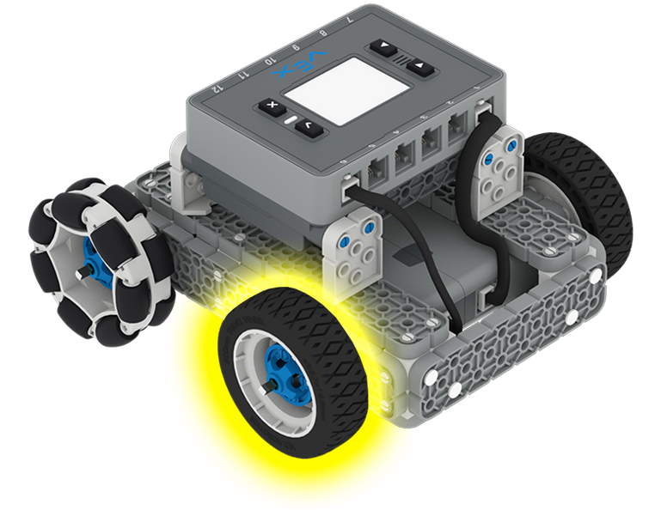 | Spin Your Wheels  Can you calculate how fast your wheel spins using measurements from a VEXcode IQ Project?

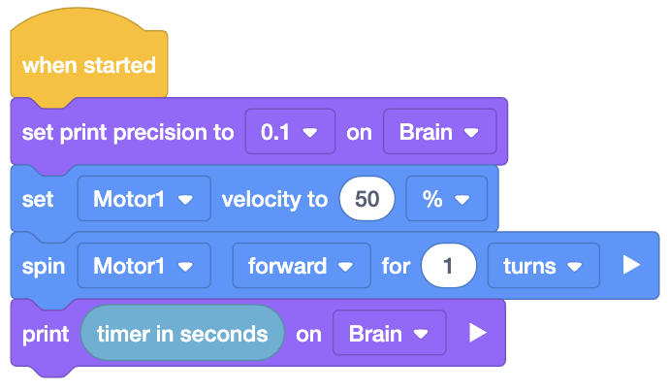
Step by Step
- Build the BaseBot and open VEXcode IQ to create a new project.
- Configure a Motor device to your project in Port 1. This will allow you to control the left drive motor.
- Recreate the project shown to the right. Save, download, and run the project.
- Divide the 1 revolution of the wheel by the time indicated in seconds measured by the project (displayed on the Brain). This will give you the wheel speed in revolutions per second. Multiply your value by 60 seconds per minute. This will give you the wheel speed in the standardized revolutions per minute (RPM). Record your results.
- Change the parameter in the [Set motor velocity] block to 60%. Download and run the adjusted project. Using the step above to calculate the new wheel speed in RPMs. Repeat this step for 70%, 80%, 90%, and 100%. Record your results for each velocity value.
- Test to see if there is a difference in the wheel speed with the BaseBot elevated (the wheels not touching the ground) and with the BaseBot driving on the ground.
‘LEVEL UP’  - Picture your Data - Create a line graph of RPM versus percent velocity from the data you collected. Can you use the graph to predict how fast your wheel will spin at 75% velocity?  - Ground Travel - The 200 mm wheel will travel 20 cm for every turn. Can you calculate how far the wheel will travel in one minute at 100% velocity? Can you calculate the wheel’s ground speed in centimeters per second (cm/s) at 100% velocity? | Pro Tips  - Ensuring the motor is securely fastened to the drivetrain and the shaft is not bent will reduce friction and increase your wheel speed.  - Engineers can use a handheld tachometer to measure the RPMs of a motor shaft.
Standard: CCSS.MATH.CONTENT.7.RP.A.2.B: Identify the constant of proportionality (unit rate) in tables, graphs, equations, diagrams, and verbal descriptions of proportional relationships.

