Activity
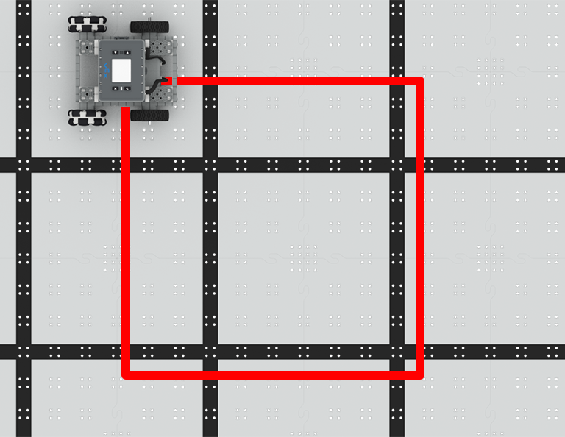 | Square Dance  Code the BaseBot to drive in a square!

Step by Step
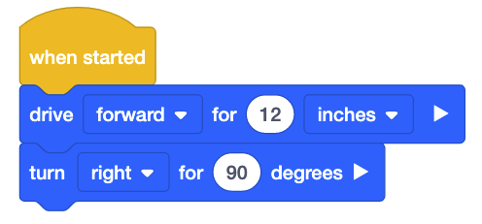
- Build the BaseBot and open the BaseBot (Drivetrain 2-motor) template in VEXcode IQ.
- Drag in a [Drive for] block and change the parameter to “12” and the dropdown to inches.
- Drag in a [Turn for] block, placing it under the [Drive for] block. These two blocks will make the first corner of the square.
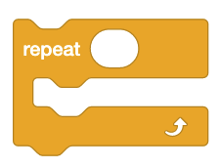
- Add additional blocks to code your robot to drive in a square.
- Download the project to the Brain and run it.
- In order to make a complete square with fewer blocks, you can repeat the actions of making one corner. Drag in a [Repeat] block, and wrap it around the first [Drive for] and [Turn for] blocks. How many times should the blocks be repeated to make a complete square?
‘LEVEL UP’  - Upsize - Change the parameters to make a bigger square.  - Rectangle Challenge - Now that you can make a square, how can you use the repeat block to make a rectangle? | Pro Tips  - In order to better understand looping and repetitions, write out each action the BaseBot will take to drive in a complete square. Note where steps repeat.
Standard: CSTA (2-AP-13) Algorithms and Programming - Decompose problems and subproblems into parts to facilitate the design, implementation, and review of programs.

