Activity
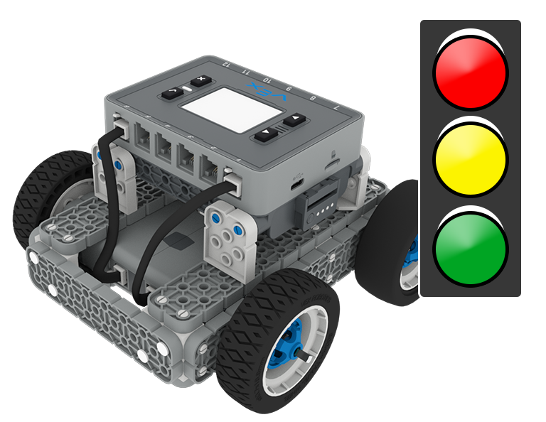 | Stop and Go  Code the BaseBot to travel to different locations!

Step by Step
- Build the BaseBot and open the BaseBot (Drivetrain 2-motor) template in VEXcode IQ.
- Mark three different locations on an IQ Field using a dry erase marker or tape. Label the locations A, B, and C.
- Measure the distance between the locations, and plan a route for the BaseBot in your engineering notebook. Your robot should begin at location A and stop at the other marked locations.
  - In what order will you travel to the stops? When will the BaseBot need to drive forward or turn?
- Drag in a [Drive for] block. Change the parameter to the distance from the starting position to the first location. Download and run the project.
- Continue adding [Drive for] and [Turn for] blocks to travel to the next two locations on the field. Download and run the project.
‘LEVEL UP’  - Over Here - Add more locations for the BaseBot to stop.  - Shortcut - What is the shortest route from each of the different locations? Measure the distance and the angle to travel the smallest distance from each location to the next. | Pro Tips  - Add a [Wait] block when you reach each location. The BaseBot will wait a given number of seconds before travelling to the next location.
Standard: CSTA (2-AP-10) Algorithms and Programming - Use flowcharts and/or pseudocode to address complex problems as algorithms.

