Activity
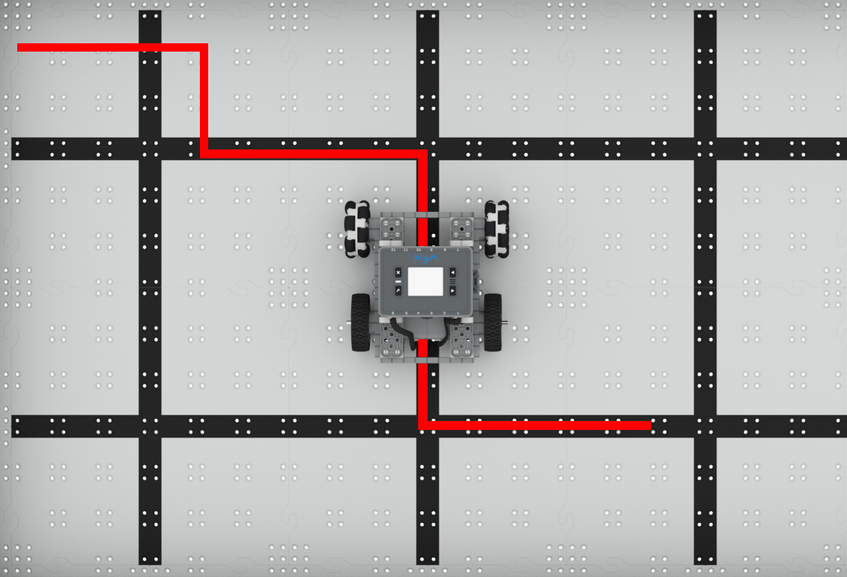 | To the Left, To the Right  Code the BaseBot to turn left and right.

Step by Step
- Build the BaseBot and open the BaseBot (Drivetrain 2-motor) template in VEXcode IQ.
- Drag in a [Turn for] block and attach it to the {When started} block. What do you expect the BaseBot to do?
- Download the project to the Brain and run it.
- Change the dropdown on the block to “left”, download, and run the project. Now what does the BaseBot do?
- Use masking or colored tape on the floor or tiles to create a path with at least two turns for the BaseBot to travel.
- What order should the robot drive forward and turn right or left? Plan your project flow in your engineering notebook. Then add additional [Drive for] and [Turn for] blocks to make the BaseBot travel the path.
‘LEVEL UP’  - Changing Angles - Change the parameter of the [Turn for] block to have the BaseBot turn at different angles. | Pro Tips  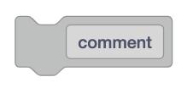  - Outline your planned path in a VEXcode IQ project using [Comment] blocks!
Standard: CSTA (2-AP-11) Algorithms and Programming - Create clearly named variables that represent different data types and perform operations on their values.

