Activity
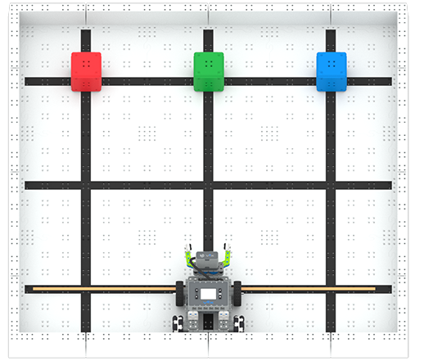 | Triple Transfer  How fast can you move three blocks to a new location?

Step by Step
- Build the Simple Clawbot and set up a field that is 3’x3’ and includes the Field Walls. Using colored tape, such as red or orange, mark the first black horizontal line going across the bottom of the Field. The area below the line will be considered the “Home” zone, as shown in the image above.
- Set one cube of each color (red, green, and blue) across the top of the field where the third black horizontal line meets the three vertical lines.
- Place the Simple Clawbot, with its back Omni wheels touching the back wall, anywhere along the back wall.
- Using the Driver Control Program, drive and move each colored cube to the “Home” zone. Cubes have to be inside the home zone, and cubes that are on the line do not count.
- Record the time it takes to move all three cubes. Can you do it even faster?
‘LEVEL UP’  - Stack It - Set a second cube on top of each current cube on the Field, and move all six to the Home zone, one at a time.  - Obstacle - Place objects, like pulleys or corner connectors, for the Simple Clawbot to drive around to complete the task. | Pro Tips  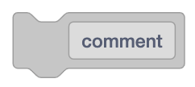  - When having to complete a multi-step task, divide the task into smaller sections and use [Comment] blocks when coding to help keep organized.
Standard: ISTE- Empowered Learner - Students use technology to seek feedback that informs and improves their practice and to demonstrate their learning in a variety of ways.

