September 5, 2016
In this unit of work, you will be completing a small design case study. You are to design and draw a small game that you would be able to print. Read through the case study so you understand what you will need to complete as there are certain restrictions.
Aim:
You are to design a 3D drawing of a small game, for example you could create something similar to the maze, you could look at making chess pieces or even a 3D puzzle.
Challenges:
Using the skills you have learnt from the name tag and the maze you will need to design something within your abilities. You need to be realistic about what you design, something overly complicated will take more time to draw, stick to simple shapes if possible.
Restrictions:
3D printing is an expensive process and printers have a limited size that they can effectively print, often they are also limited by bed size on the printer. For this case study you max size is listed:
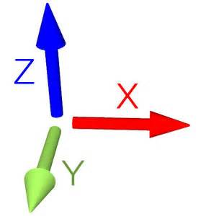
X: 150mm Y: 150 mm Z: 100mm

Actions:
- Within your case study you will discuss how and why you chose your specific item to model. You will go into detail as to how you modelled the item in CAD (You will need a minimum of 4 screenshots of your progress in CAD).
- Based on the item you choose you will need to discuss how it would be printed, i.e. will it be printed with support structures, on a printing bed etc.
- You will need to investigate and discuss print materials i.e. what type of material will be used to print your item (a handy site for a point of reference is https://www.3dhubs.com/materials)
- You will need to discuss any restrictions or issues that would arise from either the design process or the printing process.
Evaluation:
When you have completed the design and 3D drawing you will need to evaluate your work and describe how you feel you went in designing it and if it meets the criteria and restrictions.
Due Date:
You have 4 lessons and any time at home in between those lessons to complete this. I would recommend doing some research at home and leaving the lesson time to get your 3D models completed.

