Design and Technology
Timber Knowledge
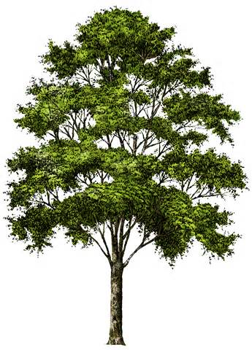
- Why is timber such a valuable resource?
……………………………………………………………………………………………………………………………………………………………………………………………………………………………………………………………………………………………………………………………………………………………………………………………………………………………………………………………………………………………………………………………………………………………...
- The timber we are using this term is …………………………………………….
It is grown in plantations in ………………………………………….and ……………………………….................
- You are working on your project and find that you are short of wood. Can you go outside and chop a branch off a tree and use it for your project, why?
…………………………………………………………………………………………………………………………………………………………………………………………………………………………………………………………………………………………………………………………………………………………………………………………………………………………………………………………………….
- Timber is classified into 2 main types, what are they?
1)……………………………………….
2)……………………………………….
5. Name 4 varieties of timber commonly used in our homes:
1)…………………………………………….
2)……………………………………………
3)……………………………………………
4)…………………………………………….

