THE BANDSAW
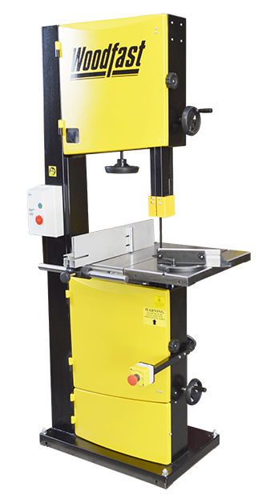
The bandsaw has a narrow continuous blade that enables the user to cut curved and straight cuts in both wood and plastics.
Parts and their Function
Guide Post – Provides support for the blade and blade guides. The guide post has a clear acrylic guard fitted at its base which should be set no more than 10mm above the work surface. The guard is designed to keep fingers clear of the blade and must be set correctly.
Blade – The continuous blade allows efficient cutting of curves; however, it cannot cut sharp curves unless the blade fitted is very narrow e.g. less than 10mm wide. Twisting the blade during cutting is the most common cause of blade breakage.
Table – The table provides a flat work surface which supports the work being cut. The table can be tilted for cutting angle cuts. The table can be fitted with a squaring and angle guide when required.

SAFE OPERATING PROCEDURE
- Permission is required before use
- Check and set the guide post and guard correctly before cutting.
- Never place fingers in line with the cutting edge of the blade.
- Use a push stick for feeding small pieces through the saw
- When cutting curves, keep your hands to the side of the work at all times ensuring fingers stay clear of the blade.
- Eye protection must be worn at all times.
- The blade must be at a complete stop before any adjustment is made.
- Avoid backing out of curved cuts while the blade is running. This may dislodge the blade from its guide wheels.
- Do not cut cylindrical or irregular shapes.
- Ensure the floor around the saw is free of debris that could cause tripping or distraction.
- Never leave the saw running unattended.

