Heritage College Design and Technology
Workshop safety Assessment
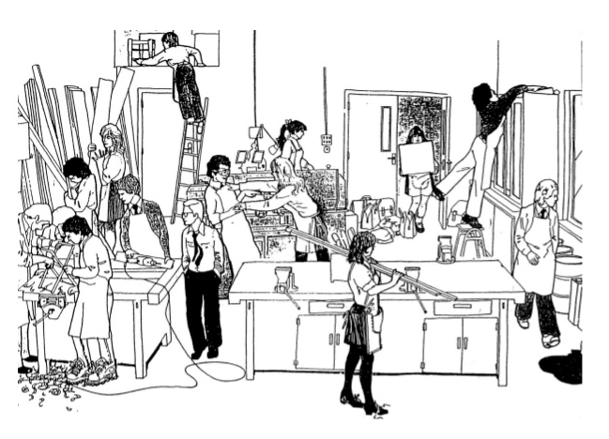
- This picture above shows a number of safety hazards and dangerous work practices. Circle or highlight all of the things that you believe to be dangerous.

- Now that you have identified the dangers and hazards pick 3 of these and provide the answers to the following questions:

- Explain 3 things that you have found wrong in the picture.
________________________________________________________________________________________________________________________________________________________________________________________________________________________________________________________________________________________________________________________________________________________________________________________________________________________________________________________________________________________________________________________________________________________

- What might happen to endanger the student or others as a result of the problems identified?
______________________________________________________________________________________________________________________________________________________________________________________________________________________________________________________________________________________________________________________________________________________________________________________________________________________________________________________________________________________________________________________________________________________________________________________________________________________________________________________________________________________________

- Explain ways to avoid or reduce the hazards that you have found.
____________________________________________________________________________________________________________________________________________________________________________________________________________________________________________________________________________________________________________________________________________________________________________________________________________________________________________________________________________________________________________________________________________________________________________________________________________________________________________________________________________________________________________________________________________________________________________________________________________________________________

