Design and Technology
Logo Design Task

TASK:
Use computer aided design software to create a sign plate including a logo which has been generated by importing an image into your CAD drawing. Your Logo can be one of your own making which includes the use of an image or a favourite brand.
Constraints
- Plate must not exceed 90mm in any dimension.
- Must utilise extrusion to allow colour change.
- Use 2 colours restricted to the choices available.
Once you have created your design you will provide an .stl file for printing and a drawing printed in colour showing the colour choices for 3D printing.

Evaluation
An evaluation of your final product and the process involved in production should be completed. The year 8 workbook has templates for your written evaluation.

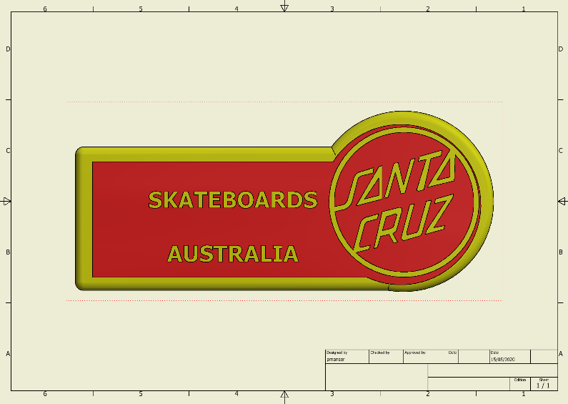
Hand in a coloured iso.dwg drawing in colours of your choice. Remember to print to the Tech printer and make sure you have selected best fit in the printing properties.
Produce a 3D rendered model in the 2 colours of your choice. Save as a .ipt and .stl file ready for printing.

