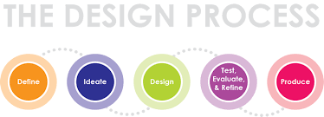

The Need – Problem (Something that requires a designed solution)

Design Brief (A short statement that guides the designer providing specifications and constraints)

Possible Solutions
Positives

Negatives

IMAGE HERE

Positives

Negatives

IMAGE HERE

IMAGE HERE
Positives

Negatives

Conclusion: What I have learnt from considering these ideas.
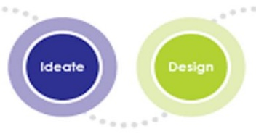

The Solution
Intention

Investigate the How to?
Specifications

Joining Methods

Materials

Finishes

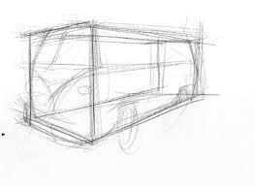
Drawings and Prototypes
Sketches

Working Drawings?
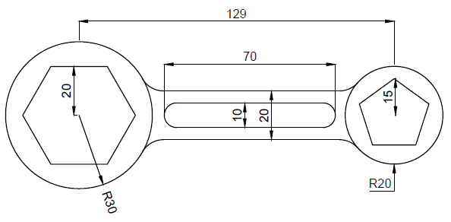
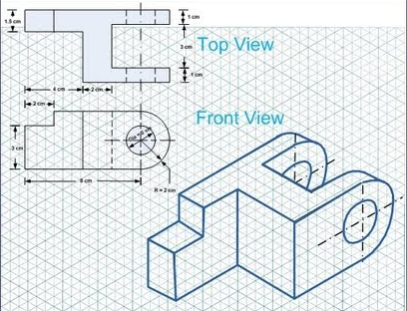
These are drawings which include all the detail required to produce the product designed. Information will include all dimensions and annotations providing explanations of features not shown. Computer Aided Design drawings are the best way to produce drawings but they could also be scaled manual technical drawings using the correct standards. The test for your drawings should be the ability for anyone to take your drawing and produce the product to the specifications given.
Lathe spanner: hardened 10mm thick steel.

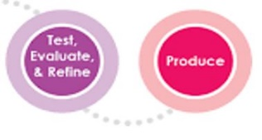

Production and Modifications
The making process is part of the design process as you test, prototype and refine your ideas. During this process you may need to revisit the planning and drawing steps to refine and modify the product. A record should be kept as evidence of your thinking and problem solving. Its useful to take images of your progress.

Evaluation
This is the time to reflect on your product and the process and consider the following questions. Use an electronic document if you choose to expand on the evaluation.
What changes would be made to the process and product if you were to repeat this project?
The most challenging steps were..
The most rewarding step in this project was..
Did the completed project meet the design brief?
Describe the project, what was produced?
