Heritage College Design and Technology

Year 9 Mortise and Tenon Joints

How to Make Mortise and Tenon Joints
Step1: The first is to mark out the mortise or tenons using a sharp pencil. Start with the tenons. To mark out the tenon you need to start by drawing a line around the entire piece of wood using a try square to mark the length of the tenon.
The tenon length is usually about 2/3rds the depth of the piece of timber it is being inserted into. Now you must mark your tenon width and it should be around 1/3rd the thickness of the timber.
Check to see if the tenon matches the closest size chisel or mortising drill bit and if it doesn’t modify the lines to match the chisel or mortising drill bit.
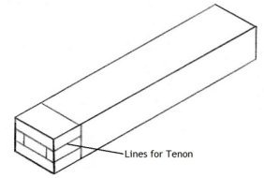

Step2 Cut the tenon and there are two methods of doing this the first is with a tenon saw. Put the piece of timber in a vice on a slight angle to create a neater and straighter cut and then carefully cut along the lines.
Next put the timber back upright in the vice and mark around 5 millimetres in from each end although it can be slightly more with larger tenons.
Now cut straight down where you marked to create small cut outs on both sides of the tenon, the reason you do this is to create a neater and more flush joint but it also hides any gaps you may have from your mortises if they are cut slightly to wide.
The second method of cutting tenons is with a radial arm saw and band saw and all you have to do is cut the depth on the radial arm saw and trim out with the band saw.
This method is usually better because the band saw has a guide rail making the cuts quicker and more accurate. Remember to cut the shoulders of your tenons first so that you do not cut to far later on.
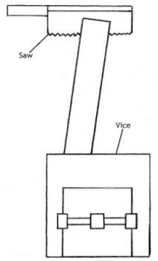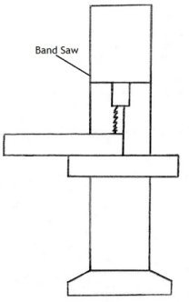
Step3: Marking out the mortise and the first things you need to do is decide where you want to position the joint.
Next you can use your recently cut tenon as a guide for the width of your mortise and you do this by resting it across the timber that will have the mortise and drawing lines along the two edges of the tenon.
After you have the width set you must put two more lines in between the ones you have already drawn to mark the thickness of your mortise.
The thickness will be the same as the tenons thickness and you can use it again as a template if you need to but remember to measure the space on each side of the mortise to ensure it is centre.
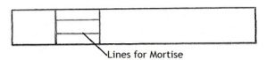
Step4: Now you must cut the mortise and once again there are two methods and the first involves a mallet and chisel.
If you use the first method you need to put some timber in a vice to rest your timber against and then clamp the two bits of timber together to hold them steady but make sure to put some scrap timber in between the clamp so that it does not mark your timber.
Now get the chisel and hammer it straight into the wood with your mallet. Apply some pressure away from the chisel bevel and repeat this on the other side of the mortise to create a V shape.
Work from the centre to the outside of the mortise and be patient meaning do not remove too much timber at once also remember to stop at a depth that is the same as the length of your mortise.
The second method involves the mortising machine and what you must do is set the width and depth before you use it. Once they are set simply drill into your mortise bit by bit to remove the timber.

This method is also the faster more accurate one but remember not to drill too much at once and make sure the gap in the drill bit is facing the empty space of the mortise so the excess timber can escape when it is removed.
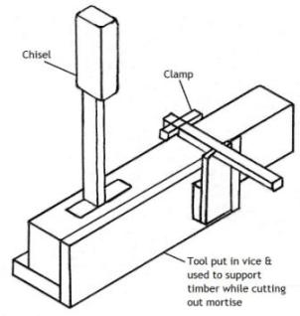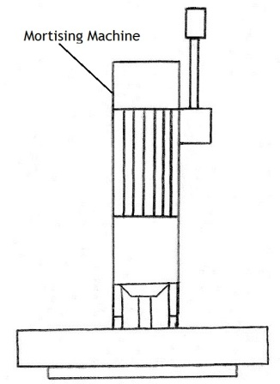
Step5: After you have completed the mortise and tenon check to see if they interlock neatly. If your tenon won’t fit you can shave a minimal amount of timber off with a chisel but ensure that you do it to both sides.
If the tenon does not fit properly with the mortise you may have to remove some timber from the mortise. Do not use excessive force or the mortised timber may split.

Step6: Once you are happy with the joint and it fits flush and neat you can now bond it together with clamps and an adhesive.
Always dry clamp first to ensure everything fits and always keep checking for squareness while clamping plus remove the excess glue with a damp cloth or you will have glue spots which are hard to remove later.
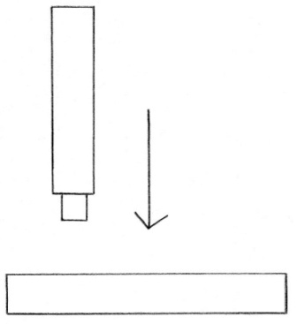
http://www.woodworkbasics.com/how-to-make-mortise-and-tenon-joints.html

