Autodesk Inventor Nameplate Tutorial.
Computer Aided Design Software such as Autodesk Inventor allows us to design and model a product in a virtual drawing space. The following tutorial will guide you through the production of a nameplate which can be produced using a 3D printer.
Follow the steps below to produce your nameplate:
1)
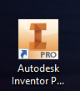
Select the Icon for Autodesk Inventor which can be found on your desktop.

2)
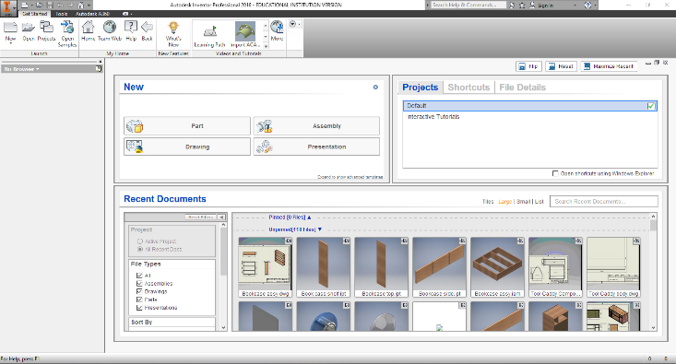
The screen shown should be the opening screen. If this is not the case, you may have to select the box that says “start working” before seeing this screen.

3)
Place your cursor over the word New in the top left corner of the screen and click. This will open the “Create New File” box as shown.
Ensure that Metric is selected and then double click on the “Standard (mm) .ipt” icon.

4)
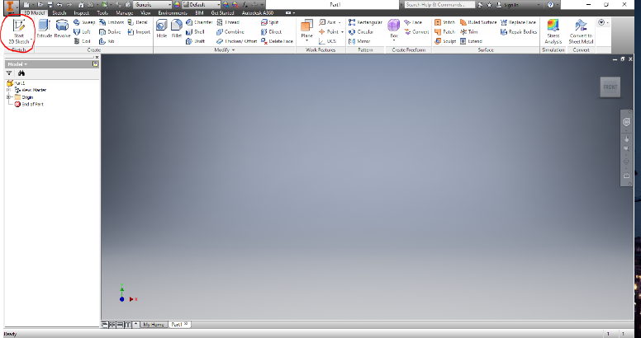
Click on the “Start 2D Sketch” icon and you will see a drop down appear with 2 options.
- Start 2D Sketch
- Start 3D Sketch
Select Start 2D Sketch.
5)
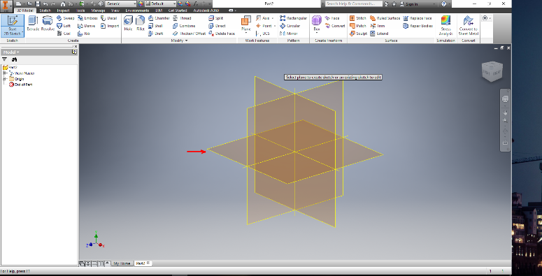
This screen should now appear. In the centre of the drawing space there is a set of planes. We will select the XZ Plane; the plane will highlight when the cursor is placed over the plane. Click.

6)
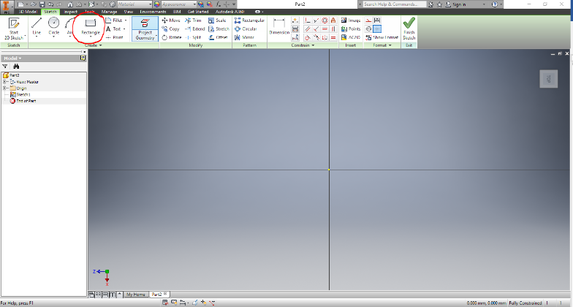
The screen will now show a set of lines which will guide our drawing. Select “Rectangle” from the top ribbon bar by clicking and then and move the cursor to the Centre of the screen. When your cursor is at the Centre you will notice the yellow dot turn green.Click and hold the mouse left button and drag from the centre to the top right of the screen as shown in the next step.

7)
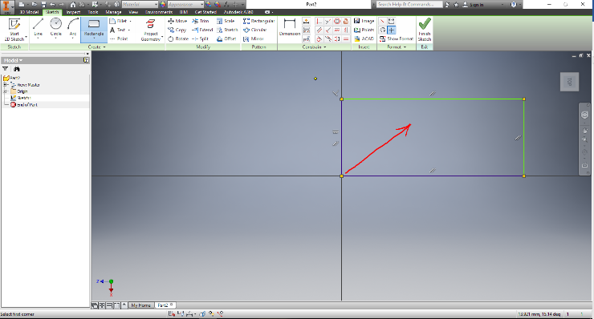
Drag the mouse while holding the left button and release once you have a rectangle. At this point the size does not matter the next step is where we will add the sizes or dimensions to the rectangle.

8)
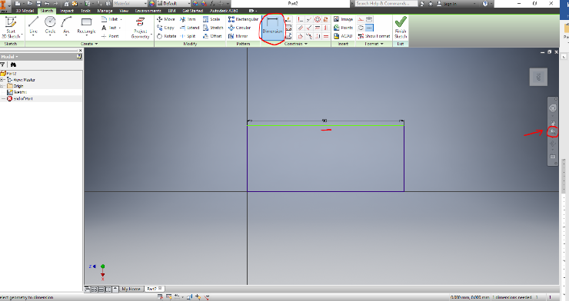
Now select the dimension icon and move your mouse over the top horizontal line, the line will change colour click and drag up from the line and a dimension box will appear. Click on this box and a dimension will appear highlight the measurement shown and type 90. The top line will now change to reflect the value entered. If your drawing moves out of view, click on the small magnifying glass or “zoom all” icon on the right. Now change the vertical line to 35mm using the same method.
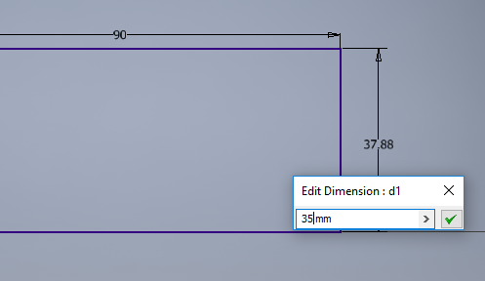

9)
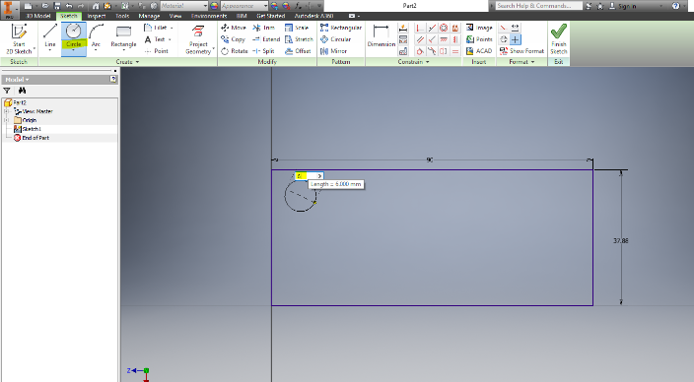
Now select the circle from the top ribbon and place it in the top left hand corner of your rectangle, click and drag a circle out from the centre and watch the dimension change you can now enter the value of 6 mm into the dimension box giving the circle a 6mm diameter.

10)
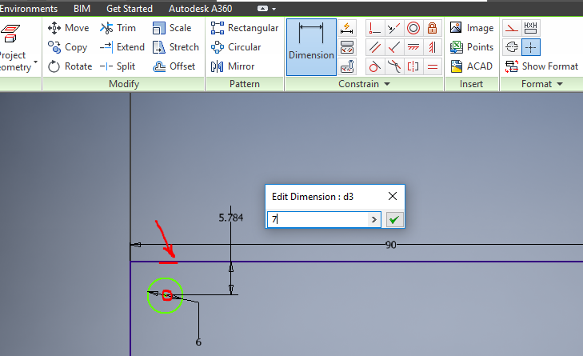
The next step is to place the circle where it should be this is achieved by dimensioning it 7mm from the horizontal line at top and 7mm from the vertical line on the left.
Select dimension and click on the centre of the circle and then the top line, then enter 7mm into the dimension box, do the same for the centre to the left hand vertical line ensuring you click on the green arrow to enter the 7mm dimension.

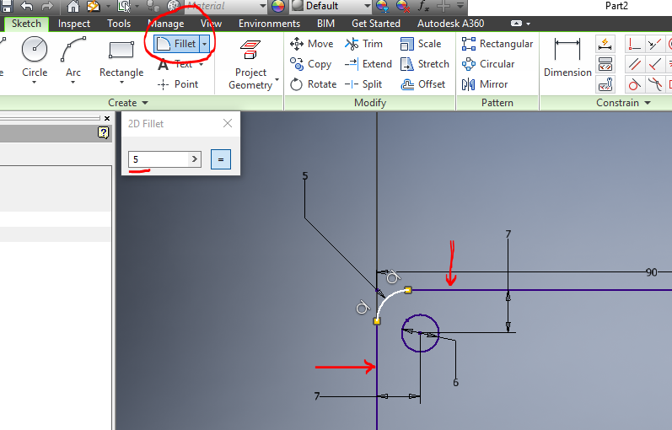
11)
We will now fillet or round the corners of our rectangle. Select the fillet icon and type 5mm into the dimension box. Click on the top line and the left hand line of the rectangle and you will see the fillet appear. Repeat for each corner this action will create a 5mm radius on each corner..

12)
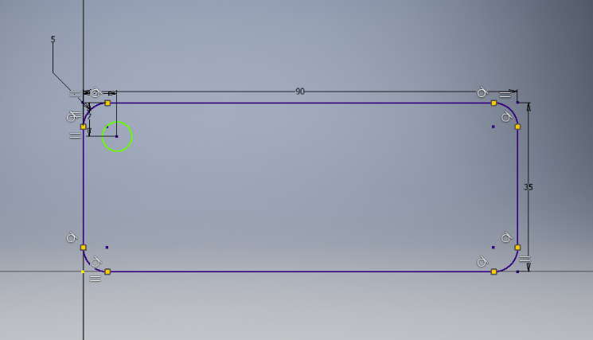
Once you have entered both the dimension 90mm horizontal and 35mm vertical and filleted your corners your 2D drawing is finished.
We will now create a 3D shape with this drawing.
Right click and select “finish 2D sketch”.

13)
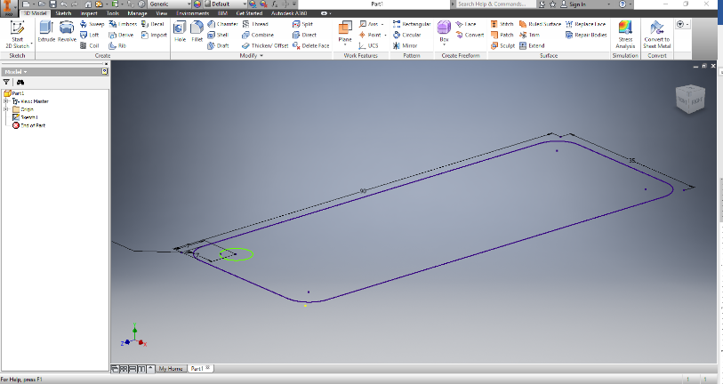
The screen has now changed and we are in 3D mode. A new ribbon has appeared with a set of tools for 3D drawing. Click on extrude.

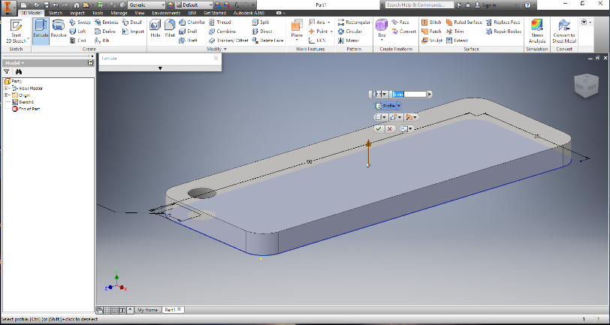
14)
The screen will provide some options. In the dimension box type in 5mm. Move your mouse onto the middle of your shape and click. The shape is now extruded to a thickness of 5mm. The other options will be used in later tasks.

15)
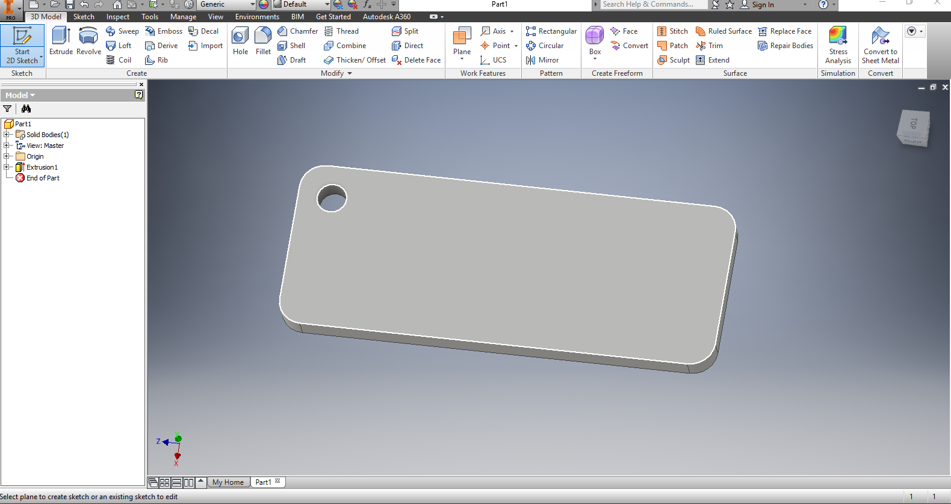The next step is to create another drawing on the face of our nameplate. Select create a 2d sketch and click on the face of our plate, the edges will turn white and click.
The plate will turn face onto the screen and we are ready to draw a rectangle.

16)
Create a 2D rectangle on the front face and dimension it so that it is centred between the horizontal edges of your shape.

17)
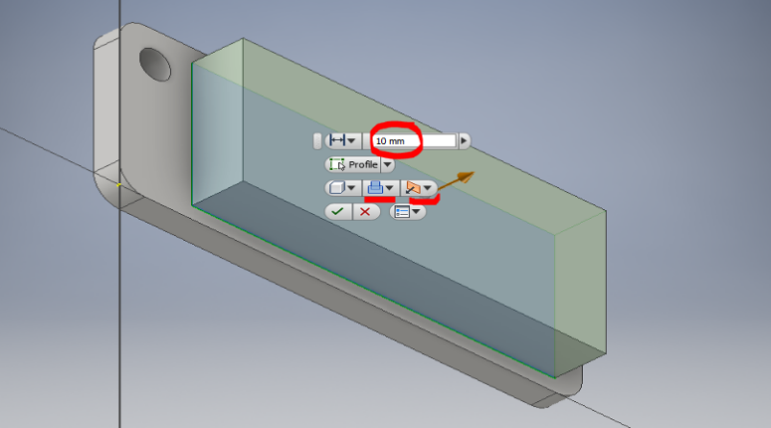
The next step is to Extrude so click on 3D Model and then Extrude. You may see something similar to the picture shown. Now we will alter the measurement and style of extrusion highlighted in red.

18)
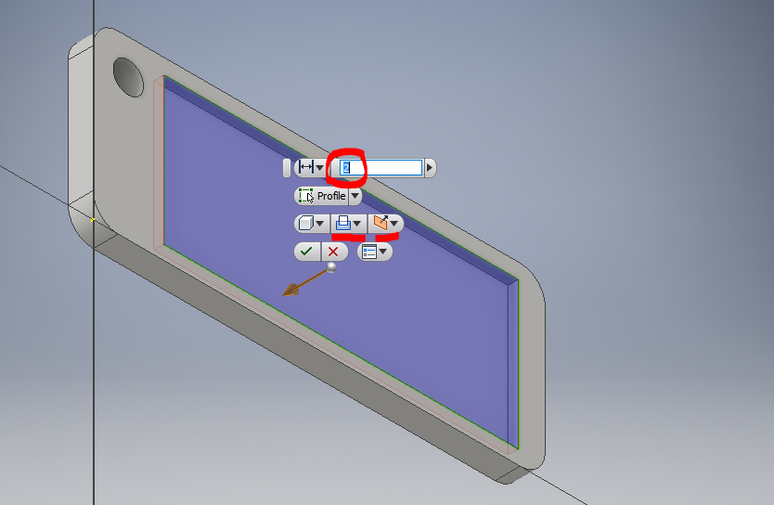
We now change the Dimension to 2mm the type of Extrusion to Cut and the direction to Direction 2. Your screen will now show the direction and type of extrusion. Click the Green tick.

19)
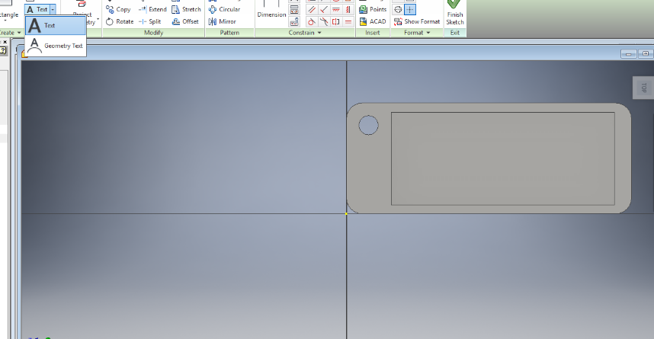
Now we will produce another sketch in the area we have extruded. Click 2D Sketch and start a new 2D Sketch clicking in the extruded area.
20)
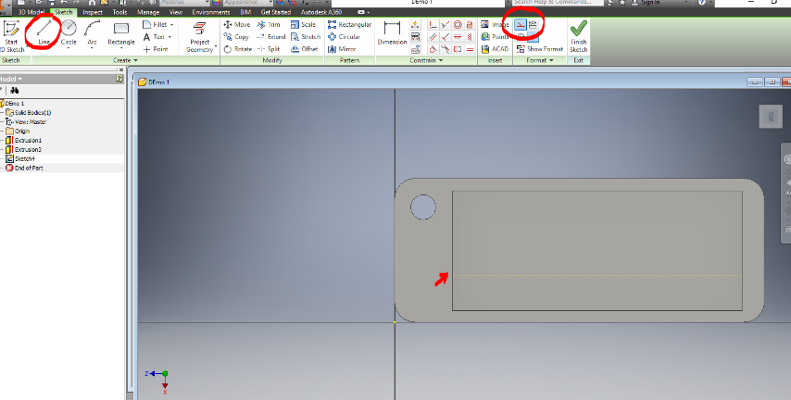
Select the Construction line by clicking on the icon in the top right section of the ribbon toolbar then select the line tool and click around on the line around the extruded area about 1/3 up from the bottom line.

21)
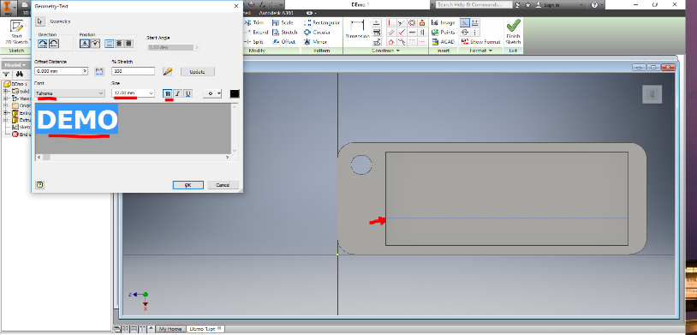
Now select the Text drop down and go to Geometry text. Select Geometry Text and click on the dotted line. A Box will appear giving a number of options, you can select a font change its size etc.
Type your text and click ok. If you need to change anything highlight the text and right click, select edit text and make your changes as necessary.
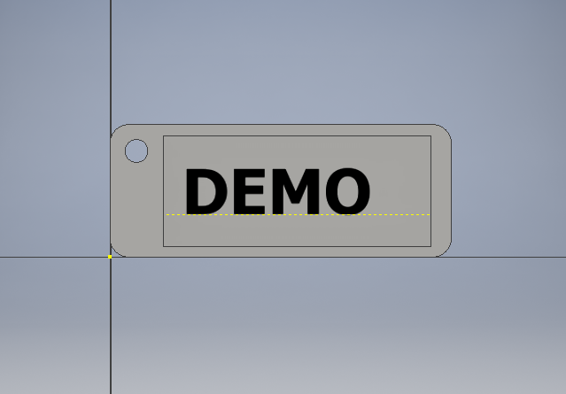
22)
Your plate should now look like this.

23)
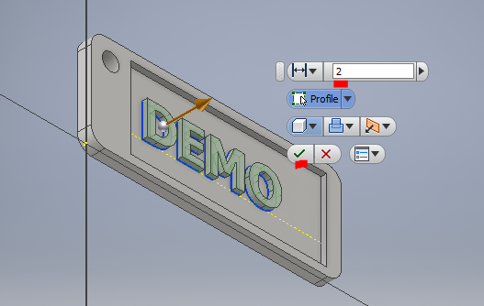
Click on 3D Model and select extrude, change the dimension to 2mm and ensure the direction is as shown.
Once you have done this you have finished the tutorial. You can add your own touches including colouring the plate if you explore the options available. Make sure you save this version of the plate first.

