Heritage College Design and Technology

CAD Tutorial
Make a Mug
Learning Intention
To introduce new skills in using Inventor 2016 and create opportunities for design thinking. The following is a guide and students are encouraged to produce their own version of the mug to suit their individual personalities and needs.

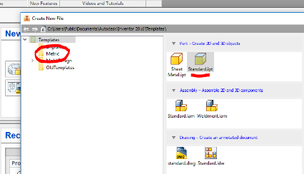
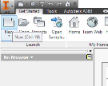
Step 1. Open Inventor 2016 and click on New and ensure that Metric is selected then click on Standard mm. ipt

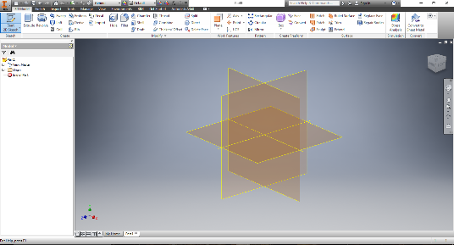
Step 2. Your drawing space will appear. In the left hand top corner click on Start 2D sketch and a drop down will appear select Start 2D sketch. Once you have selected this you will see a set of Planes appear.
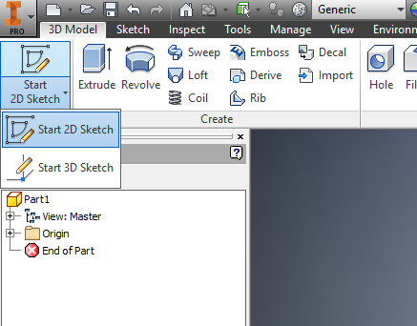

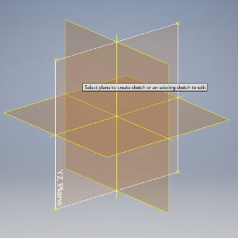
Step 3. Select the YZ Plane.

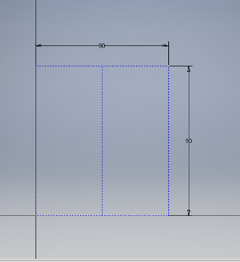
Step 4. Select the Rectangle tool and draw a rectangle 90mm high by 80mm wide. This will be a guide for your mugs size, select the Line tool and draw a vertical line down the centre, you will notice the cursor will turn green and snap to the centre of the horizontal line making it easy to create this line. Turn OFF the Construction Line.

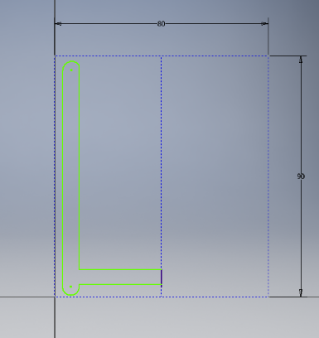
Step 5. Using the drawing skills that you have previously learnt draw a profile for your mug. This should resemble a mug that has been cut in half on one side of the line. As this diagram shows.

Step 6. Click Finish Sketch and the 3D Ribbon will appear giving options for working in 3D. Select Revolve.
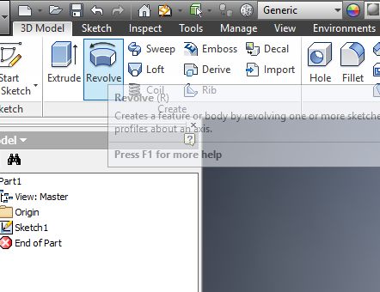
Select your profile, the same as when extruding.
Now select the axis which is the centre line making sure that the word Full appears in the box as shown.

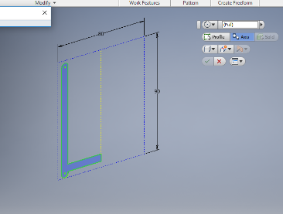

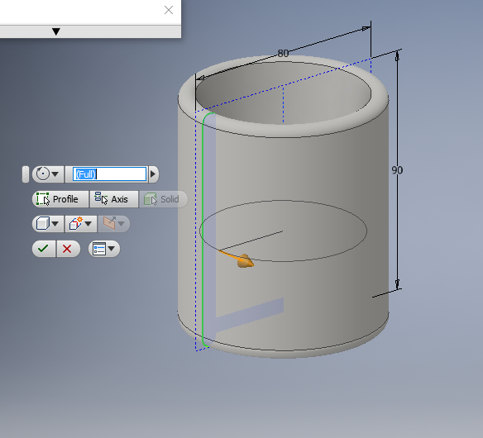
Step 7. The rotation should now appear and your mug is almost complete.

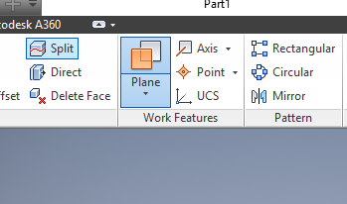
Step 8. The mug now needs a handle and this is where you design a feature that looks right for your intended use.
Select the Plane icon from the ribbon in 3D mode.

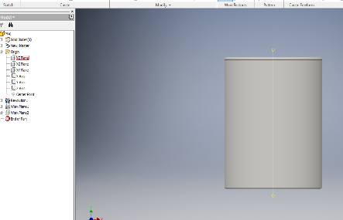
Select the YZ Plane and you will note the plane is in the centre of your mug.
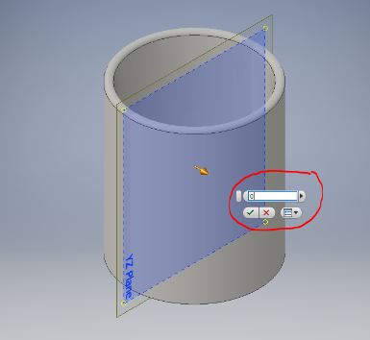

Place your cursor over the corner after adjusting the view and drag the circle on the corner of the plane forward or back Type in 0 into the measurement and the plane will remain centred.

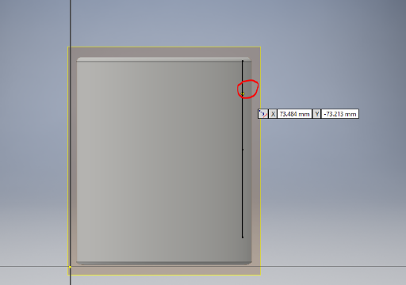
Step 9. Now select sketch and 2D Sketch and click on the Plane
Draw your handle profile making sure it meets the inner wall of your mug as shown

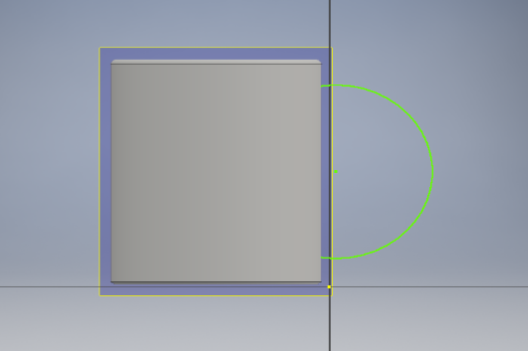
Use the Line and Arc tools to draw the handle shape.
The shape is up to your imagination, don’t make it too complex!

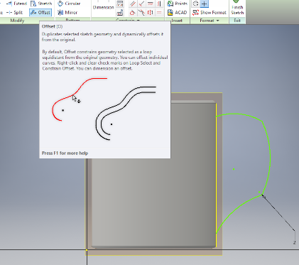
Step 10. The Offset tool is now used to create an exact copy of the line by an amount that we can choose.

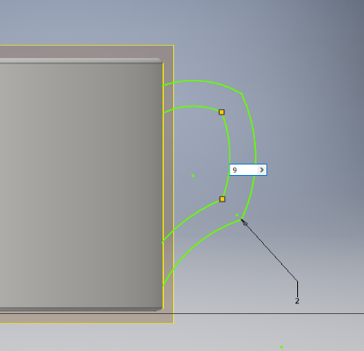
In the case shown we are choosing to offset 9mm inside of the first line.

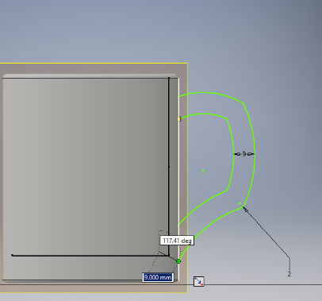
You must join the ends of these lines together to allow the next step which is to extrude the handle.
Click Finish Sketch

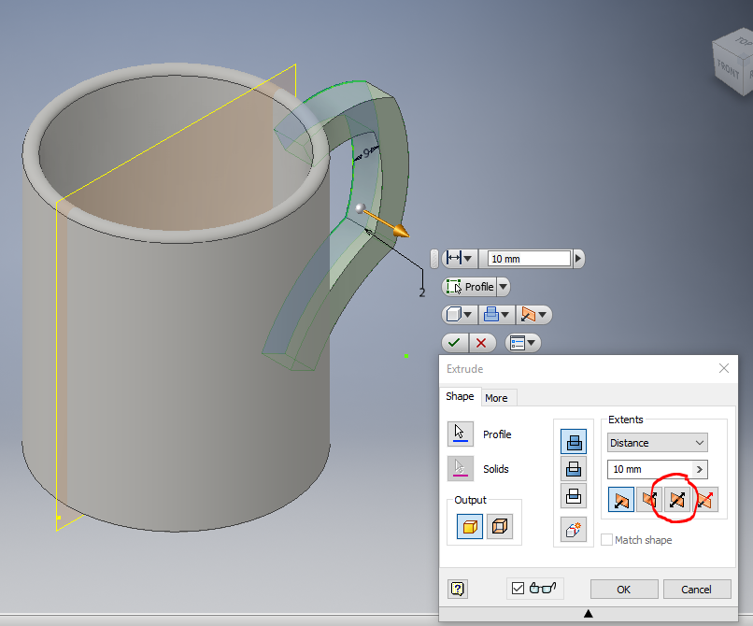
Step 11. We now Extrude the handle but we must use Symmetrical extrude. The way we do this is to select the icon as shown. The extrusion here is 10mm you may choose differently.

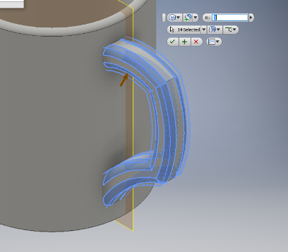
Step 12. The final touches are to Fillet or Chamfer the sharp edges on the handle and colour your mug.
If you are really clever you can use the decal command to apply an image to your mug.
If you have come this far you will be able to work it out using inventor help and the tutorials.

