Heritage College Design and Technology

Computer Aided Design
Saving a file as an STL ready for 3D Printing

After completing a part in Autodesk inventor or any other CAD software package it is necessary to save it in the correct format for drawing printing or any other manufacturing process.
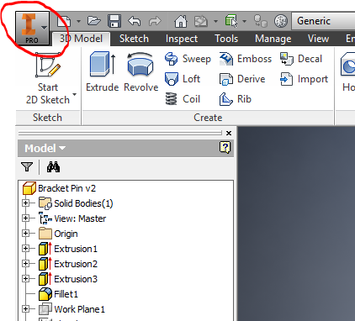

Step 1. Move your cursor to the top left and click on the I Pro Icon. Select Save As but click on the small arrow as shown to open Save Options.

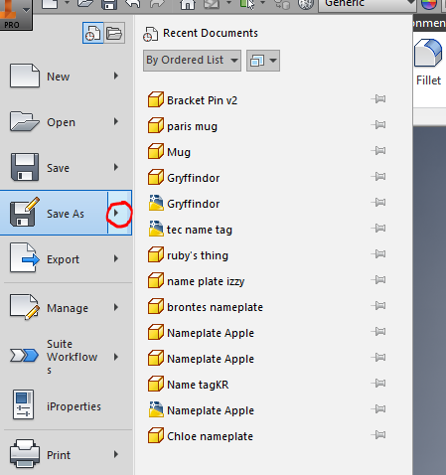

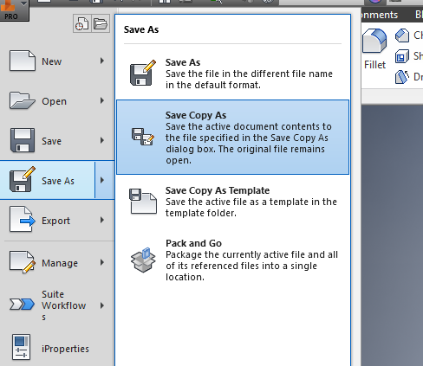

Step 2. Select Save Copy As

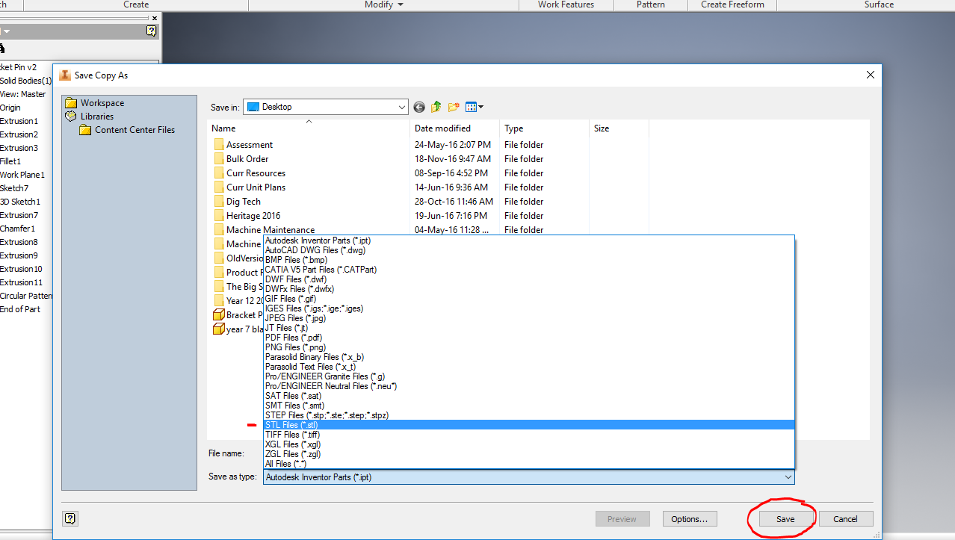
Step 3. Select the drive where you wish to save the file and ensure that you select. STL file. Your file will now become recognisable by the 3D printer software.

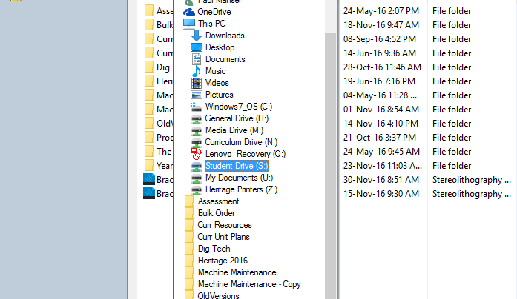

The drive for saving your work which can be accessed by the teacher is the Student ‘S’ drive.

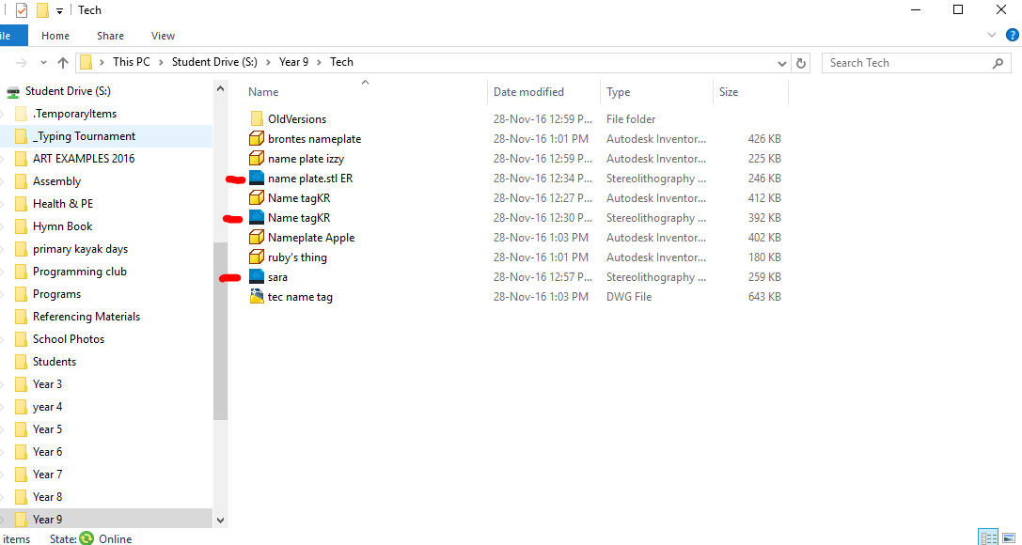

Step 4. If you have saved this file correctly, you will notice the icon has changed and the file type will show a Stereolithography file.

You are now ready to print.

