In Design and Technology, you will learn about the correct and safe use of tools materials and machinery for specific processes that are necessary to construct a project.
Learning Intention
Students demonstrate safe practices in the use of materials, tools and equipment in the context of producing design and technology projects.
Activity: The Safe use of Machines
Use the word bank to complete the following statements:
Distance | Safety guards | Instruction | Protection | Distracted
Cleared | Machine | Unattended | Teacher | Switched Off

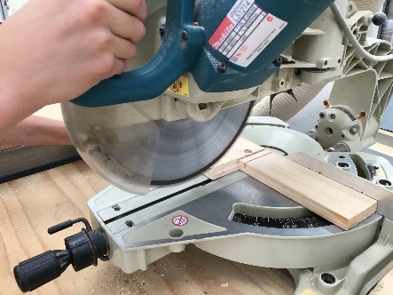
- Do not operate a _____________________ unless you have received thorough
_________________________ and fully understand how the machine should be used. When using machinery that is fitted with___________________ __________________, ensure that they are fitted correctly. When appropriate wear eye and ear _________________________ and restrain long hair.
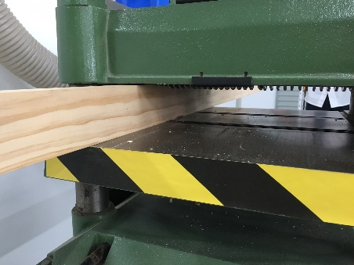
- Keep a safe ______________________ between your hands and any moving parts of the machinery. When making adjustments to the machine ensure the power is ______________________ _________. Ensure that you operate a machine by yourself, and do not leave a machine ______________________________ while it is running. Give your machine your full attention and do not look away or talk to others while using a machine. Operators of machinery should not be _________________________.
- Never Lean on machines. If any part of the machine is broken or malfunctions notify your _____________________ immediately. After using machines, the work area should be _____________________ of scrap material and machine tools and accessories.
Safe Working Procedures
General Workshop Procedures

CIRCLE “T” for TRUE OR “F” FOR FALSE TO ANSWER THE FOLLOWING:
- Running is forbidden in the workshop. T or F
- Scrap materials and offcuts should be left on the floor and/or the bench T or F
- Soft topped shoes and thongs can be safely worn in the workshop T or F
- Protective clothing and equipment is to be worn during practical lessons T or F
- Safety zones are necessary around machinery and other hazardous areas T or F
- Tools, materials or other items must not be left on the edges of benches T or F
- Blunt, damaged or badly adjusted tools should be reported to the teacher T or F
- It is ok to crowd around and distract another student while they are using tools or machinery T or F
- If you have any doubts about any operation, ask the teacher T or F
- Hair must be tied back or restrained when working around machinery and power tools T or F
- Only major accidents need to be reported to your teacher T or F
- All jobs should be clamped to the bench or held in a vice when being worked on T or F
- The operator is responsible for switching machinery on or off T or F
- You do not need to ask permission to use tools and equipment in the workshop T or F
- Eye protection must always be worn while using machinery or power tools T or F
- Running in the workshop is permitted if you are in a hurry T or F
- Describe one particular hazard that could be encountered in the workshop and state how you can minimize your risk of accident or injury?
______________________________________________________________________________________________________________________________________________________________________________________________________________________________________________________________________________________________________________________________________________________________________________________________________________________________________________________________________________________________________________________________________________________________________________________________________________________________________________________________________________________________________________________________________________________________________________________________________________________

