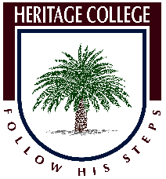
Heritage College Design and Technology
Workshop Safety Assignment

Safety in any workplace is the number one priority for any business or school. This assignment will help you with understanding of issues around safe work practices and the impact that injury and death in the workplace has on the community.
Task
- Research the impact of workplace injury in Australia and provide a paragraph of 150 words that explains the impact on the community and economy of Australia.

- Choose one particular hazard in the workshop and explain how that hazard could lead to injury and then discuss ways that could minimise the risk of injury or incident. 400 words

- Explain in detail the procedure for using one of the following machines to complete a project of your choice.

- Band Saw
- Radial Arm Saw
- Mortising Machine
Provide the main points covered in the SOP and how the risk of injury can be reduced while using the machine to complete the operation.

