

BANDSAW (wood)
DO NOT use this machine unless a teacher has instructed you in its safe use and operation and has given permission
Safety glasses must be worn at all times in work areas. |   Long and loose hair must be contained or restrained.
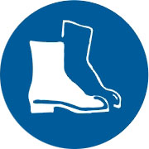  Appropriate protective footwear with substantial uppers must be worn. | 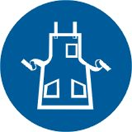  Close fitting, protective clothing or a workshop apron is encouraged.
  Rings and jewellery must not be worn. |   Hearing protection may be required for some operations.

PRE-OPERATIONAL SAFETY CHECKS
- Ensure no slip/trip hazards are present in workspaces and walkways.
- Locate and ensure you are familiar with the operation of the ON/OFF starter and E-Stop.
- Check that all guards are in position.
- Ensure push stick is available.
- Lower the blade guide and guard to full effect.
- Start the dust extraction unit before using the saw.
- Faulty equipment must not be used. Immediately report suspect machinery.

OPERATIONAL SAFETY CHECKS

Keep your fingers off the line of the cut at all times

- Never leave the machine running unattended.
- The work piece should be fed forward evenly and held firmly on the table to ensure effective control during cutting whilst keeping hands in a safe position.
- Use a push stick when feeding material past the blade.
- Do not force a wide blade on a cut of small radius. Use relief cuts when cutting sharp curves.
- Before making adjustments switch off the saw and bring the machine to a complete standstill.
- Stop the machine before attempting to back the work away from the blade.
- Stop the saw immediately if the blade develops a ‘click’. Report it to your teacher.

HOUSEKEEPING
- Switch off the saw and reset all guards to a fully closed position.
- Leave the machine in a safe, clean and tidy state.

FORBIDDEN

■ Attempting to cut very small items
■ Cutting cylindrical or irregular stock

Date of last review | ______________ | Signature ______________________

