Heritage College Design and Technology

Carbon Dioxide Powered Racer
CO² powered vehicles have been raced in schools and universities for years and provide a fun way of learning about design for speed and the principles of forces and motion. This tutorial will guide you through the process of designing a vehicle using Autodesk Inventor 2016.
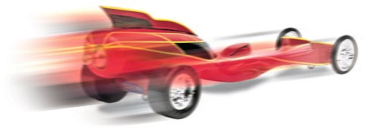

Step 1. Find the CO2 Body blank .ipt file in Haiku or school drive and open the file in Inventor.
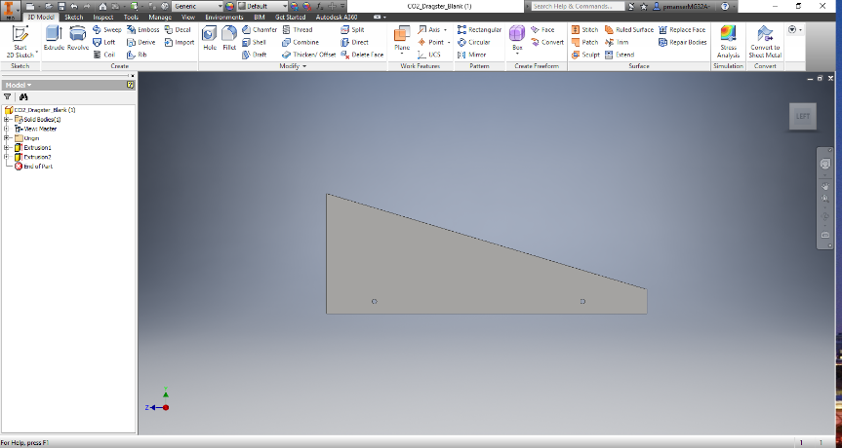

Step 2. This body blank is shape to provide a base for your design and is dimensioned to the current design specifications that allow a racer to compete in national competitions. The position of axles, canister hole, height, width and length are specified to meet the attached rules. If you wish, you can modify some of these within the specifications given.

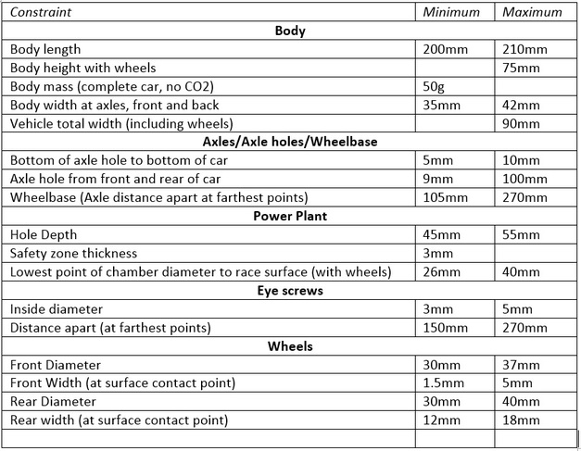
2016 CO² Racer Specifications

Step 3. Shaping the racer is a creative process and there is freedom to make the vehicle look good, but if you want to win there are things that you need to consider.
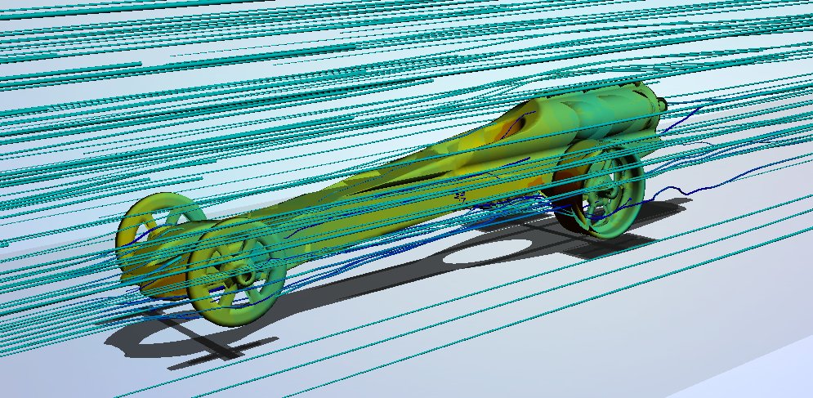
A fast racer will be aerodynamic, have the right balance of weight and structural integrity. If you think, you would like to be the fastest in your class you should look carefully at how to design an aerodynamic shape that has a good drag co-efficient or Cd. We will test our racers in a virtual wind tunnel and each vehicle will have its aerodynamic performance tested.
Autodesk Flow Design

Step 4. Begin Shaping by using the Inventor drawing tools.
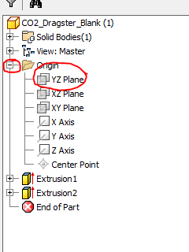
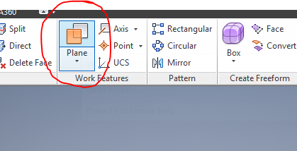
- First, select a plane from the top ribbon.
- Select the YZ plane from the origin in
the browser on the left side of your screen
- Use the cursor to select (left click and hold) one of the yellow circles that appear in each corner of the plane that now appears over the left view. Drag the plane forward and add a dimension of 5mm.
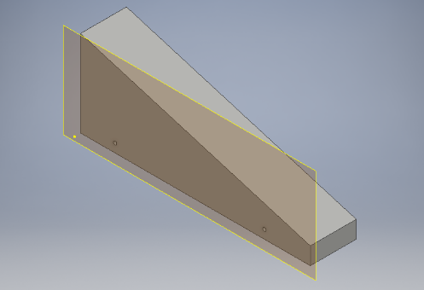

Step 5. Select 2D Sketch and click on the work plane. We will now Project the Geometry from our body onto the work plane. Select Project Geometry and click on the model, you will note that the perimeter of the block will turn yellow.
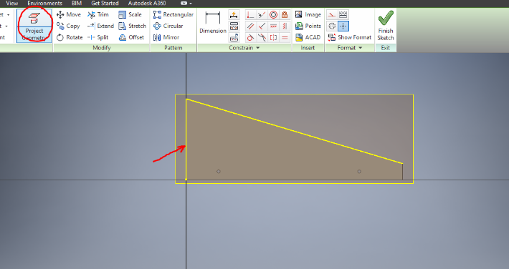

Step 6. It is now time to set our visual style to help us draw around key features of the design such as axle holes. Select View from the top ribbon as shown below and select Shaded with hidden edges.
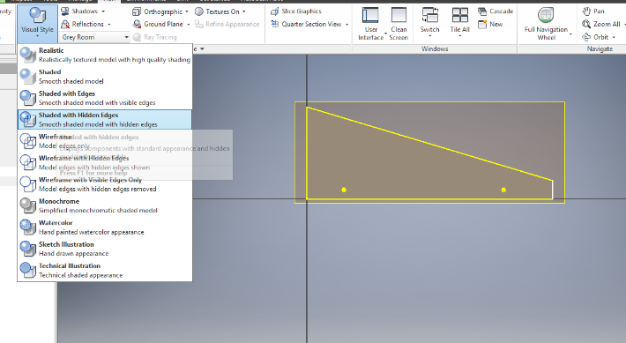

Step 7. Draw your body shape using the line and arc tools ensuring that you stay inside of the lines projected onto the plane
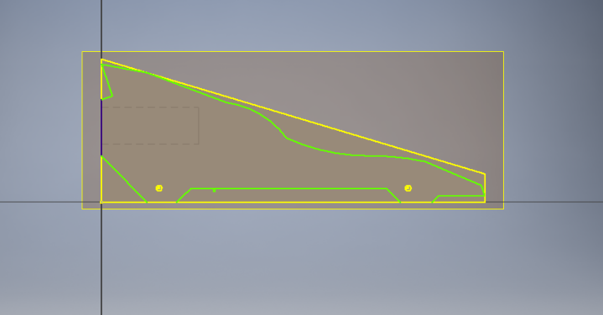

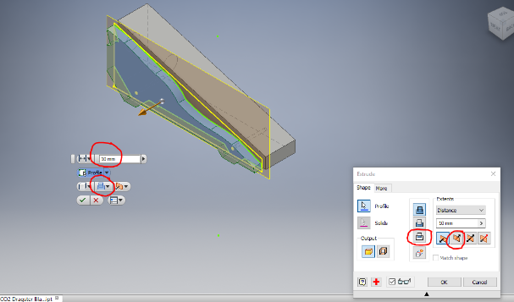
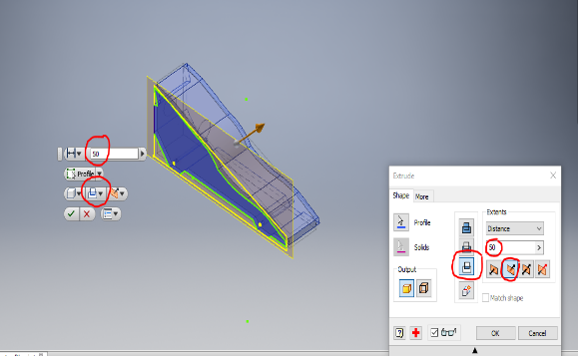
Step 7. Finish the sketch and select extrude from the 3D menu. If there are, no gaps in your body shape the extrusion will become obvious when you click inside of the shape drawn.

Select 50mm /Intersect, change the direction to Direction 2, and click OK.
Step 8. Your first shaping extrusion is complete, this process will repeat for each of the planes that you wish to shape. To turn off the visibility of the work planes that you have finished with right click on the plane and uncheck visibility and the plane will disappear.
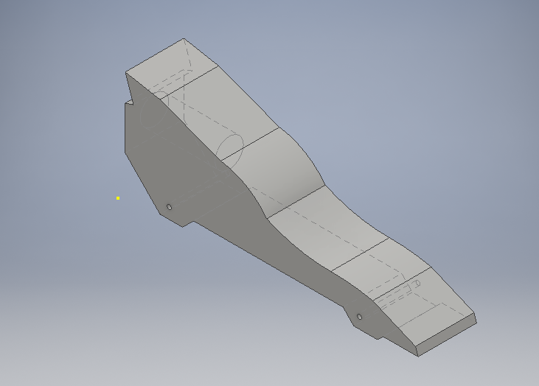

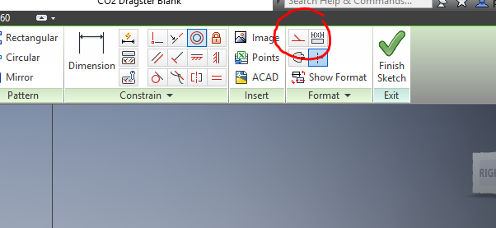
Step 9. Repeat the previous procedure but this time select the XZ plane. Project the geometry again and then select the Construction line tool.
Use the construction line to draw a line down the centre of your work plane. Then draw one-half of your top view shape ensuring there are no gaps and the lines all meet the centre line.
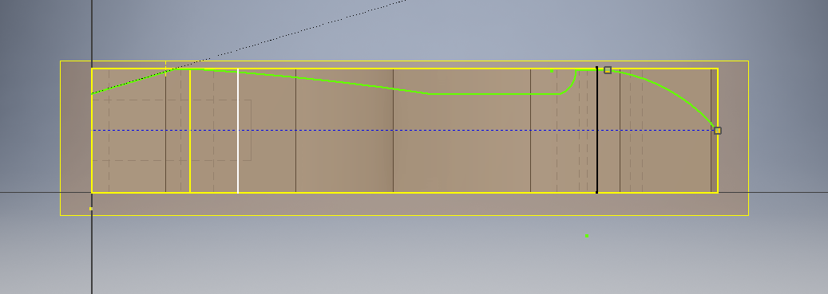
*draw your shape just inside the projected geometry.

Step 10. Once you have drawn your top shape, extrude as per the previous plane and continue on to the XY plane.
You may choose to complete an assembly of your racer and colour it to your specification once complete.
