Heritage College Design and Technology

Year 9 Abrasives

Abrasives come in a vast number of types for use on differing materials. In Our workshop we have abrasives that are used with timber, plastics and metals. Most of these abrasives are applied to papers that allow us to “sand” materials to a smooth finish. Abrasive paper is coated with different abrasive materials such as garnet, emery, aluminium oxide and even diamonds which provide a medium which can cut or abrade the surface of a material. The common name sandpaper has remained common despite the fact that sand has not been used as an abrasive coating for hundreds of years.
Abrasive papers should be used with a sanding block for most operations in woodworking. Power sanders should only be used on flat surfaces using the correct grit pad.
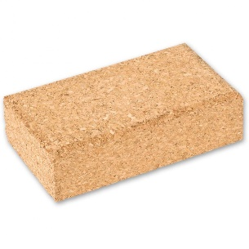
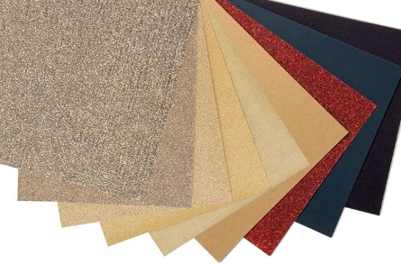

In woodwork we use a range of abrasive papers that are listed in a table below. The task is for you to match the abrasive grit number to the operation that you will complete.
Grit | Common Name | Uses
40-60 | Coarse | Heavy sanding and stripping, roughing up surfaces including removing heavy coatings.
80-120 | Medium | Smoothing of surfaces, removing smaller imperfections and marks.
150-180 | Fine | Final sanding before finishing the timber with polish or coating.
220-240 | Very Fine | Sanding between coats of sealer or polish.
280-320 | Extra Fine | Removing dust spots of marks between finish coats.
360-6000 | Super Fine | Removal of fine surface blemishes or reduction of gloss where needed.

Task
Insert the grit number of the paper you will use for the following operations.
- Removing working marks, putty and pencil lines from your work

- Preparing your project for its first coat of sanding sealer

- Once the sanding sealer is applied and before application of polish

- After one coat of polish is applied the project will be sanded with

