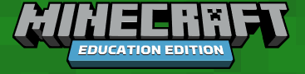
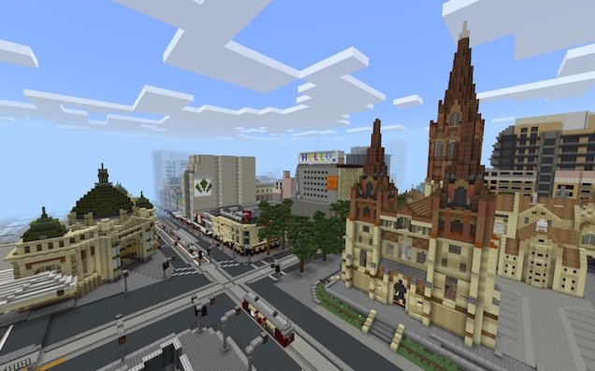
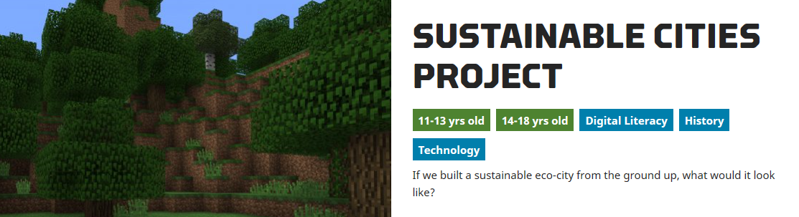

Design and Technology is all about interaction of human beings with the environment we live in. This project should take between 2 and 3 weeks to complete and involves your engagement with the design process utilising Minecraft educational software.
Recently the Victorian Government used Minecraft as part of the Metro Tunnel project and this can be viewed on You Tube (https://www.youtube.com/watch?v=rnTua5BV9Kk).

Learning Objective
You have been chosen as the designer in a competition to create a sustainable eco-city from the ground up. You have been chosen to compete against other designers to submit a plan for this model city. The Goal: To create a plan for a sustainable high-tech city that uses existing/or soon-to-exist technologies and products to provide a healthy and enjoyable place for people to live and work in an environmentally sustainable way.

Guiding Ideas

What is a “sustainable city”? “a city designed, built, and managed in a manner where all its citizens are able to meet their own needs without endangering the well-being of the natural world or the living conditions of other people, now or in the future” – Fred Lee, University of Hong Kong
Sustainable cities satisfy human needs and minimize the human impact on the environment. (ecological footprint) A sustainable city uses less resources and produces less waste than an unsustainable city. This concept can be built into the design of cities and buildings.
The Goal: To create a plan for a sustainable high-tech city that uses existing/or soon-to-exist technologies and products to provide a healthy and enjoyable place for people to live and work in an environmentally sustainable way.

The Task (Design Brief)
To create a plan and model for a sustainable high-tech city that uses existing/or soon-to-exist technologies and products to provide a healthy and enjoyable place for people to live and work in an environmentally sustainable way.

The Geography:
A coastal city similar to Adelaide in layout e.g., Mountains, a plain with some elevation changes if possible, a coast including a port and a river.
Things to Consider:
How will you lay out the city in a way that enables people to have easy access to the different districts? How will you minimize or eliminate the use of fossil fuels? What sort of renewable energy sources will you use? How will electricity be generated? What are the options for getting rid of trash and garbage without burying it in landfills?
How will you ensure that water and electricity is used efficiently in residences, business, and public places? How will you build ecofriendly buildings and residences that include greenery & city gardens? How will you encourage people to walk & cycle? How will you encourage people to “recycle, reduce, reuse, rethink, and renew”
Remember to use existing or soon-to-exist technologies (driverless cars); no science fiction fantasy stuff.
- Assume hydropower is relatively plentiful
- Don’t worry about the economic structure – assume close to full employment and a vibrant mixed economy (industrial, tech, service jobs & government employment.
- Don’t worry about the sewer system (that’s for another plan)
- You’re creating a plan, so assume you have the funding you need, but it’s not limitless
- Because the city will be built from the ground up, your plan doesn’t need to worry about any existing infrastructure
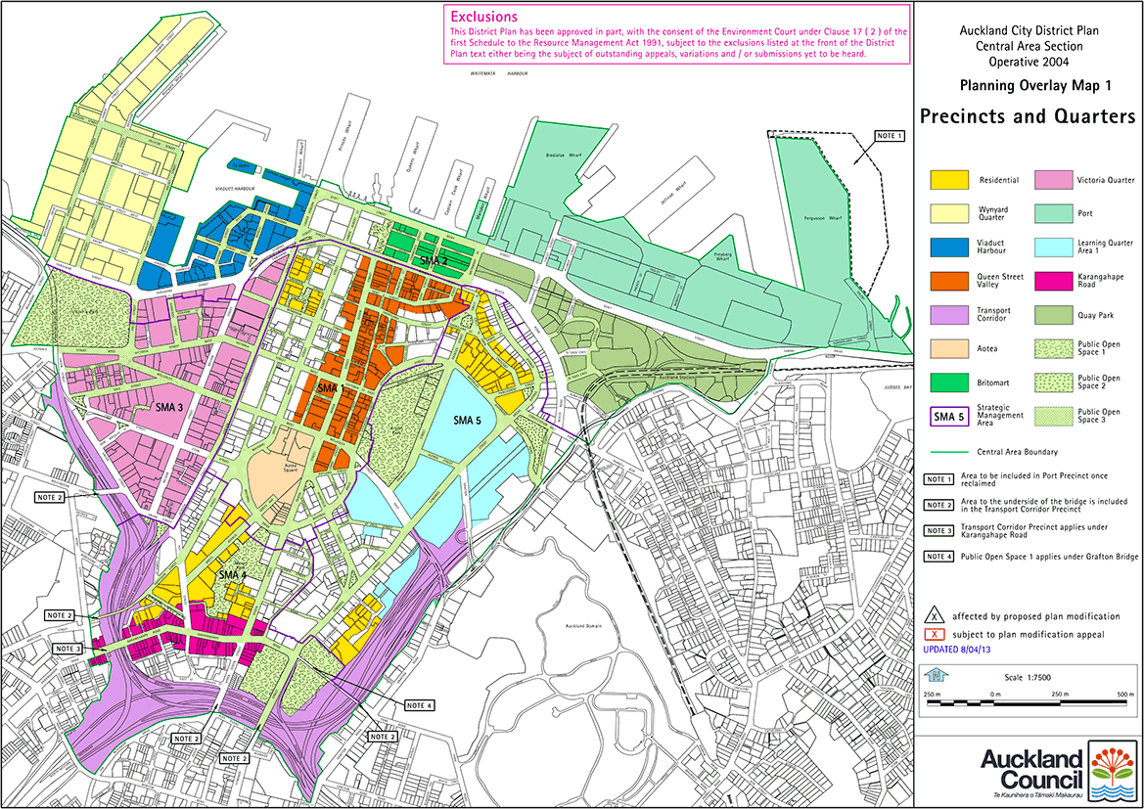
- Create a city in Minecraft that includes: A business/service district Residential districts City-wide transportation system City-wide parks & recreation/cultural system. When laying out your initial plan use a colour coded legend that should be neat, colourful, and easy-to-follow.

Assessment Expectations
- Create a name for your city and give an overview of the population numbers and main features or focus industries in the city. Industries could include manufacturing, education, tourism, sport or something that you create.

- Research the topic of sustainable cities (don’t forget YouTube) to answer this question: What kinds of sustainable cities already exist or are being built? Record your research and findings in a Word document. (500 words)

- Create rough drafts of your city plan using Microsoft paint or other tools that suit the purpose. If you use paper take images and include them in your documents as .jpg or .png files.

- Create your city/town in Minecraft and keep a record of your development using the snipping tool function in Windows. The record will provide images with supporting text to explain design decisions.

- Once your design is finished evaluate your outcome against the initial Task Design Brief. (200-250 words)

- Email your completed project to your teacher.

Curriculum Links:
- Investigate the ways in which products, services and environments evolve locally, regionally and globally and how competing factors including social, ethical and sustainability considerations are prioritised in the development of technologies and designed solutions for preferred futures (ACTDEK029)

- Independently develop criteria for success to evaluate design ideas, processes and solutions and their sustainability (ACTDEP038)

- Critique needs or opportunities for designing and investigate, analyse and select from a range of materials, components, tools, equipment and processes to develop design ideas (ACTDEP035)

- Generate, develop, test and communicate design ideas, plans and processes for various audiences using appropriate technical terms and technologies including graphical representation techniques (ACTDEP036)

- Use project management processes when working individually and collaboratively to coordinate production of designed solutions (ACTDEP039)

