Material Selection…..
The material Mild Steel (ms) we use in metalwork comes in a variety of sectional profile shapes and sizes. From small handyman profiles such as flats and angles to large industrial size profiles for commercial use such as I beam and C sections. There are four main categories that are quite common.

- Solid section
- Hollow section
- Sheet – under 3mm thick
- Plate – over 3mm thick
As we know we have 3 main grades of steel:
LOW CARBON STEEL (mild steel)
Is iron containing 0 .05 % carbon, referred to as mild steel.
MEDIUM CARBON STEEL
Is iron containing 0.5 - 0.8% of carbon it is tough and hard wearing, used for springs and guns etc.
HIGH CARBON STEEL – TOOL STEEL
Contains 1.5 % carbon, hard wearing and very tough but very brittle, used for knives, chisels plane blades lathe cutting tools

Solid section MS …
Flat Bar, Angle, I Beam, C Section, Round Bar, Hexagonal, Square….
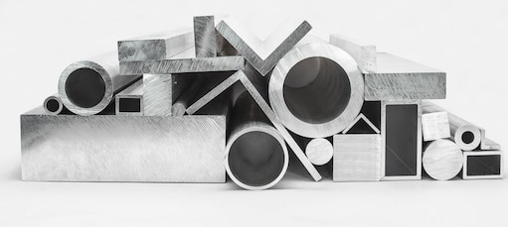

Solid Sectional steel can is available in a grade of Black or Bright.

Black Steel
Refers to the mill scale coating (oxide) on the material. It is black to blue in colour, forming on the surface as an oxide as it is let to cool during the production process.
Mill scale protects the steel from rusting during storage and fabrication of projects, however must be removed if a corrosion treatment is to be applied such as painting or galvanizing. Mill scale is not a good key in terms of surface preparation as it will eventually flake and expose raw steel which in turn will rust and any treatment over the top will also be defected.
Commonly, fabricated projects for commercial use that are made with black steel are simply sand blasted and galvanised or painted on completion.

https://en.wikipedia.org/wiki/Mill_scale
Bright Steel
Is much cleaner in appearance, more accurate in its size and more expensive. It is made just as black steel but on cooling is again rolled cold which elongates structure and compresses the material, making it a little harder than black mild steel. Advantages achieved include improved machining, less wastage at component production stage, enhancement of physical and mechanical properties and improved dimensional tolerances and straightness.
Plate and Sheet Steel
Sheet is formed by an industrial process into thin, flat pieces through rolling. Sheet metal is one of the versatile fundamental forms used in metalworking as it can be cut and bent into a variety of shapes.
Countless everyday objects are fabricated from sheet metal.
Thicknesses is used to classify from sheet to plate, extremely thin sheets are considered to be sheet grade and measure under 3mm thick.
Thicker plate from 3mm thick and above considered to be plate steel or "structural steel".
Sheet metal is available in flat pieces or coiled strips.
Common sheet metal full sheet sizes are 1200mm high by 2400mm long.
https://en.wikipedia.org/wiki/Sheet_metal

Solid Section Production
Solid sectional profiles are formed by rolling, which is a process where heated steel stock is passed through pairs of rolls to reduce the thickness and to make the thickness uniform. A little like rolling out bread dough, however on an industrial level with red hot steel and hydraulic rammed and driven rollers.
https://en.wikipedia.org/wiki/Rolling_(metalworking)

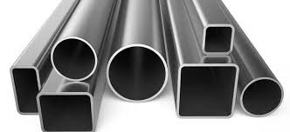
Hollow Sectional Steel – RHS and SHS
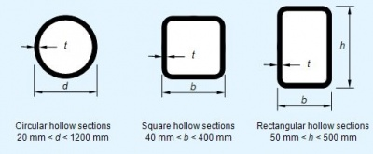

Mild steel hollow section or box sectional steel is hollow in its cross section.
Members can be Square SHS, Rectangular RHS or round / circular and is commonly called RHS or box section. Hollow sectional steel is very strong in its weight ratio, and in many directional forces remains quite stable. This strength characteristic across multiple directions makes an excellent choice for steel frames.
https://en.wikipedia.org/wiki/Hollow_structural_section
The production of Hollow sectional steel is quite interesting, steel on a flat coil is fed through a number of rollers and dies which slowly for the shape desired. The shape join is then welded through a process called ERW (Electric Resistance Welding).
https://www.youtube.com/watch?v=0x1uRR9Jb34

SHS – Square Hollow Section

Available in many sizes and wall thickness depending on application and desired properties.
Very common sizes include 25 x 25 x 1.6mm thick, 50 x 50 2mm thick and 100 x 100 2mm thick.
However, on investigation you will find many hardware but in particular steel wholesalers will carry quite a large range.

RHS – Rectangular Hollow Section

Again, available in many sizes and wall thickness depending on application and desired properties.
Very common sizes include 25 x 50 x 1.6mm thick, 50 x 100 2mm thick and 100 x 200 5mm thick.
However, on investigation you will find some in hardware but in particular RHS steel wholesalers will carry quite a larger range.

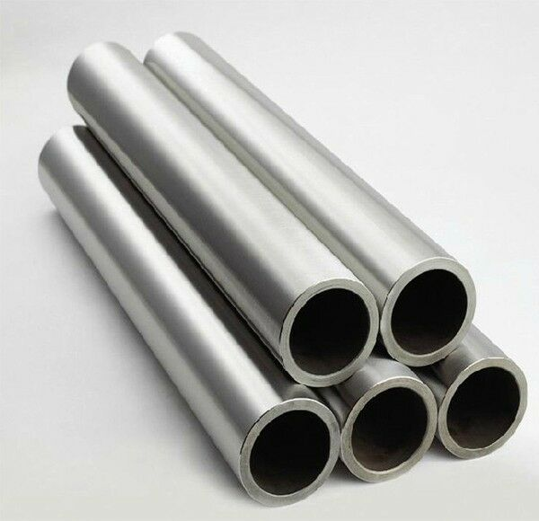
Pipe or Tube…

Tube.
Used for pressure equipment, for mechanical applications, and for instrumentation systems. Tubing is usually more expensive than pipe due to tighter manufacturing tolerances.
Tubes are designated by their outside diameter and wall thickness, which are exact measures in inches or millimeters.
For tubes, the difference between the outside diameter and the wall thickness, multiplied by two, defines the inside diameter of the tube.
Pipe.
The word “steel pipe” refers to round hollow sections to convey fluids and gases – such as oil & gas, propane, steam, acids, and water
The most important dimension for a steel pipe is the inside diameter (“pipe ID”), which indicates the rough (not the exact) fluid conveyance capacity of the tubular. The ID is expressed in “NPS” or “DN” (nominal pipe size, or bore size).
Watch the following …

https://youtu.be/M6te8o9GtXM

https://blog.projectmaterials.com/pipes/difference-pipe-vs-tube

Surface Finish – Corrosion coating.
SHS and RHS is very commonly found with a blue primed coating to reduce rusting from water and air contact whilst in storage. The primer can easily be welded through without removing and painted over after job completion.
It is very common practice to fabricate a product from blue primed steel and then have it galvanised coated for external application, benefits also include inside of the tube is coated.
However, if the product will remain indoors it is common to be powder coated or simply painted. If a high-quality indoor finish is required the product usually is painted by an industrial spray-painting business.
Galvanised SHS and RHS is also very common. However, with more surface preparation needed to weld and paint, is usually only used for posts and bolt in applications.
# Further information found on surface finishing teacher notes…

Structural Steel
Mainly elongated beams and used for heavy construction applications. I beam, Plate, C section and hollow are quite commonly used, fabricated to be bolted together, galvanised and then bolted together on site.

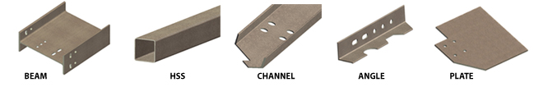

https://en.wikipedia.org/wiki/Structural_steel

