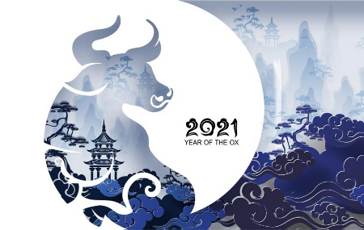
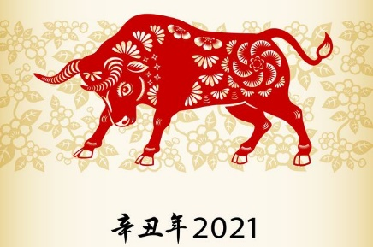
CHINESE ASTROLOGY
Year of the Ox, 2021

Do some research into the Chinese Zodiac signs and what your personal sign would be in this system.

I was born on:
My astrological animal is:
According to the Chinese Zodiac, some of my characteristics are:

Social/ Relationships

Work Ethic

Career

Emotional

Health

Lucky numbers/colours/etc

Unlucky things

Agree with (which traits or predictions DO seem to line up with your personality?):

Disagree with (which traits or predictions DO NOT seem to line up with your personality or what you are like?):

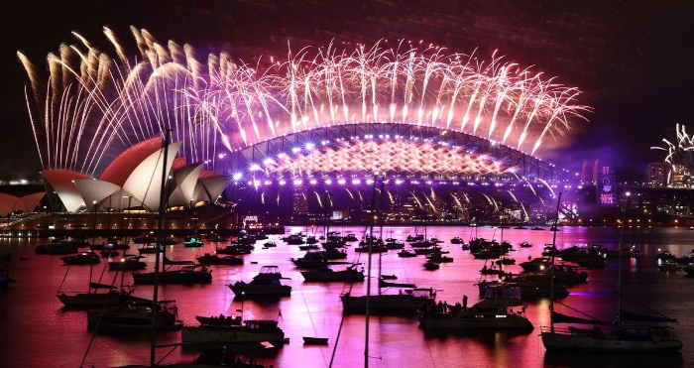
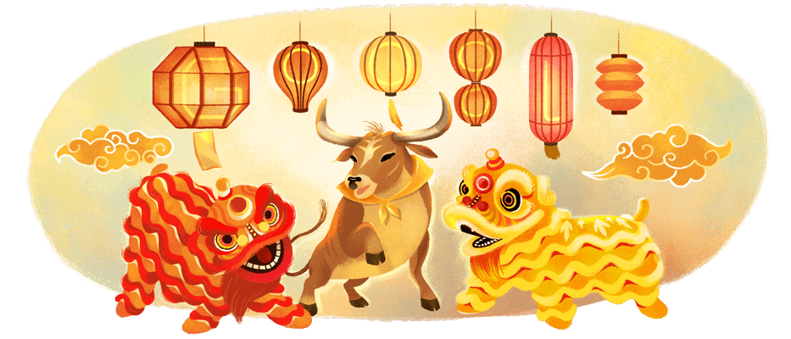

Chinese New Year vs Australian New Year

 | Australia | China
Length of time….

Where we go….

What we do….

What we drink/eat….

Beliefs? Rituals?

Superstitions?

Which customs are the same?

Which customs from Chinese New Year would you enjoy and/or think we should do?

Which customs from Chinese New Year sound like something you would NOT enjoy and you’re glad we don’t do?

What’s your favourite thing about Australian New Year celebrations?

Are there any customs from Australian New Year that you don’t like and would prefer to stop doing?

