Landforms and landmasses
Year 8 Geography – Assignment 1

Step 4: Explaining to Others
Create a power point that will teach the rest of the class about your landform.
- Introduce your landform
Say what it is and what it looks like. Show some pictures.
- Where it can be found
Describe the type of terrain or biome where it is normally found. Include pictures.
- Notable examples
List at least 3 notable, interesting, or famous examples of your landform. Include pictures and maps of locations.
- What forces formed your landform
Identify internal/external and the specific type of force from the list on your sheet.
- Explain in detail how it was formed
Including:
  - Written step-by-step explanation
  - Pictures or diagrams
  - The animation that you made
- How are people affected by it?
List at least three ways. Did ancient cultures use them, or have a legend/story about how they were formed? Do tourists come and visit them? Do people choose to live near them, or not?
- How is it affected by people?
List at least three ways. Does pollution damage them? Are they harmed by acid rain or clearing of forests? Do they get damaged by tourists?
- What are the consequences of changes to your landform?
What might happen to this landform if some of the things mentioned above continue unchecked? What can we do to manage this?
- Use good research skills
Make sure you put the information in your OWN WORDS – no copy/pasting. Include a bibliography (list of the websites or books where you got your information) on the last slide.
- Hand everything up. Include:
- Your document of labelled minecraft screenshots (email or print)
- Your sheet with answers to questions and categorised table
- Animation planning sheet
- Your power point

Instructions for putting your animation into power point:

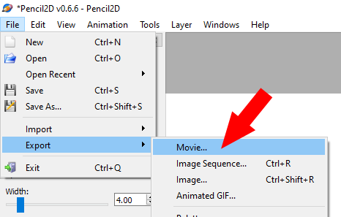
In Power Point, on a blank slide, click on the video icon to insert your animation.
In Pencil2D, go to: File>Export> Movie. Save the movie file in your documents or on the desktop.

Marking Rubric

Performance Standards | A | B | C | D
Minecraft screenshots
- +5 points for every correctly labelled example

Questions & Categorising sheet
- Thoughtful answers to questions
- Correctly categorised landforms
- Detailed & correct draft of animation

Power point
- Detailed information on what landform is, where it’s found, notable examples. Relevant images ONLY.
- Clear & detailed explanation of formation process. Correctly identified types of forces.
- Clear animation, showed good understanding of formation
- Identified changes, effect on humans & our effect on it, possible management strategies.

Research & presenting skills
- Information on PP is in own words
- Created a bibliography with at least 3 good sources
- PP was well laid out, clear & easy to understand
- Presented to class

Work in class
- On task during lessons, not distracting others

