Great Barrier Reef
Poster
Learning intention: I can discuss how humans impact (and change) the environment (ocean) and how we can reverse any negative change.
The Great Barrier Reef is an extremely fragile eco-system. After considering some of the specific threats and their causes in the Video Unit, create a poster which outlines why the reef is unique, how it is threatened, and what can be done to help.
- You may use the internet to help you research your information, but the text on your poster must be in your own words.
- You may create your poster digitally using Word or another program. You can also do it by hand it if you wish (be aware this takes longer!)
- Your poster should be informative as well as illustrative. It should clearly explain 3 main things:
- Why the Great Barrier Reef is unique
- What the key threats to the Great Barrier Reef are (natural and human)
- How we can help
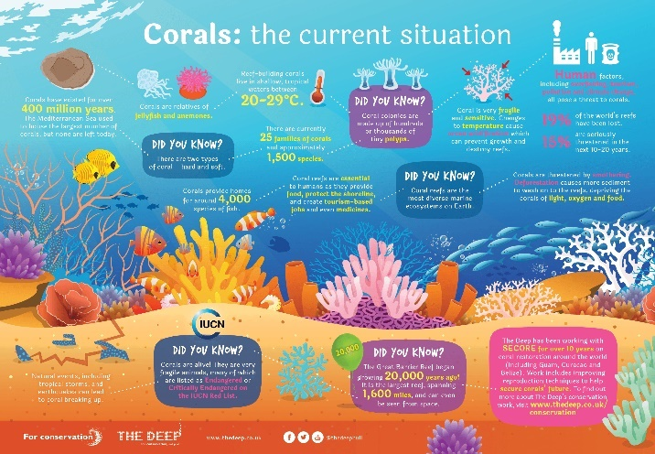
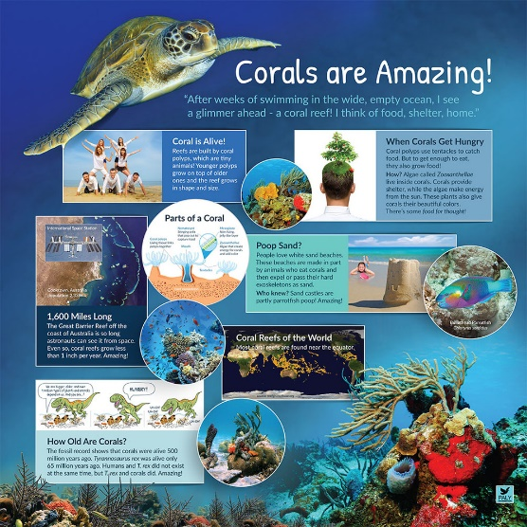

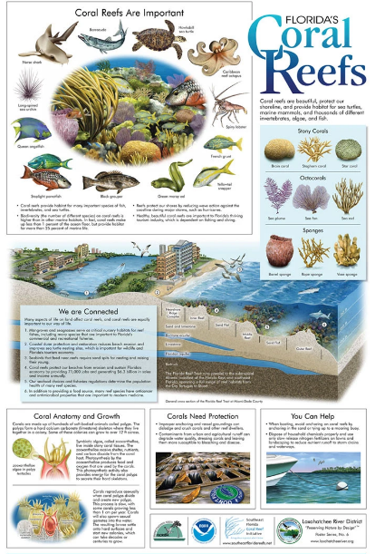
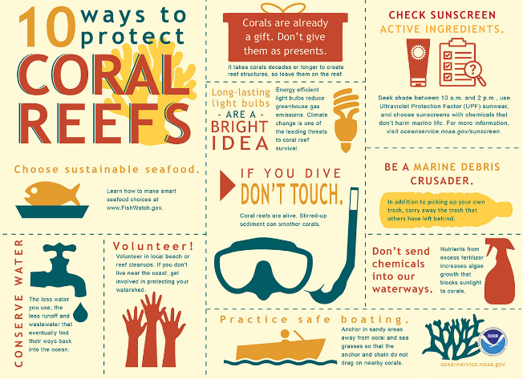

Assessment Rubric
Category | xcellent | Good | Fair | Poor
Title | Poster has a clear, attractive and visible title that expresses the purpose of the poster very well | Poster has a visible and appropriate title that indicates the purpose quite well | Poster has title but somewhat hard to read or doesn’t express purpose well | No title or unclear poster title that isn’t relevant to purpose
Presentation | Layout is aesthetic and visually impressive, very clear and informative, gives a good visual summary | Layout is fairly clear and informative, gives a reasonable visual summary | Layout shows an attempt at being informative but is somewhat unclear or untidy | Layout is very unclear, badly organised, messy or unfinished
Pictures | Pictures are extremely well chosen, relevant and interesting | Pictures are mostly well chosen, relevant and interesting | Some relevant and appropriate pictures | Pictures are lacking, unfinished or irrelevant
Information | Gives 3+ reasons why the Reef is unique, 3+ threats and 3+ possible solutions. Information is very detailed, shows thoughtful insight into the topic, and is in own words. | Gives 2 reasons why the GBR is unique, 2 threats and 2 possible solutions. Information is fairly detailed and shows adequate thought, and is in own words | Gives at least 1 reason why the GBR is unique, 1 threat, and 1 possible solution. Information is partially relevant, some level of thought, mostly in own words | Does not give at least one reason for each of the categories. Information is irrelevant, lacking, or copy/pasted from other sources
Class work | Work in class on the poster was always organised and dedicated | Work in class was mostly organised and dedicated. | Showed some attempt to focus on task during class | Off task, wasting time or mucking around during class time

