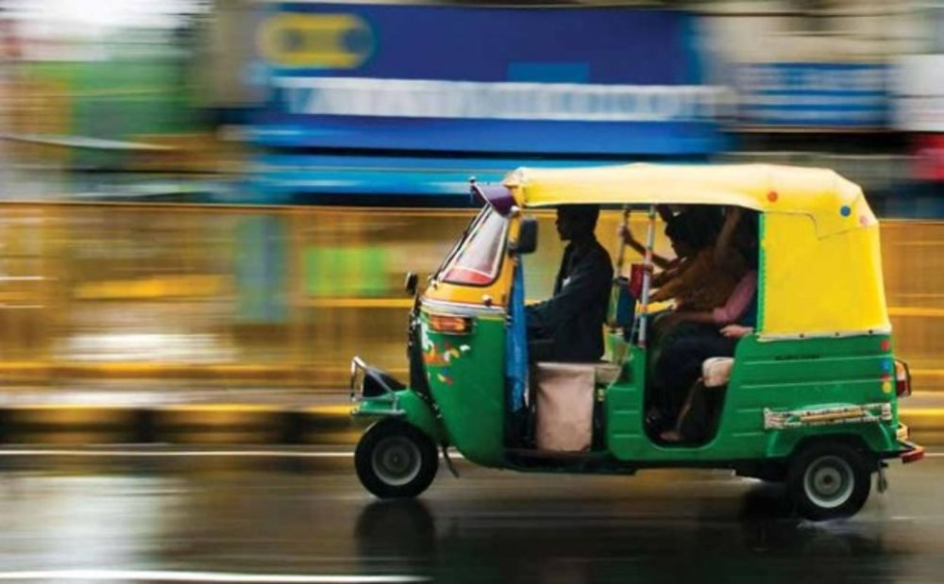
Rickshaw:
Poverty Simulation Game

Evaluation Questions
- What were some of the experiences of the passengers?
- Was it easy to get a ride?
- How did the bartering go?
- Did you find it difficult to know who to choose?
- Were the prices fair?
- What were some of the experiences of the drivers/vehicles?
- How much money did different people make?
- Have a look at the price poster below and see how much you could afford to buy with that money. How many days would you have to work to pay your rent?
- How long would you have to save up to buy clothes or a TV? What would life be like for you if this was all you had to live on? (The prices are close to 2003 Delhi prices.)
- Was it hard to find passengers?
- Who got a lot of work? Why?
- Who didn’t get much work? Why?
- Was there enough work for everybody or were too many people trying to make money from the same service?
- How do you think this experience might be similar to that of people who really work at these jobs in countries like India and Bangladesh?

