Globalisation & Transport

Transport Connections: Container Ships
- Watch the clip International Shipping Life blood of World trade - YouTube (start from 4:15)
- Record the types of ships and the types of cargo

- Read the article How container shipping changed the world through globalisation - Rear Vision - ABC Radio National
- List the benefits of containerisation.
- List five items you own that are moved around the world via container ship.

- Conduct some research on the Shanghai Container Port and the Port of Rotterdam.
- How many ships visit there each day?
- Why are they so important in terms of the movement of goods?

- Go to the Marine Traffic website: www.marinetraffic.com/
- Identify a major port in Australia, the USA, China and Europe.
- List the features of 5 boats going into or out of these ports.
- Describe the characteristics of air freight as a method of trade.
- Describe how road transport is used in Australia to transport goods.
- Outline the features of rail as a method of transport for trade.
Transport Connections: Air Travel
- Watch the clip: https://www.youtube.com/watch?v=WxkJuEbKKCQ
- What features will the new airport have?

- Research the destinations you can fly to from Dubai.
- How many destinations can you travel to?
- Roughly how many flights land and depart Dubai International Airport each day?
- Select 6 places you can travel, one from each continent. Plot each place on the map. State the flying time and distance to each location.
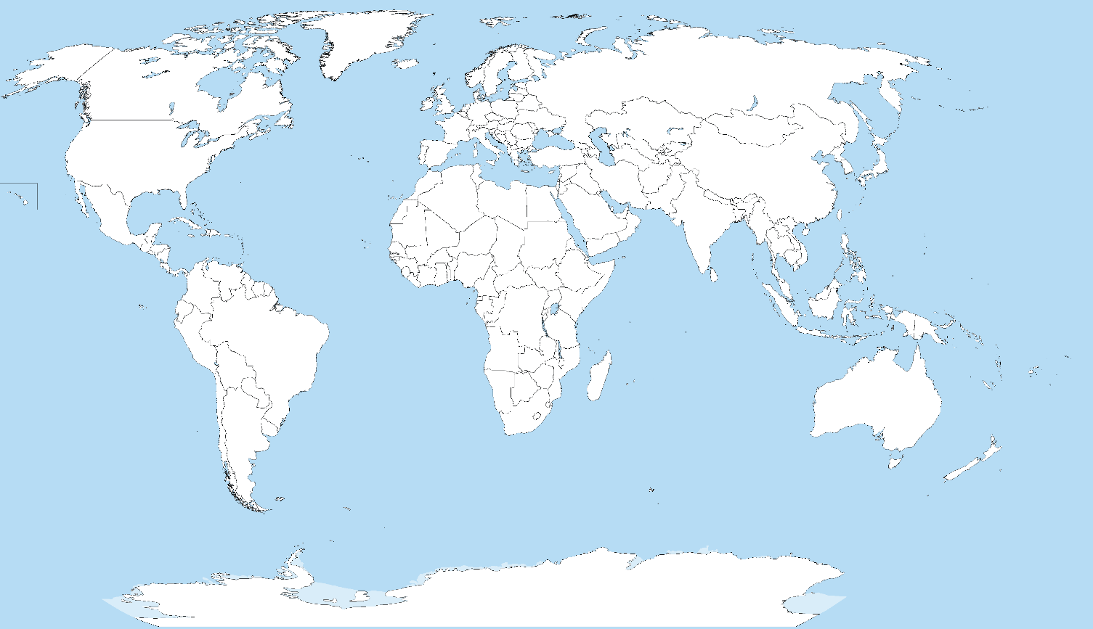

- Use the statistics in the table to construct a column graph.
- Investigate ONE of the major car exporters in Germany. For your chosen manufacturer, find the following information:
- Location of headquarters
- 5 locations where the cars are manufactured
- Number of nations that this company exports their cars to.
- Number of cars that are exported each year

