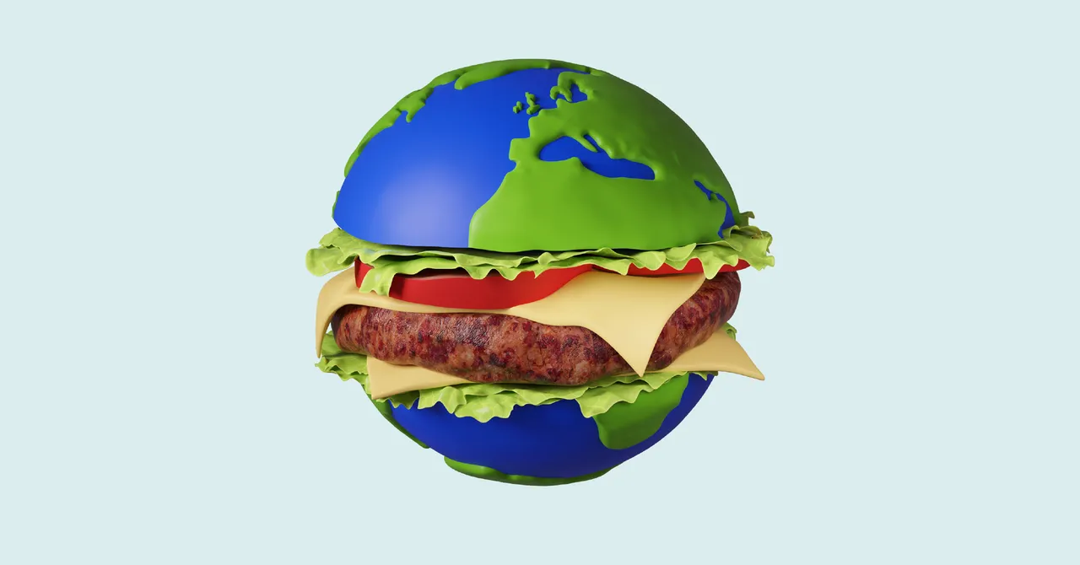
Year 9-10 Geography
Extension Booklet
Biomes & Food Security
Name: ______________________________
Part 1: Biomes
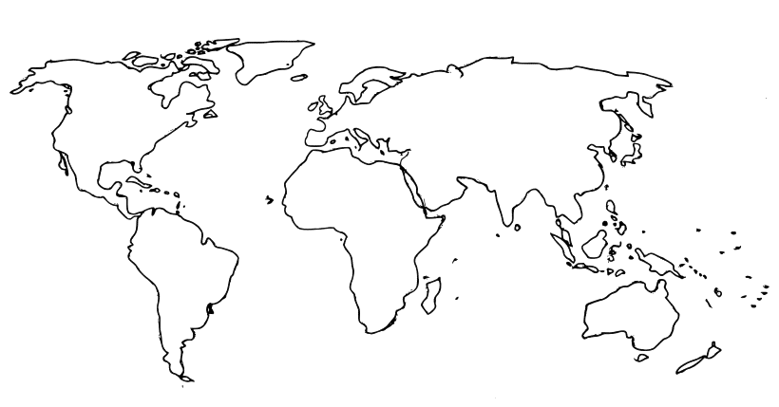
- On the maps below, use coloured pencils to show the location of the major biomes on the earth, and then a more detailed map of Australia’s biomes. Don’t forget to create a key for each.

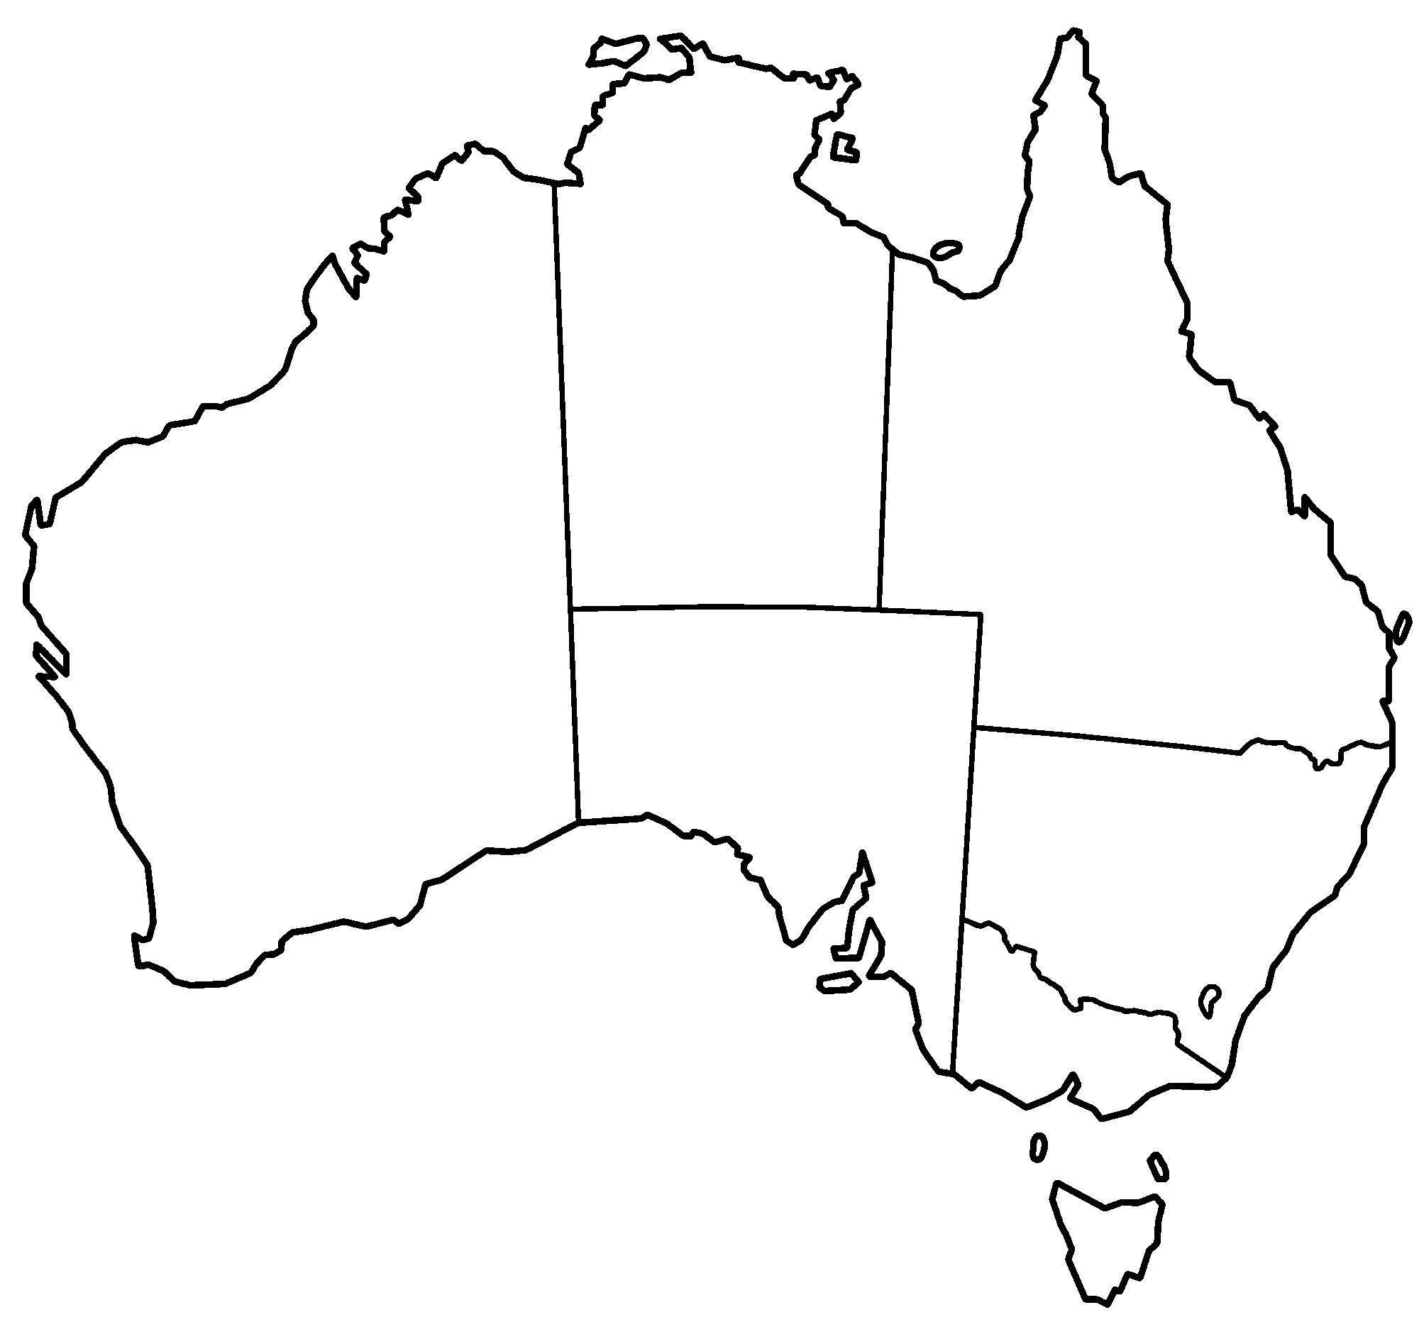

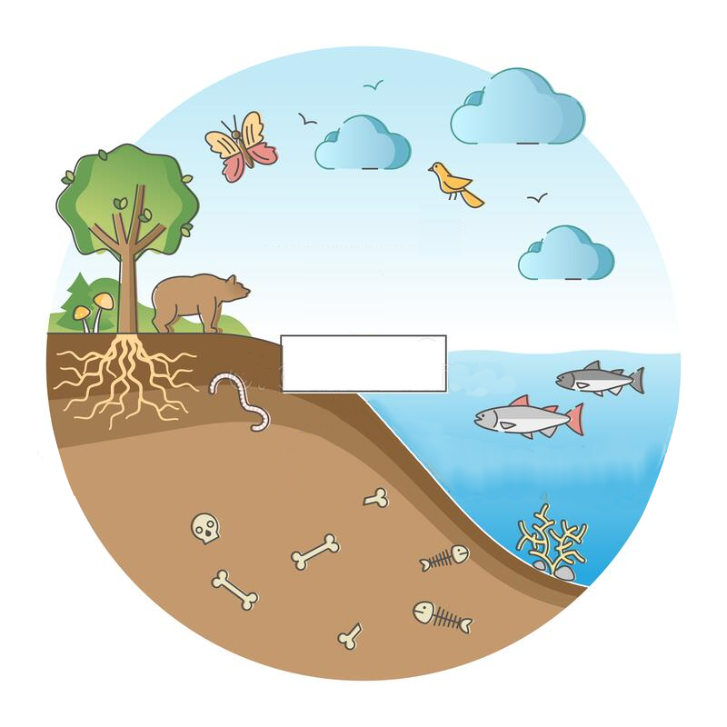
Part 2: Ecosystems
- On the diagram on the left, label the four spheres of the earth.

- Explain the difference between a biome and an ecosystem.

- What is the biggest factor that influences ecosystems?

- What type of climate creates the most productive biomes?

- Draw a simple model of an ecosystem in the space below, using arrows to show the movement of energy and nutrients.

- Explain why seasonal rainfall (wet and dry seasons) creates the best conditions for soil fertility.

- Rank the major biomes in terms of which ones are able to produce the most useful resources for humans.

Lowest Highest

- Draw a line from these Woolworths items to their country of origin. (You will need to look them up online to find the product information).
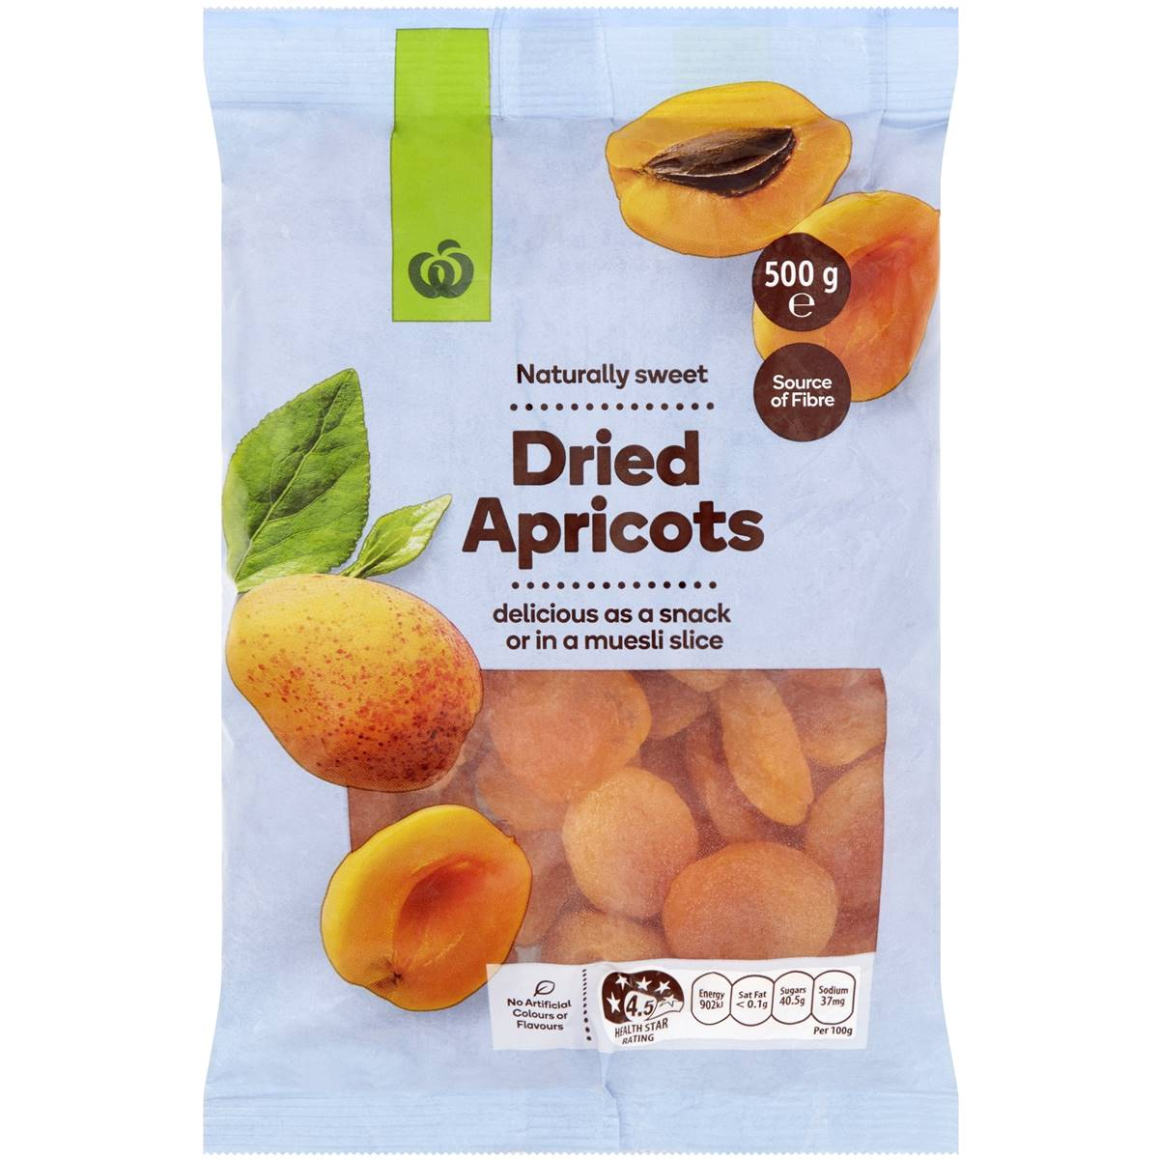
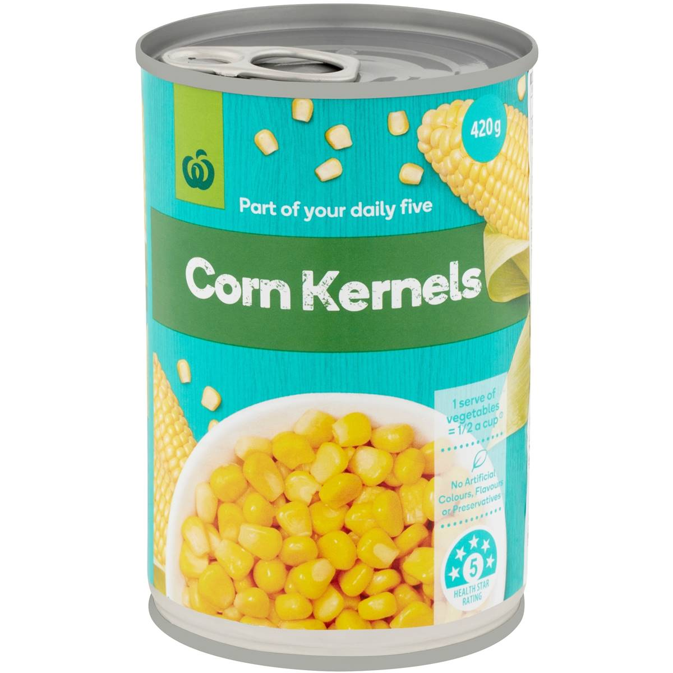

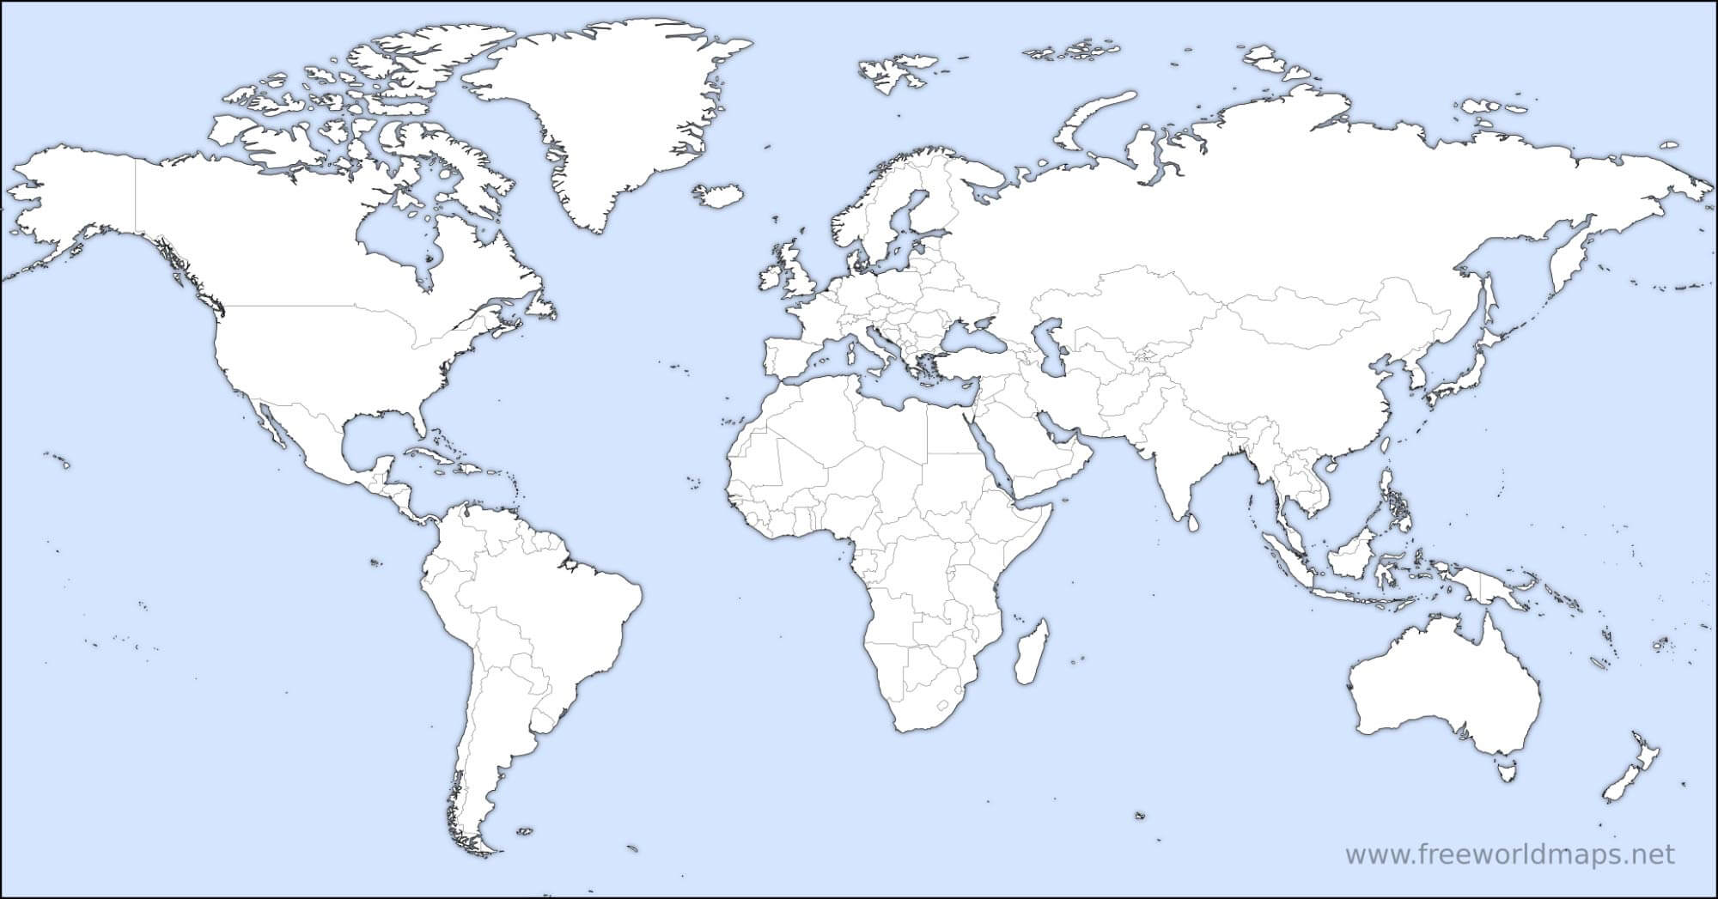

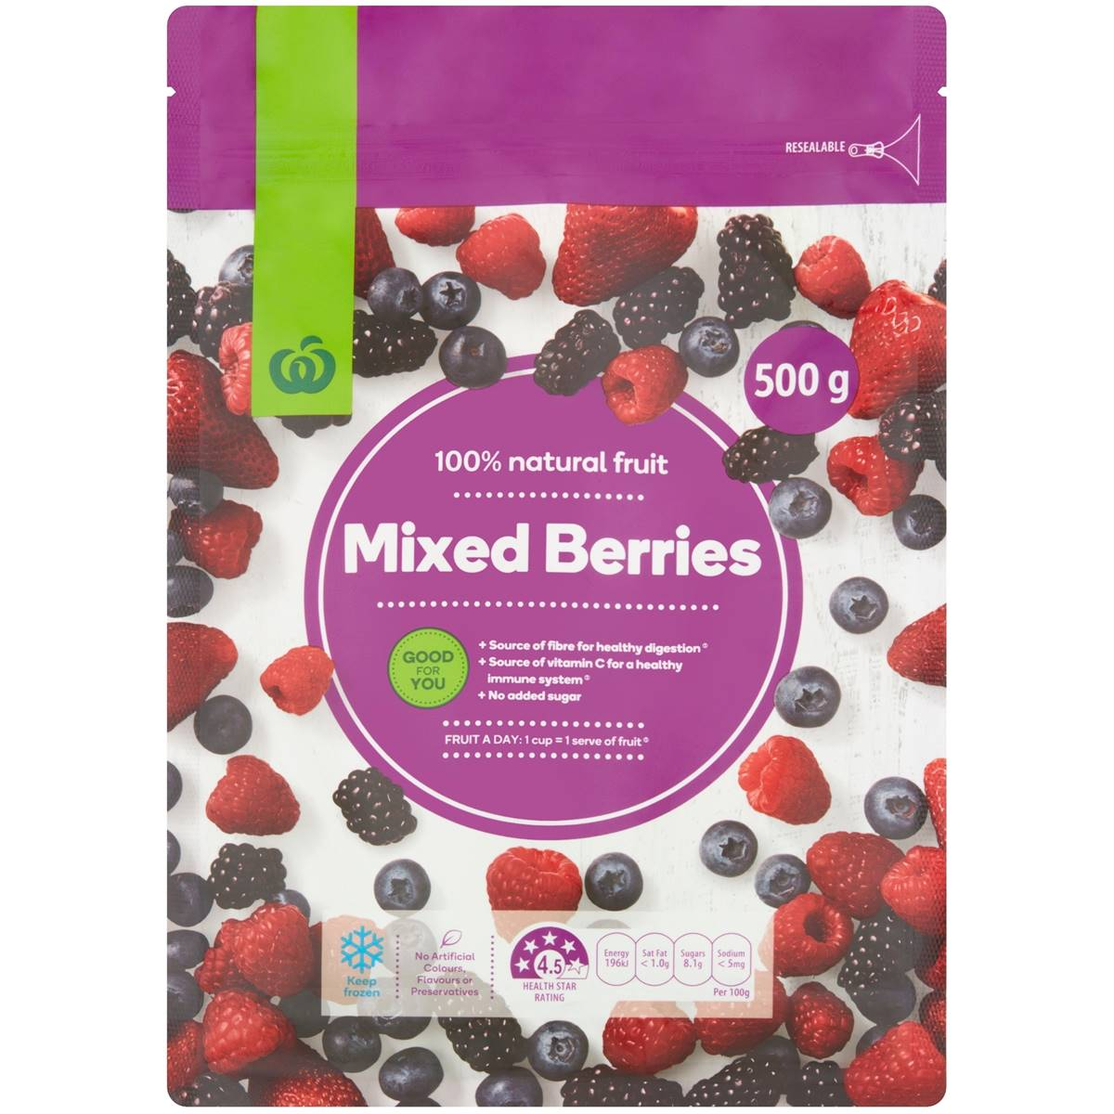
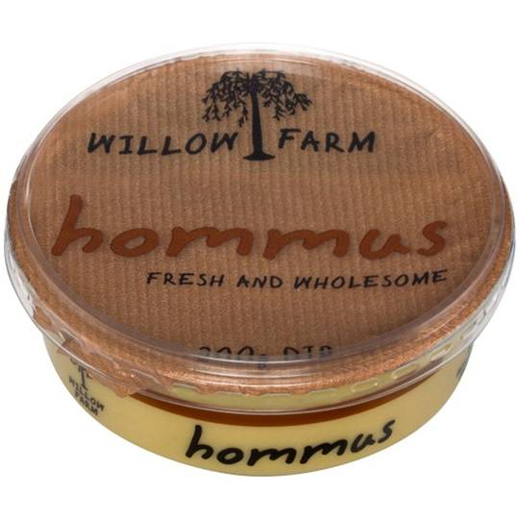
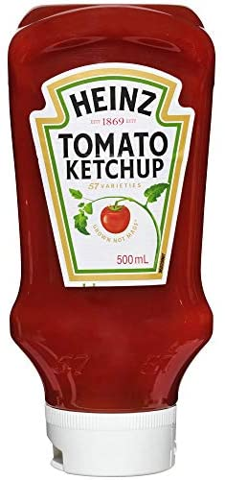

Part 3: Human Impact

- Create a table showing the differences between natural and agricultural ecosystems:
 | What’s put into it? | What’s produced? | How are nutrients recycled? | How are populations controlled?
Natural

Natural
Agricultural

Agricultural

- Watch the video, 'Biomes that produce our Food, industrial material and fibres’ (on haiku)
- List all the foods and fibres produced.

- Describe the climatic characteristics that are needed to produce these foods and fibres.

- How are farmers trying to be more sustainable?

- In the table below, mark which spheres are affected by the following food production activities:

How Food Productions Affects the Four Spheres
Activity |  |  | 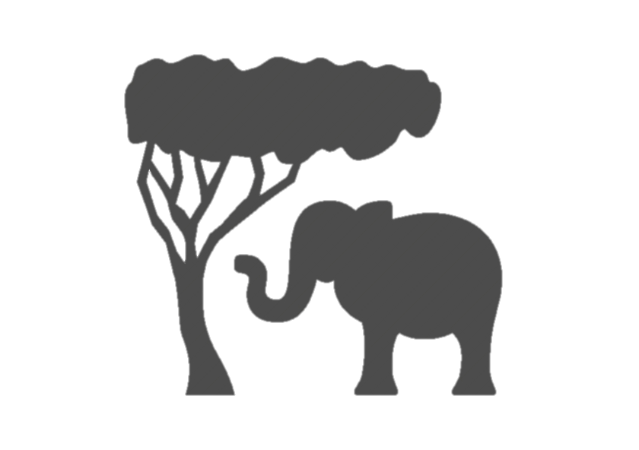
Clearing of native vegetation for agriculture
Overgrazing animals
Overusing irrigation water, causing saline soils
Burning forests to clear land for cultivation
Run-off of pesticides and fertilisers into streams
Producing greenhouse gases by grazing animals and rice farming
Changing from native vegetation to cropping
Withdrawing water from rivers and lakes for irrigation
Overcropping soils
Overfishing some species
Farming on marginal land

- Watch the video ‘Animal Agriculture – Environmental Impacts’ (on haiku)
- List some of the consequences that animal agriculture has on our planet

- Write a short paragraph about the ethics of eating meat. Consider the following: Does knowing the consequences make you want to choose to eat less meat? Do you think people would eat less meat if they were more aware of the impact? Why or why not?

Part 4: Food Security
Look at the graph in Figure 1 above.
  - Which group and gender have the highest food insecurity?

  - Suggest a possible reason for this:

Figure 1. Source: U.S. Department of Agriculture, Economic Research Service

Percentage of Population Undernourished, by Year
 | 2005 | 2010 | 2015 | 2016 | 2017 | 2018 | 2019 | 2020
World | 12.4 | 9.2 | 8.3 | 8.3 | 8.1 | 8.3 | 8.4 | 9.9
Africa | 21.3 | 18.0 | 16.9 | 17.5 | 17.1 | 17.8 | 18.0 | 21.0
Asia | 13.9 | 9.5 | 8.3 | 8.0 | 7.8 | 7.8 | 7.9 | 9.0
Latin America & Caribbean | 9.3 | 6.9 | 5.8 | 6.8 | 6.6 | 6.8 | 7.1 | 9.1
Oceania | 6.9 | 5.3 | 6.1 | 6.2 | 6.3 | 6.2 | 6.2 | 6.2
North America & Europe | 2.5 | 2.5 | 2.5 | 2.5 | 2.5 | 2.5 | 2.5 | 2.5
Figure 2. Source: Food and Agriculture Organisation of the United Nations, 2020

- Plot the information in Figure 2 onto a graph in excel. Explain what the graph shows about the percentage of undernourished population over the past 15 years:

- Suggest a possible reason for the increase after 2019:

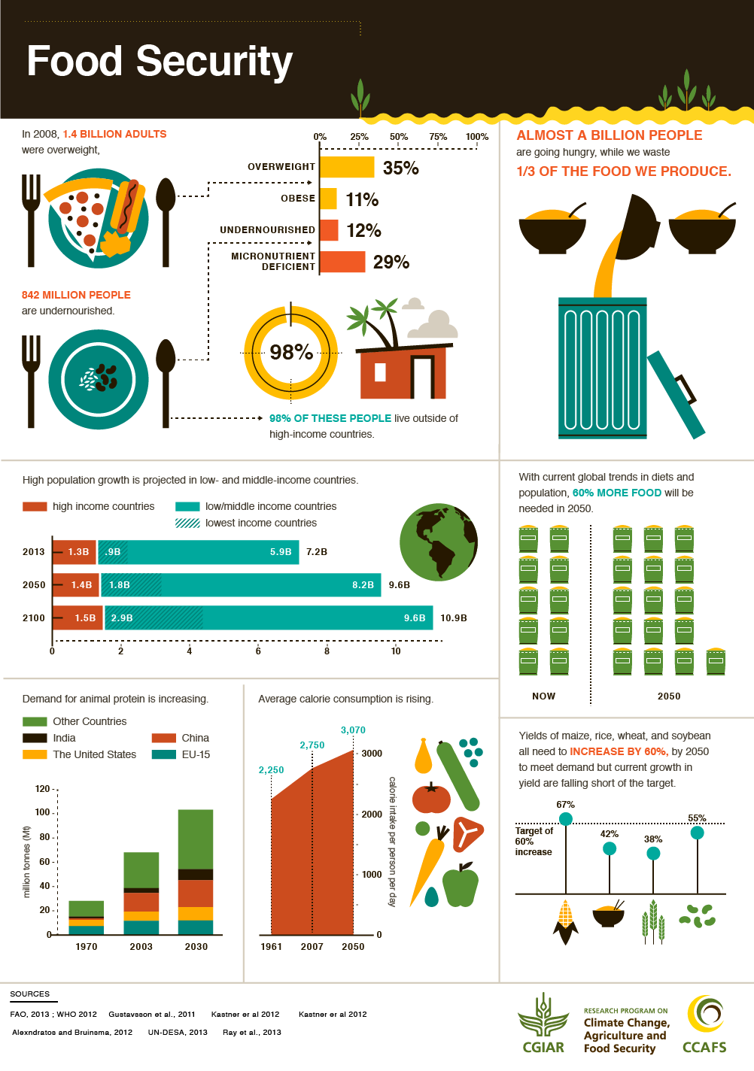

Study the infographic on the previous page.
- List 3 things that humans could do to combat threats to food security

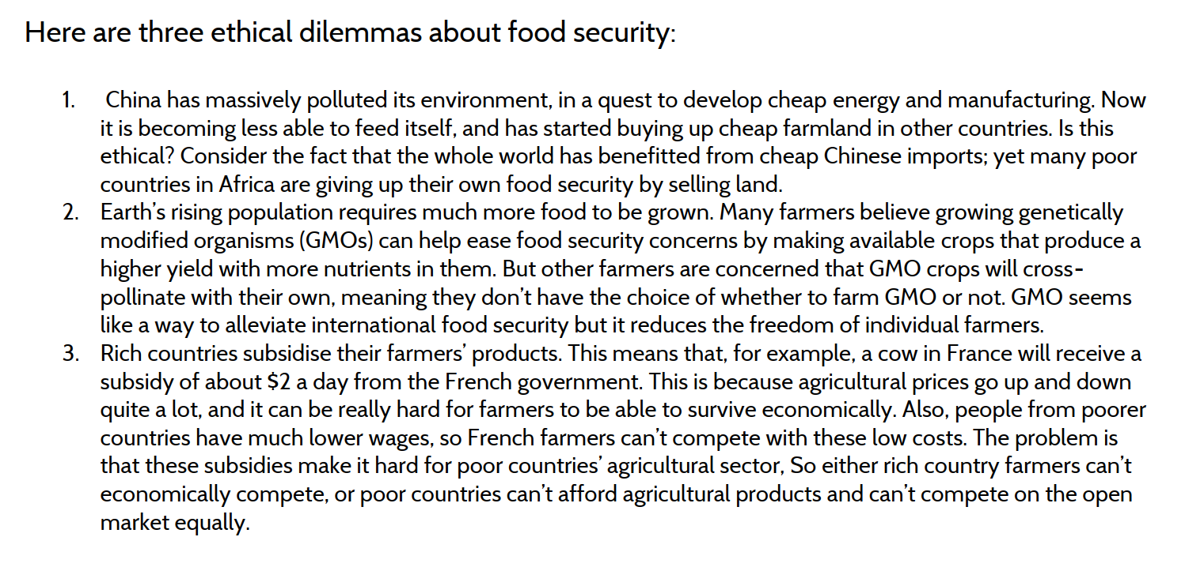

- Pick one of the dilemmas above. Write a short persuasive paragraph arguing for one side of the argument. Make sure to include a topic sentence, 2-3 sentences of persuasion, and a concluding sentence.

Watch the video ‘The Futuristic Farms That Will Feed the World’ (on haiku).
- Describe some of the technological innovations discussed in the video that may solve the problem of producing enough food for the world’s increasing population.

- List some potential problems that could arise from these methods of farming.

Part 5: Biomass
  - What is biomass?

  - In the space below, draw a diagram of the three methods of converting biomass to biopower
Direct combustion:

Gasification:

Anerobic digestion:

In the table below, list some of the positives of biopower and some of the challenges or drawbacks that it creates.

Biopower
Positives | Challenges and Drawbacks

