Who’s not hungry?
Very few Australians, by choice, would go to bed at night hungry. We live in a country where there is a plentiful supply and wide range of food items available. Our relatively high standard of living enables most of us to afford to purchase, store and prepare food, or even dine out. Most of us are secure in the knowledge that there will be food at the next meal time.

What is food security?
Food security exists when all people, at all times, have physical and economic access to enough safe and nutritious food to meet their dietary needs and food preferences for an active and healthy lifestyle.
Source: Food and Agriculture Organization
Food security for you, as a student, means that your family either grows its own food, has sufficient income to purchase food, or is able to barter or swap food. Similarly, food security for a country means that it is able to grow sufficient food, or it has enough wealth to import food, or it combines the two. Not all people in the world are able to achieve this — for example, compare the two families in figures 1 and 2.
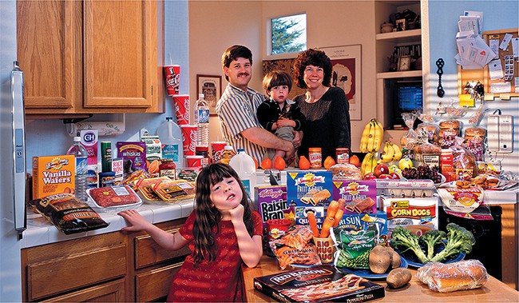
Figure 1 Average weekly food consumption for a family in the United States
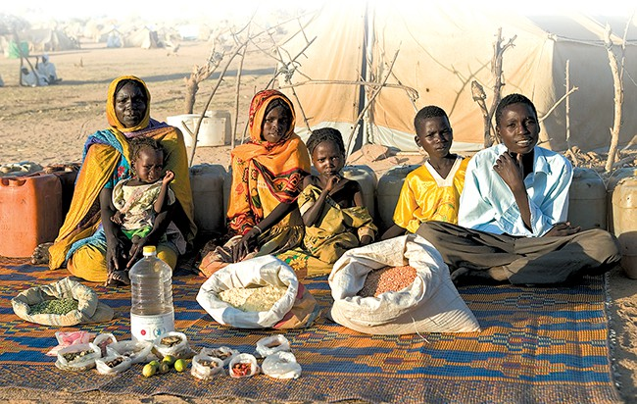
Figure 2 Average weekly food intake for a refugee family in Chad

Who has food security?
Figure 3 shows the countries of the world regarded as having low risk of food insecurity. This is based on a range of twelve different indicators, including the:
- affordability of food
- accessibility of food
- nutritional value of food
- safety of food
- nutritional and health status of the population.
The map shows only those countries that have low risk of food insecurity. These countries are able to produce more food than they require, so they can export their surplus; or they are able to afford to import all their needs, as is the case for the United Arab Emirates, for example.
Australia, for instance, produces three times as much food as it consumes, and is a major exporter of both fresh and processed food. We can trade competitively in cereals, oil seeds, beef, lamb, sugar and dairy products. Ninety per cent of our food is grown in Australia. Of the remaining 10 per cent that we import, many foods are either processed or out of season; oranges are an example. Global trade is an important component of food security because it is almost impossible to exactly match food production to food demands.
As a country, Australia does not have a problem feeding its population but it has a humanitarian interest in the food security of developing nations. As a major food producer, Australia does face future challenges. There is declining growth in agricultural productivity, the threat of climate change, and increasing competition for land and water.
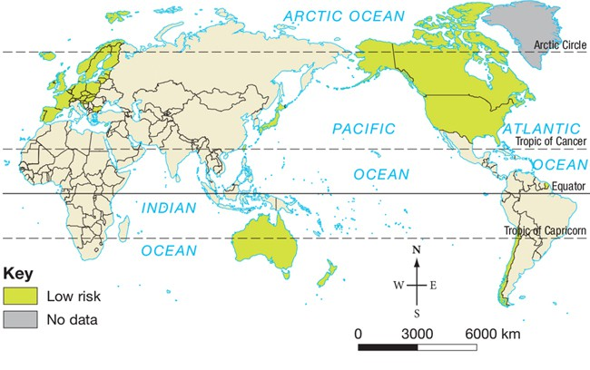
Source: www.maplecroft.com
Figure 3 Countries with low risk of food insecurity

