1.5 ✍ Source Analysis Practise

Source 1 - https://theconversation.com/from-shell-shock-to-ptsd-a-century-of-invisible-war-trauma-74911
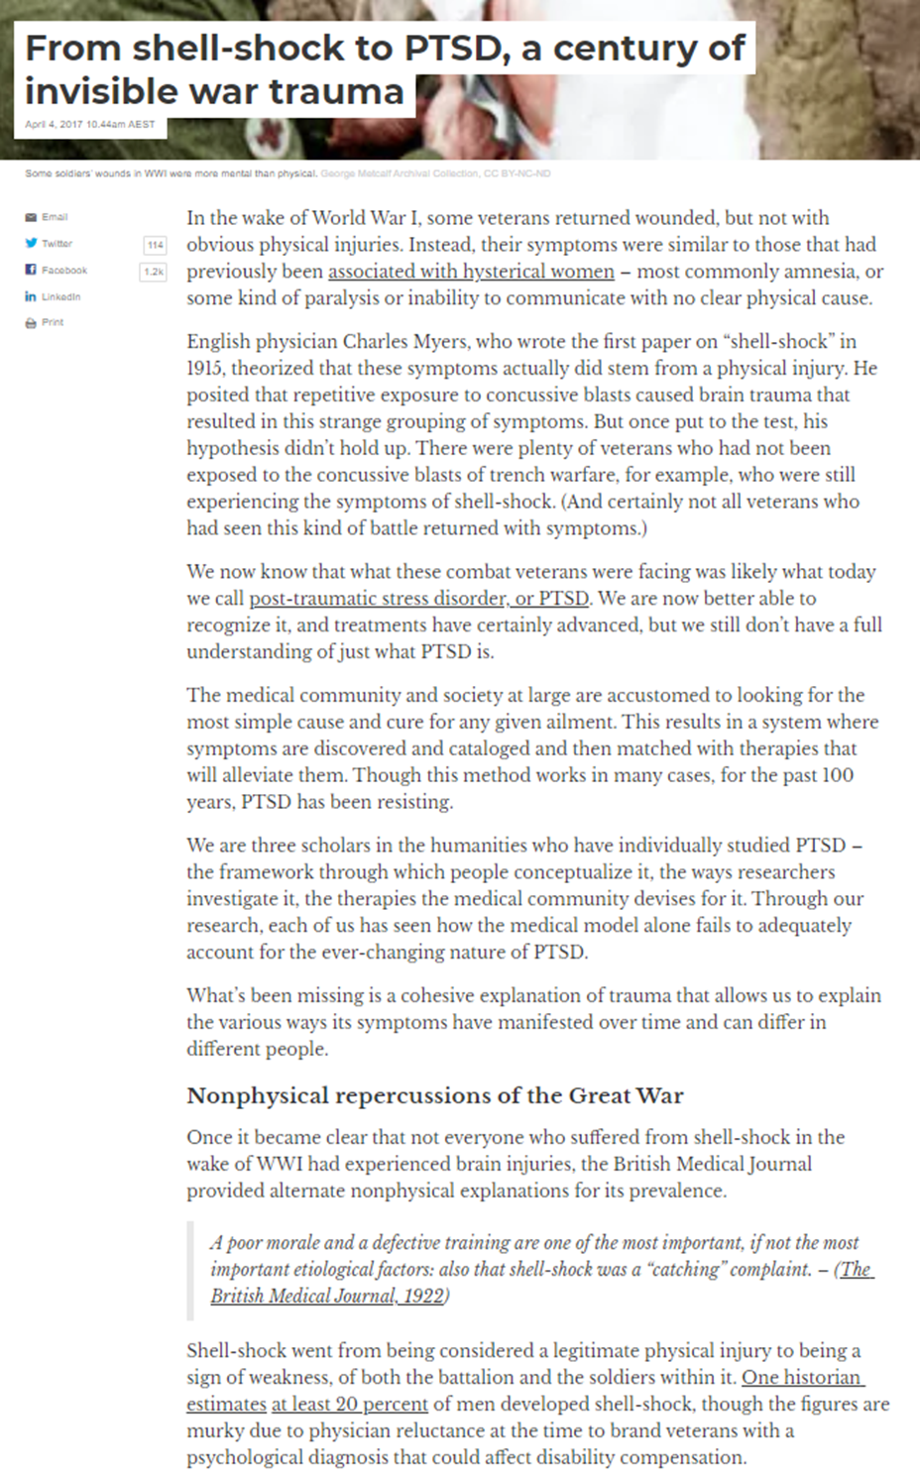

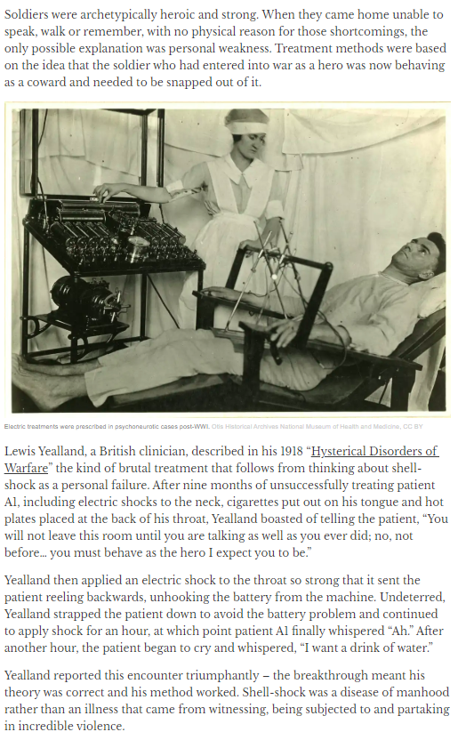

Source 1 Analysis and Evaluation
SOAPS categories | Answers
Speaker:
Who wrote or created this document?
What do you know about the author/?
What assumptions can we make about the speaker?

Occasion:
When was this created?
What was happening during this time period?
Audience:
Who was the document created or intended for?
Purpose:
What type of document is this?
Why was the document written or created?
Subject:
What is the document about?
What is the main idea?

Accuracy:
How likely the information is to be true. Your answer needs to talk in terms of the ‘degree of potential accuracy’.
For example: Extremely - Very – Somewhat – Rarely – Not very
Reliability:
How trustworthy is the source. Do they have a reason to lie about the topic they are talking about? Like accuracy talk in terms of ‘degrees of reliability': Extremely - Very – Somewhat – Rarely – Not very
Representativeness:
Does the source represent only that persons view or did most of the people in that time and place feel that way?

Source 2 - Letter from Private Fred Wigglesworth to his parents.

Feb 23/1916
My Dear Pa and Ma.
I am afraid I have more bad news for us all.
A shell dropped in the traverse held by number 9 this morning.
Graham was rather badly smashed also another chap named Wood.
Dickenson (my pal Dickie) was killed by the shock of the explosion and Cox was killed by splinters.
It was what we call a Whizz Bang.
Poor Graham was down here and away before I knew about it.
I asked the Doctors Orderly and he said there was a good chance for him. I do hope so.
Am enclosing a letter for Mrs Graham but I can tell her nothing.
Please read it and address it for me, I have forgotten where he lives.
Cox was the chap I met in the Empire while at home, Frank and Dick did not see him but will remember it.
I came and went back on leave with him, I spoke to him on the station, tell Margery he was the party who had the Whiskey bottle, a young well built lad with a round face.
As soon as I hear news of Graham I will let his Mrs Graham know.
But as I told you the first news we get of men who have been wounded is from England when they write.
I feel as though I cant write much tonight.
Birdsall and Dickie dead, Graham wounded and perhaps.... Bedford in England, Fred Neal with the Trench Mortar Section ....... Everett and I left.
I dont think I want to go back to the Company now, the 8 of us always hung together ever since we came out.
Still I would like to get my own back. A lot took Dickie and I for brothers we are rather alike and I often got called Dickie. Its a million to one I would have been in it if I had not come to the Orderly Room. I have been up to see Graham and Dick every night since we came in.
Last night abouyt 10.30 we were all three sat in their dugout, all the rest were on guard and they had just come off. I hasd taken a candle up as I had promissed and a paper or two also a few things I had been able to pinch for them. Graham was in his blanket and Dick sat on his bed.
Just when I was going Graham thanked me for getting the things and trailing up with them; its a long lonely way and perhaps a tyrifle risky alone, because if anything happens you might lay there for a while.
I remember answered "Its a pleasure boys, I only wish I could take you backwith me, if there is anything you want, let me know and do take care of yourselves." Dickie chimed in with "We could do with you back wi’ us Wiggy, chuck it up and come, we miss him a lot don't we Tim?"
He is the one I told you tales about, he talks very broad. I have seen him pull out his pipe just before we finished a lot of our marches and light up, the majority of us could hardly breathe let alone smoke. It was a vary big, French pipe and somone would shout "Dickie’s kitchen is going". Then he would turn to Tim and me and say "get yours out and kid ‘em up a bit."
He was a typical Yorkshireman, slow but he always got there. He never went sick since he joined and never missed a day in the trenches. He got more than his share of fatigues. The three of us were always together and very rarely had a quiet time.
Graham was a comical chap and Dickie the driest humorist I ever struck. I wish a record had been kept ofhis original remarks, he never lacked an answer. Between us we hadn’t an enemy in the Battalion I am sure.
The last night we had together will always be one of my happiest memories and if only we had known.
I don't think I have ever had a blow as hard as this in all the war and I have had a few. It’s the fortunes of war and all we can expect but God it’s hard. I am glad I went up last night, I was going up again tonight but they are both gone.
Now don't worry about me, I shall get over it and I know you feel for me.
God bless you all, Fred
PS Feb 24th 1916
Am all right now, we go out of the line tonight.

Source 2 Analysis and Evaluation
SOAPS categories | Answers
Speaker:
Who wrote or created this document?
What do you know about the author/?
What assumptions can we make about the speaker?

Occasion:
When was this created?
What was happening during this time period?
Audience:
Who was the document created or intended for?
Purpose:
What type of document is this?
Why was the document written or created?
Subject:
What is the document about?
What is the main idea?

Accuracy:
How likely the information is to be true. Your answer needs to talk in terms of the ‘degree of potential accuracy’.
For example: Extremely - Very – Somewhat – Rarely – Not very
Reliability:
How trustworthy is the source. Do they have a reason to lie about the topic they are talking about? Like accuracy talk in terms of ‘degrees of reliability': Extremely - Very – Somewhat – Rarely – Not very
Representativeness:
Does the source represent only that persons view or did most of the people in that time and place feel that way?

Source 3

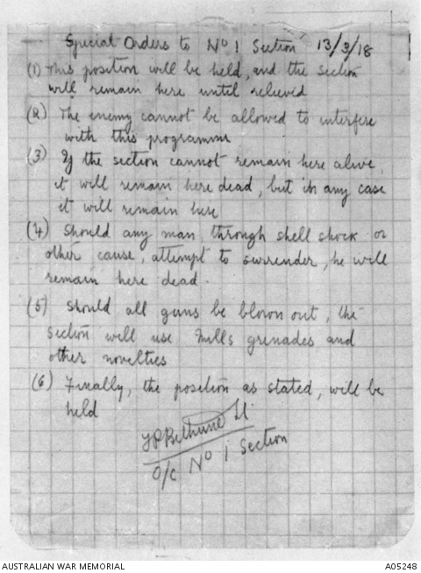

Photograph of the famous order issued by Lieutenant Frank P Bethune on 13th March, 1918, when the Section was ordered to occupy a defensive position at Buff Bank near Messines in France. The Section survived and held the position for 18 days.

The order reads:
'Special Orders to No 1 Section 13/3/18
(1) This position will be held, and the section will remain here until relieved.
(2) The enemy cannot be allowed to interfere with this programme.
(3) If the section cannot remain here alive it will remain here dead, but in any case it will remain here.
(4) Should any man through shell shock or other cause, attempt to surrender, he will remain here dead.
(5) Should all guns be blown out, the section will use Mills grenades and other novelties.
(6) Finally, the position as stated, will be held.

F P Bethune LT O/C No 1 Section.'

Source 3 Analysis and Evaluation
SOAPS categories | Answers
Speaker:
Who wrote or created this document?
What do you know about the author/?
What assumptions can we make about the speaker?

Occasion:
When was this created?
What was happening during this time period?
Audience:
Who was the document created or intended for?
Purpose:
What type of document is this?
Why was the document written or created?
Subject:
What is the document about?
What is the main idea?

Accuracy:
How likely the information is to be true. Your answer needs to talk in terms of the ‘degree of potential accuracy’.
For example: Extremely - Very – Somewhat – Rarely – Not very
Reliability:
How trustworthy is the source. Do they have a reason to lie about the topic they are talking about? Like accuracy talk in terms of ‘degrees of reliability': Extremely - Very – Somewhat – Rarely – Not very
Representativeness:
Does the source represent only that persons view or did most of the people in that time and place feel that way?

