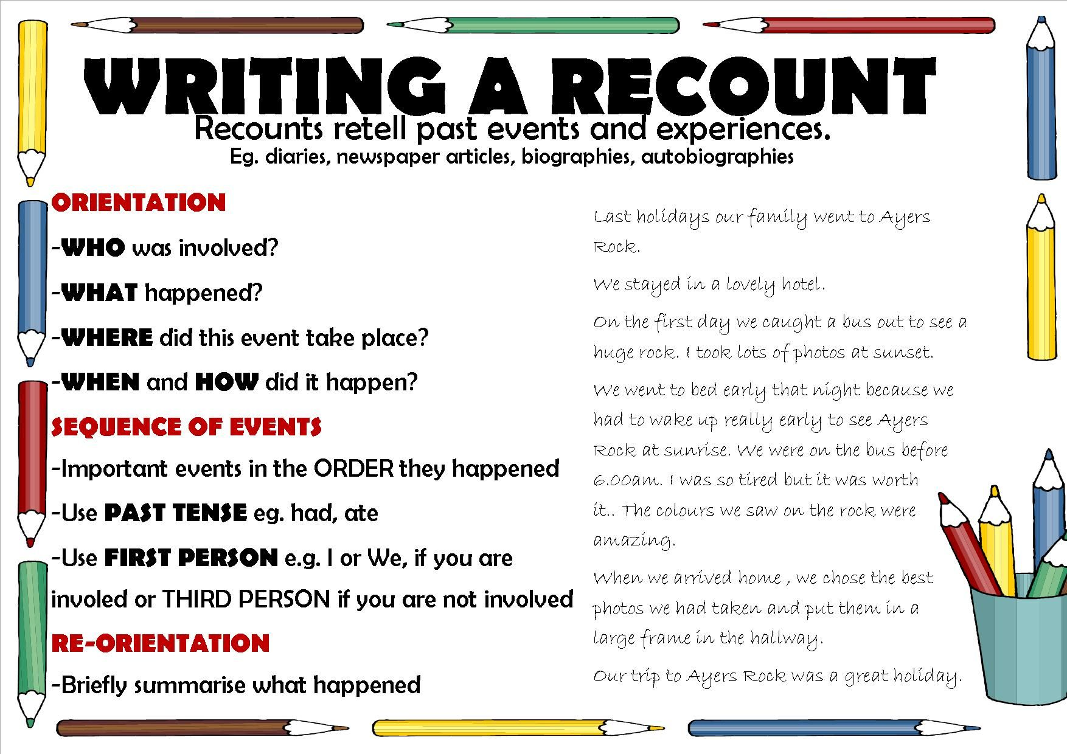

Personal Recount

Retells events that the writer was personally involved in. Can be recent or a long time ago.

**E.g. My Day at the Beach, The Big Car Accident, How I Got Out of Trouble**

Imaginative Recount

Apply factual knowledge to an imaginary person or role. Can also be completely imaginary.

**E.g. A Day in the Life of a Roman Slave, How I Invented Radium, My Amazing Hover Shoes**

Factual Recount

Based on an incident such as a historical event, a police report, a science experiment or newspaper article

**E.g. Albert Einstein’s Life, The Ash Wednesday Bushfires**

Types of Recounts

Types of Recounts

