The Great Mouse Plot

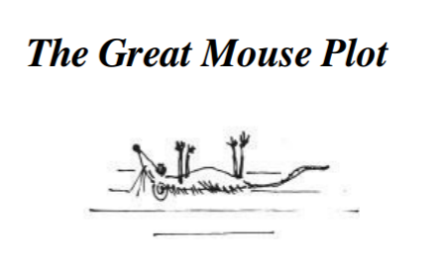

My four friends and I had come across a loose floor-board at the back of the classroom, and when we prised it up with the blade of a pocket-knife, we discovered a big hollow space underneath. This, we decided, would be our secret hiding place for sweets and other small treasures such as conkers and monkey-nuts and birds’ eggs. Every afternoon, when the last lesson was over, the five of us would wait until the classroom had emptied, then we would lift up the floorboard and examine our secret hoard, perhaps adding to it or taking something away.
One day, when we lifted it up, we found a dead mouse lying among our treasures. It was an exciting discovery. Thwaites took it out by its tail and waved it in front of our faces. “What shall we do with it?” he cried.
“It stinks!” someone shouted. “Throw it out of the window quick!”
“Hold on a tick,” I said. “Don't throw it away.”
Thwaites hesitated. They all looked at me.
When writing about oneself, one must strive to be truthful. Truth is more important than modesty. I must tell you, therefore, that it was I and I alone who had the idea for the great a daring Mouse Plot. We all have our moments of brilliance and glory, and this was mine.
“Why don't we,” I said, “slip it into one of Mrs Pratchett's jars of sweets? Then when she puts her dirty hand in to grab a handful, she'll grab a stinky dead mouse instead.”
The other four stared at me in wonder. Then, as the sheer genius of the plan began to sink in, they all started grinning. They slapped me on the back. They cheered me and danced around the classroom. “We'll do it today!” they cried. “We'll do it on the way home! You had the idea,” they said to me, “so you can be the one to put the mouse in the jar.”
Thwaites handed me the mouse. I put it in my trouser pocket. Then the five of us left the school, crossed the village green and headed for the sweet-shop. We were tremendously jazzed up. We felt like a gang of desperados setting out to rob a train or blow up the sheriff’s office.
“Make sure you put it into a jar which is used often,” somebody said.
"I'm putting it in Gobstoppers," I said. "The Gobstopper jar is never behind the counter."
"I've got a penny," Thwaites said, "so I'll ask for one Sherbet Sucker and one Bootlace. And while she turns away to get them, you slip the mouse in quickly with the Gobstoppers."
Thus everything was arranged. We were strutting a little as we entered the shop. We were the victors now and Mrs Pratchett was the victim. She stood behind the counter, and her small malignant pig-eyes watched us suspiciously as we came forward.
“One Sherbet Sucker, please,” Thwaites said to her, holding out his penny.
I kept to the rear of the group, and when I saw Mrs Pratchett turn her head away for a couple of seconds to fish a Sherbet Sucker out of the box, I lifted the heavy glass lid of the Gobstopper jar and dropped the mouse in. Then I replaced the lid as silently as possible. My heart was thumping like mad and my hands had gone all sweaty.
“And one Bootlace, please,” I heard Thwaites saying. When I turned round, I saw Mrs Pratchett holding out the Bootlace in her filthy fingers.
“I don't want all the lot of you troopin' in 'ere if only one of you is buyin',” she screamed at us. “Now beat it! Go on, get out!”
As soon as we were outside, we broke into a run. “Did you do it?” they shouted at me.
“Of course I did!” I said.
“Well done you!” they cried. “What a super show!”
I felt like a hero. I was a hero. It was marvellous to be so popular.

