Essay Burger!

Introduction:

* Background/general comment about theme:
* Outline 3 main points:

Body Paragraph 1:

* First point:
* Example:
* What this means:

Body Paragraph 2:

* Second point:
* Example:
* What this means:

Body Paragraph 3:

* Third point:
* Example:
* What this means:

Conclusion:

* 3 points summary:
* Lesson or take away message:

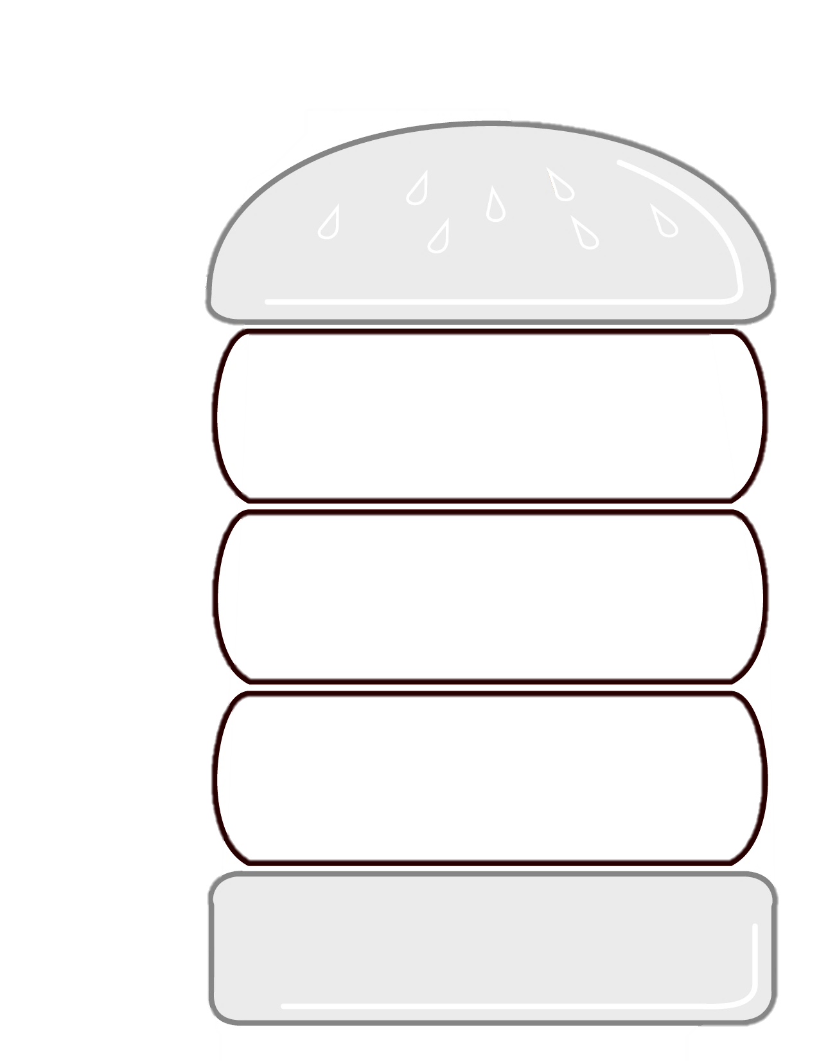Essay Burger!

Introduction:

Conclusion:

* Briefly sum up your three main points again.
* Finish by saying what the theme means, what the author thinks about it, a lesson we can learn about the theme from this story, or a suggested future action.

Conclusion:

* Briefly sum up your three main points again.
* Finish by saying what the theme means, what the author thinks about it, a lesson we can learn about the theme from this story, or a suggested future action.

Body Paragraph 3:

* Introduce your third and final main point.
* Give an example from the story. List the specific scene or quote.
* Explain what this shows about your theme or what you think the author is saying about it
* Background: say something about your theme in general or talk about the context (the author, the story, the setting)
* Explain briefly what you will talk about in your essay – outline what your 3 main points will be.

Body Paragraph 1:

* Introduce your first main point.
* Give an example from the story. List the specific scene or quote.
* Explain what this shows about your theme or what you think the author is saying about it.

Body Paragraph 2:

* Introduce your second main point.
* Give an example from the story. List the specific scene or quote.
* Explain what this shows about your theme or what you think the author is saying about it