Rikki Tikki Tavi: Essay
Due: Week 11
Word Count: 500 min

Essay Topic: Choose one theme from Rikki Tikki Tavi –
- Courage
- Loyalty
- Good vs Evil
Describe how this theme is shown in Rikki Tikki Tavi and explain what we learn about it through reading the narrative. Support your ideas with evidence.
Assignment Instructions:
- Decide which theme to write about.
- Re-read Rikki Tikki Tavi carefully, highlighting examples of your theme and quotes to use in your essay.
- Fill out a planning sheet with dot points of what you will say in your introduction, body paragraphs, and conclusion.
- Write a first draft of your essay.
- Proofread and check your essay using the Essay Self-Checking sheet and the rubric (on the back of this sheet).
- Hand in final essay before the end of the term. Also hand in your planning sheets and highlighted story.
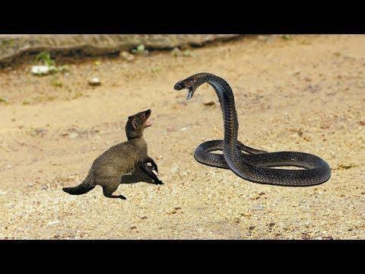

Marking Rubric
Performance Standard | A | B | C | D
Essay structure
- Has clear structure including introduction, 3-4 main body paragraphs, and conclusion
Introduction
- Has background or general comments about the theme, author, story, history
- Briefly outlines the 3 main points
Body paragraphs
- Each makes one main point about the topic
- Gives a specific example from the story
- Say what this means or what the author’s point is
Conclusion:
- Re-states 3 main points
- Finishes with a lesson for us, insight about the author or the story, meaning, or suggested future action
Vocabulary & Language:
- Uses key words from the question
- Uses academic language with no slang or contractions
- Consistent 3rd person point of view
- Uses linking phrases to connect paragraphs
Grammar:
- Proofread with few or no errors in punctuation, spelling, capitalisation etc.
- Correctly formatted quotes - quotation marks & page numbers

