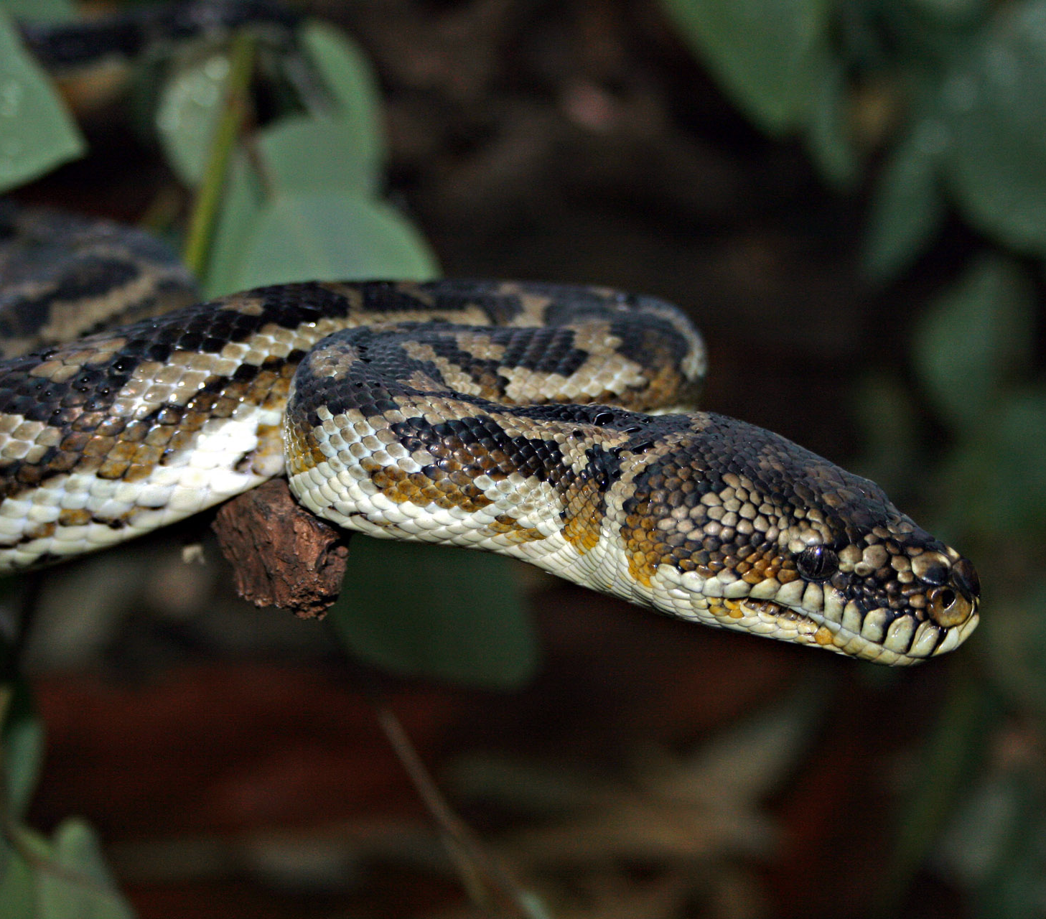
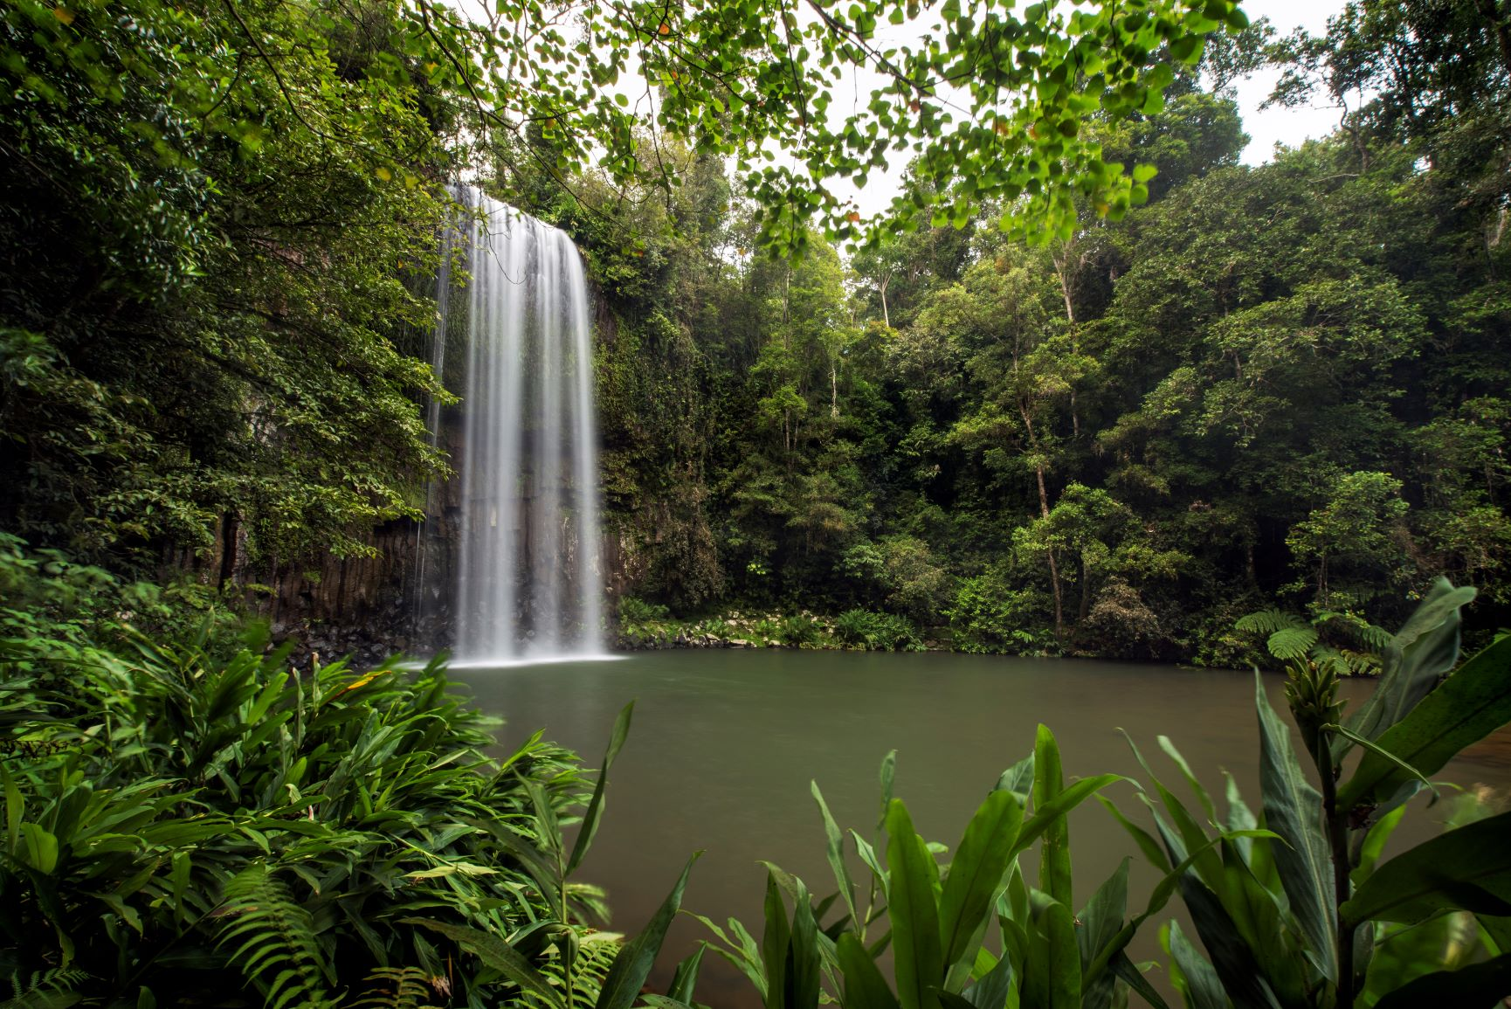
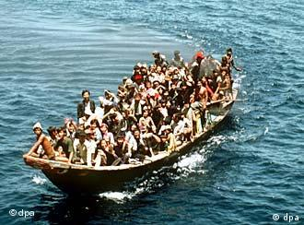
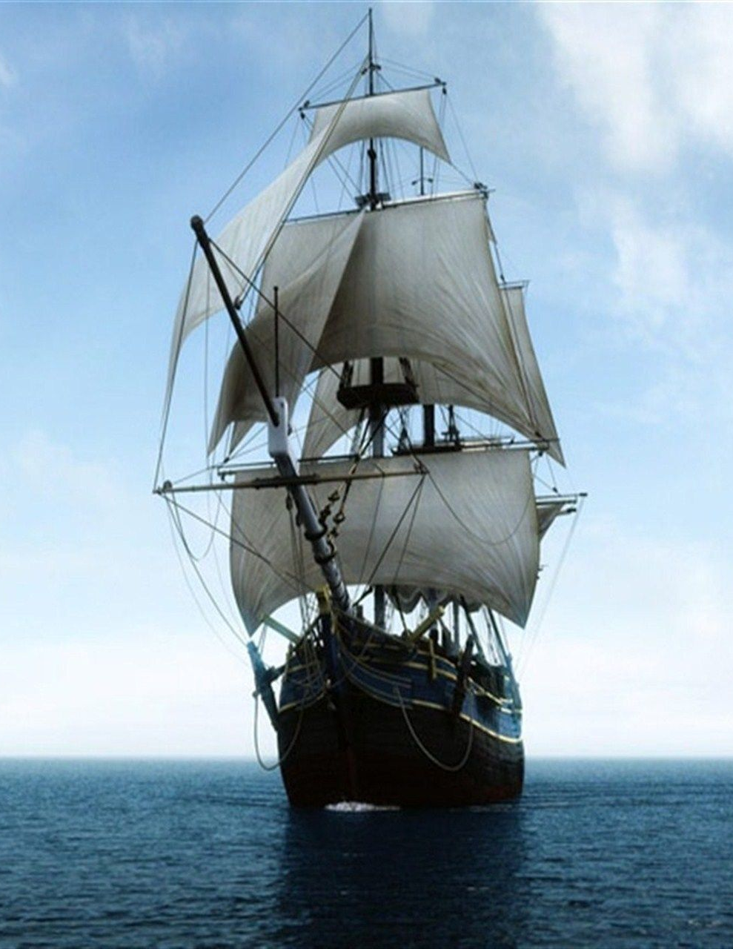
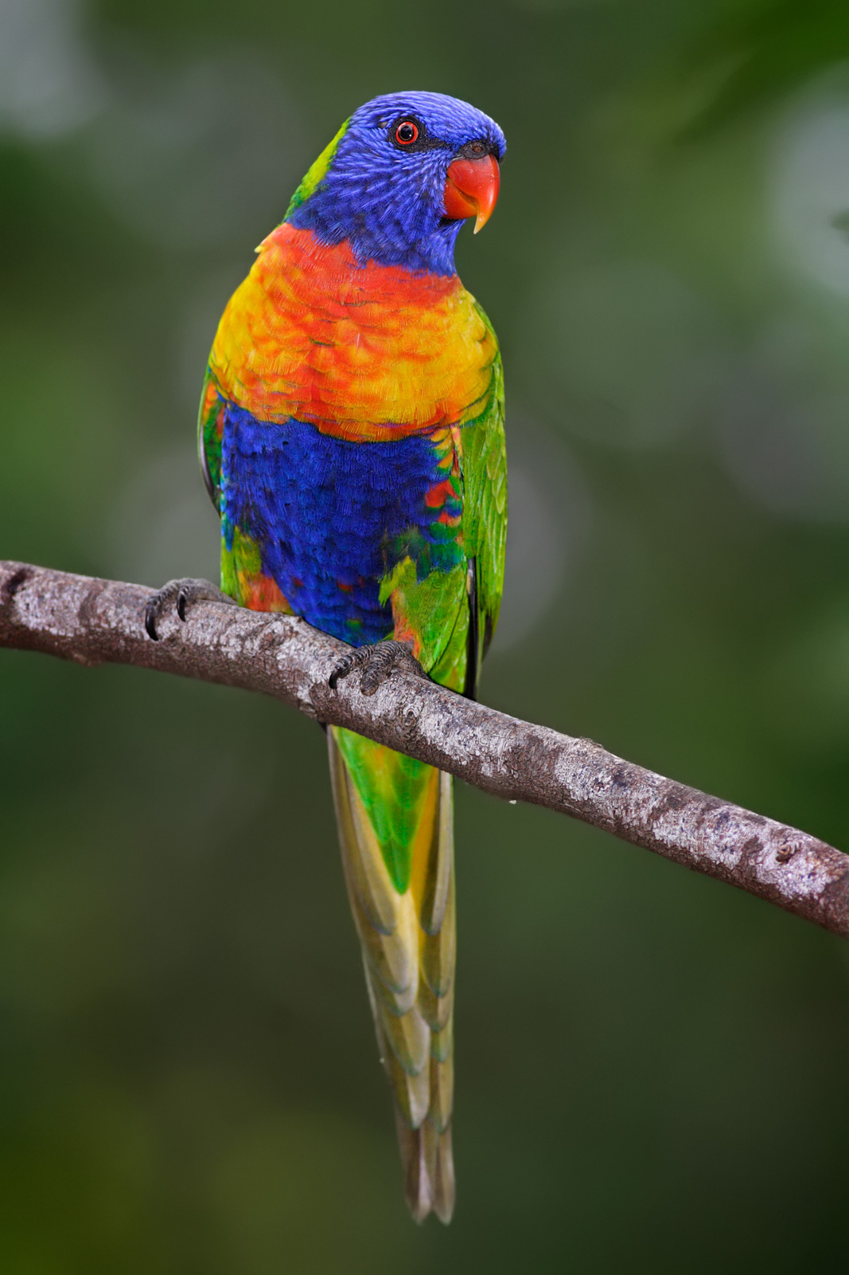
NAME:

Year 8
Poetry
Work
book

Poetry Task 1

Learning intention: We are learning to recognise poetic devices and forms in use. We are comparing how these can be used differently to create different effects.

Your task is to annotate (label) all the poems in this workbook. For each poem, label the following:
  - Highlight any rhyming words at the ends of lines in the same colour
  - In one stanza of each poem, underline the stressed syllables
  - Label any other sound devices such as onomatopoeia, alliteration or repeated sounds.
  - Label any examples of figurative language, e.g. similes or metaphors, imagery, personification, or hyperbole.
  - Underneath each poem, on the lines provided, write down the form and how many stanzas it has.

Due: End of Week 2.

Marking Rubric

Performance Standards | A | B | C | D
Rhyme pattern identified correctly

Stressed syllables underlined correctly

Identified all sound devices correctly

Identified all figurative language correctly

Identified form and stanzas correctly

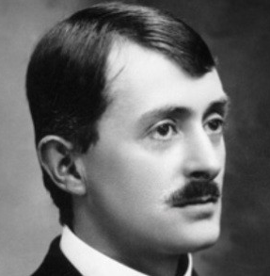
Sea Fever – by John Maesfield

I must go down to the seas again, to the lonely sea and the sky,
And all I ask is a tall ship and star to steer her by,
And the wheel’s kick and the wind’s song and the white sail’s shaking,
And a grey mist on the sea’s face, and a grey dawn breaking.

I must go down to the seas again, for the call of the running tide
Is a wild call and a clear call that may not be denied;
And all I ask is a windy day with the white clouds flying,
And the flung spray and the blown plume¹, and the sea-gulls crying.

I must go down to the seas again, to the vagrant gypsy² life,
To the gull’s way and the whale’s way where the wind’s like a whetted³ knife;
And all I ask is a merry yarn from a laughing fellow-rover,
And quiet sleep and a sweet dream when the long trick’s⁴ over.

- Plume = a long cloud or trail of smoke that looks like a feather
- Vagrant, gypsy = someone with no fixed address who moves about from place to place
- Whetted = sharpened
- Trick = shift. Ships had someone on ‘watch’ (like sentry/lookout duty) 24 hours a day, in a rotating roster of shifts.

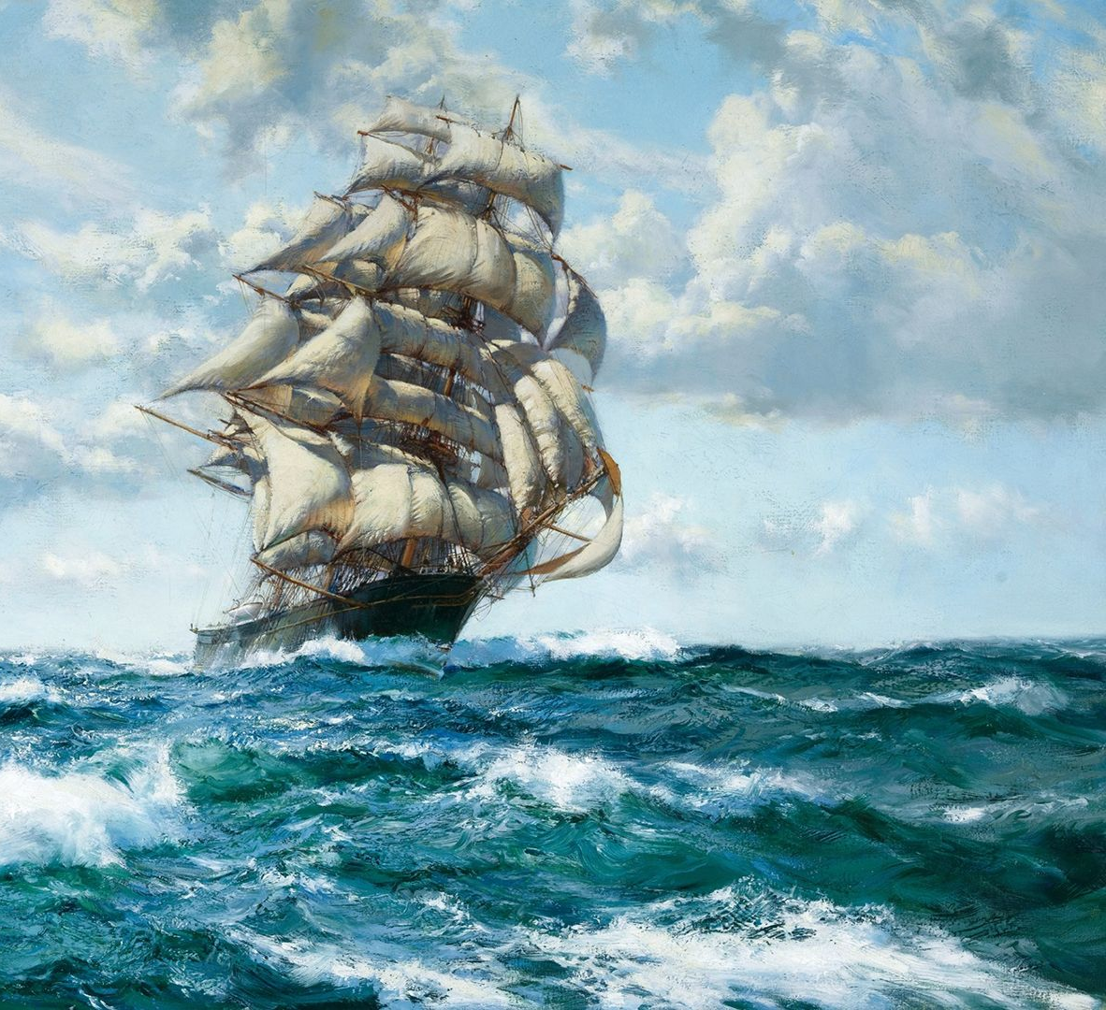

What form is this poem? __________________________

How many stanzas? __________

Ballad of the Totems – by Oodgeroo Noonuccal

My father was Noonuccal man and kept old tribal way,
His totem was the Carpet Snake, whom none must ever slay;
But mother was of Peewee clan, and loudly she expressed
The daring view that carpet snakes were nothing but a pest.

Now one lived right inside with us in full immunity,
For no one dared to interfere with father's stern decree:
A mighty fellow ten feet long, and as we lay in bed
We kids could watch him round a beam not far above our head.

Only the dog was scared of him, we'd hear its whines and growls,
But mother fiercely hated him because he took her fowls.
You should have heard her diatribes¹ that flowed in angry torrents
With words you never see in print, except in DH Lawrence².

'I kill that robber,' she would scream, fierce as a spotted cat;
'You see that bulge inside of him? My speckly hen make that!'
But father's loud and strict command made even mother quake;
I think he'd sooner kill a man than kill a carpet snake.

That reptile was a greedy-guts, and as each bulge digested
He'd come down on the hunt at night as appetite suggested.
We heard his stealthy slithering sound across the earthen floor,
While the dog gave a startled yelp and bolted out the door.

Then over in the chicken-yard hysterical fowls gave tongue,
Loud frantic squawks accompanied by the barking of the mung³,
Until at last the racket passed, and then to solve the riddle,
Next morning he was back up there with a new bulge in his middle.

When father died we wailed and cried, our grief was deep and sore;
And strange to say from that sad day the snake was seen no more.
The wise old men explained to us: 'It was his tribal brother,
And that is why it done a guy' ⁴ – but some looked hard at mother.

She seemed to have a secret smile, her eyes were smug and wary,
She looked as innocent as the cat that ate the pet canary.
We never knew, but anyhow (to end this tragic rhyme)
I think we all had snake for tea one day about that time.

- Diatribe = a strong verbal attack against someone
- DH Lawrence = an English writer known for writing controversial books which were often banned.
- Mung = mongrel dog
- ‘done a guy’ = left, run off

What form is this poem? _________________________________________________

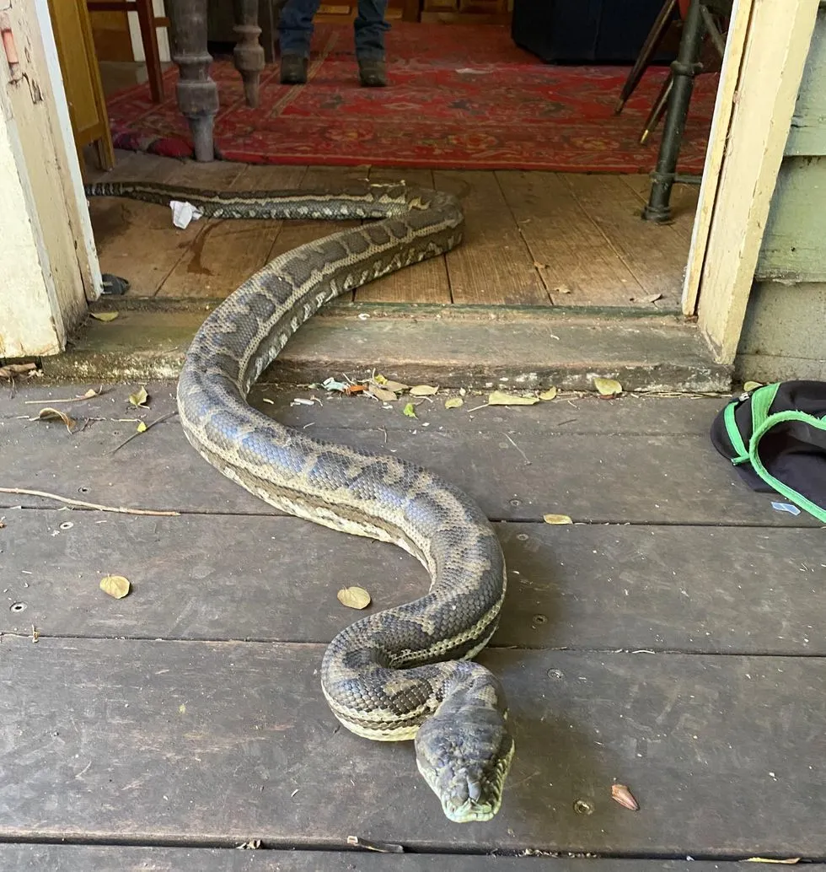
How many stanzas? _________

Things We Carry on the Sea – by Wang Ping

We carry tears in our eyes: good-bye father, good-bye mother
We carry soil in small bags: may home never fade in our hearts
We carry names, stories, memories of our villages, fields, boats
We carry scars from proxy wars¹ of greed
We carry carnage of mining, droughts, floods, genocides²
We carry dust of our families and neighbours incinerated in mushroom clouds
We carry our islands sinking under the sea
We carry our hands, feet, bones, hearts and best minds for a new life
We carry diplomas: medicine, engineer, nurse, education, math, poetry, even if they mean nothing to the other shore
We carry railroads, plantations, laundromats, bodegas³, taco trucks, farms, factories, nursing homes, hospitals, schools, temples…built on our ancestors’ backs
We carry old homes along the spine, new dreams in our chests
We carry yesterday, today and tomorrow
We’re orphans of the wars forced upon us
We’re refugees of the sea rising from industrial wastes
And we carry our mother tongues
爱(ai)，حب (hubb), ליבע (libe), amor, love
平安 (ping’an), سلام ( salaam), shalom, paz, peace
希望 (xi’wang), أمل (’amal), hofenung, esperanza, hope, hope, hope
As we drift…in our rubber boats…from shore…to shore…to shore…
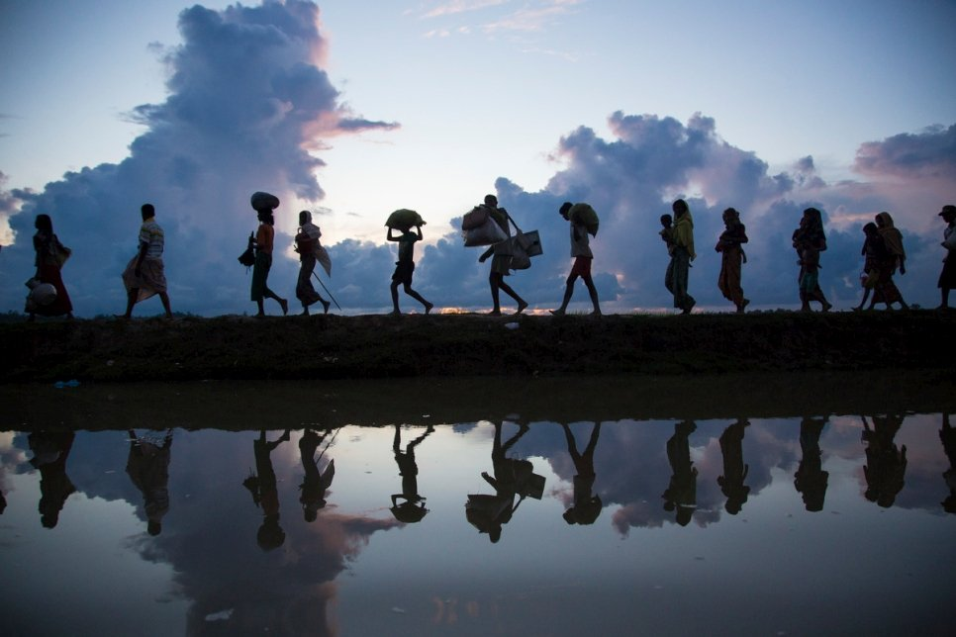
- Proxy war = a war fought on behalf of some other country
- Genocide = wiping out an entire race or ethnic group
- Bodega = corner convenience shop

What form is this poem?
_____________________________________________

The Tiger – by Rosemary Dobson
The tiger paces up and down
Behind the black bars of the page,
He pads on silent angry feet,
His heart is smouldering with rage.

Captive within the lines of type
He seeks, and yet can never find,
The world where he was free to range:
He is the poet's furious mind.

His are the unblinking eyes that stare
Into the gold heart of the sun,
He rakes the sky of stars and hunts
The darkness down, and is not done.

His was the world to roam, who now
Is captive to the black-barred page.
Reader, unlock the lines and face
The splendid danger of his rage!

What form is this poem? _____________________________________
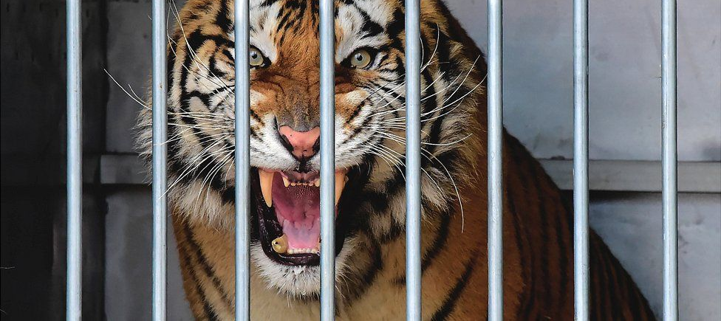
How many stanzas? _________

My Country – by Dorothea McKellar
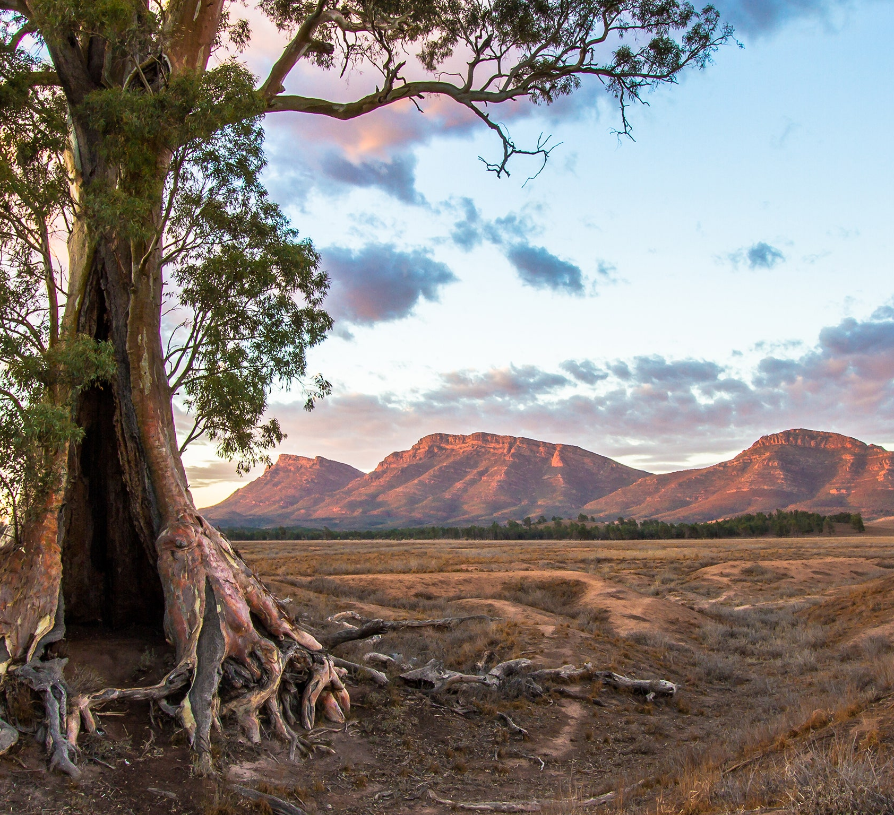
The love of field and coppice¹,
Of green and shaded lanes.
Of ordered woods and gardens
Is running in your veins,
Strong love of grey-blue distance
Brown streams and soft dim skies
I know but cannot share it,
My love is otherwise.

I love a sunburnt country,
A land of sweeping plains,
Of ragged mountain ranges,
Of droughts and flooding rains.
I love her far horizons,
I love her jewel sea,
Her beauty and her terror –
The wide brown land for me!

A stark white ring-barked forest
All tragic to the moon,
The sapphire-misted mountains,
The hot gold hush of noon.
Green tangle of the brushes,
Where lithe lianas² coil,
And orchids deck the tree-tops
And ferns the warm dark soil.

Core of my heart, my country!
Her pitiless blue sky,
When sick at heart, around us,
We see the cattle die –
But then the grey clouds gather,
And we can bless again
The drumming of an army,
The steady, soaking rain.

Core of my heart, my country!
Land of the Rainbow Gold,
For flood and fire and famine,
She pays us back threefold –
Over the thirsty paddocks,
Watch, after many days,
The filmy veil of greenness
That thickens as we gaze.

An opal-hearted country,
A wilful, lavish land –
All you who have not loved her,
You will not understand –
Though earth holds many splendours,
Wherever I may die,
I know to what brown country
My homing thoughts will fly.

- Coppice = a type of pruned English shrub
- Lianas = a native vine

What form is this poem? ________________________________

How many stanzas? ___________
Parrots – by Judith Wright
Loquats are cold as winter suns.
Among rough leaves their clusters glow
like oval beads of cloudy amber,
or small fat flames of birthday candles.

Parrots, when the winter dwindles
their forest fruits and seeds, remember
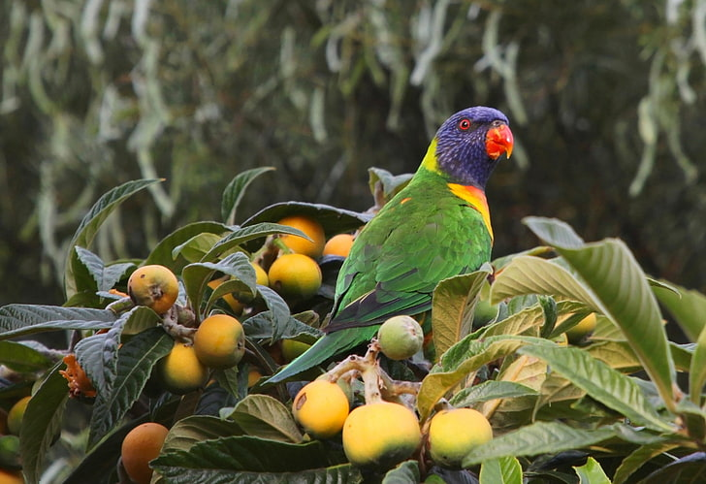
where the swelling loquats grow,
how chill and sweet their thin juice runs,

and shivering in the morning cold
we draw the curtains back and see
the lovely greed of their descending,
the lilt of flight that blurs their glories,

and warm our eyes upon the lories
and the rainbow-parrots landing.
There’s not a fruit on any tree
to match their crimson, green and gold.

To see them cling and sip and sway,
loquats are no great price to pay.

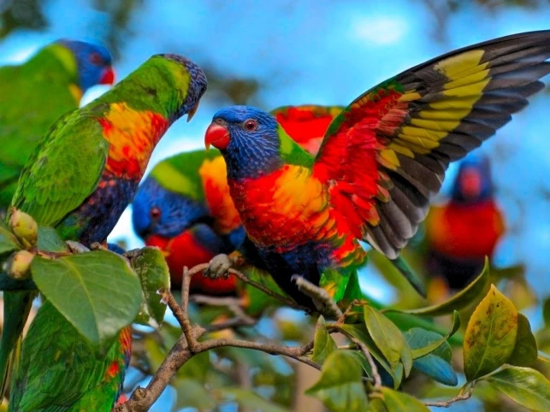
What form is this poem? ________________________________

How many stanzas? _____________

