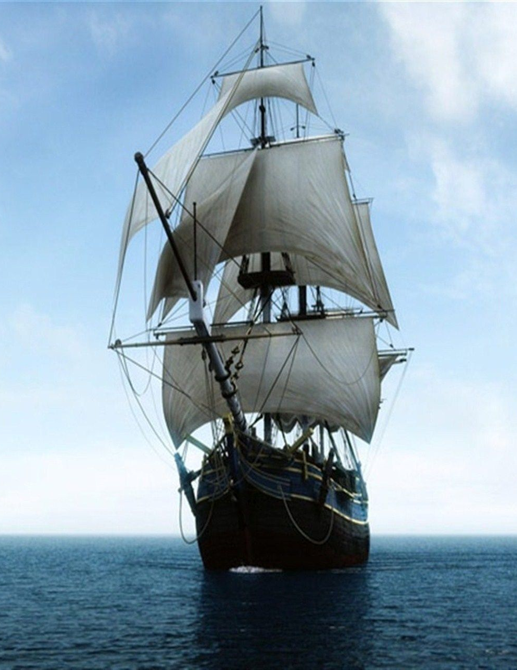
Poetry Task 2: Analysis
Year 8 English

For this task, you will choose 3 of the poems from the Poetry Workbook and write a short analysis of each of them.
Your analysis should talk about:
- The language used in the poem, including any poetic devices or techniques.
- Why the poet used these devices and what effect they have on the reader.
- Who the author was – when and where they were from, reason for writing poem.
- The mood or tone of the poem, including the poet’s ‘voice’ and point of view.
- The meaning or message of the poem.
Word count: Each analysis should be 200 words (minimum).
Due date: Friday 20 May (end of week 3)

Marking Rubric
Criteria | A | B | C | D
Language
- Correctly identified language devices in the poem
- Gave specific examples
- Explained reason for using devices & effect on reader

Author
- Found out about author’s background
- Suggested reason for writing poem

Mood & Tone
- Identified mood & tone of poem
- Discussed poet’s voice and point of view

Meaning & Message
- Identified meaning & message of poem

Editing
- Wrote in full sentences
- Work was well edited with few or no mistakes in spelling, grammar, punctuation

