Connotation and Denotation Practice
Sort the following sets of words into categories based on the connotation it has for you.
- Chatty, quiet, talkative, moody, grumpy, lively
- Thin, plump, fat, slim, slender, scrawny, lean, overweight, chubby
- Snobby, friendly, vain, proud, welcoming, gracious
- Shack, residence, apartment, mansion, tent, slum, house, home
- Confident, bossy, firm, assertive, arrogant, self-assured
- Unusual, amazing, weird, surprising, odd
- Smell, aroma, stench, perfume, stink, odour
- Nosy, curious, interested, fascinated, attentive, bored
- Bother, inconvenience, nuisance, hassle
- Visitor, intruder, guest, trespasser, tourist, client
- Meal, rations, feast, supplies, banquet, dinner, buffet
- Fanatical, enthusiastic, accepting, passionate
Positive Connotations + | Neutral Connotations = | Negative Connotations -
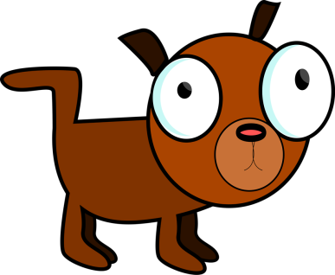
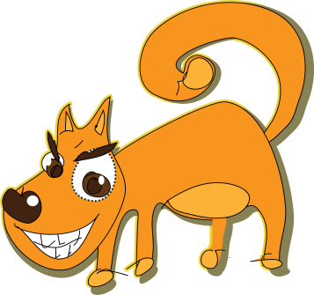
Denotations and Connotations
In the table below some everyday words are listed. Find a dictionary type meaning for each word - the denotation. Then write down as many connotations for each word as you can think of (good or bad). The first is done as an example.
Words | Denotation | Connotation
Dog | A four-legged carnivorous animal often kept as a pet or trained to hunt | Friendly, intelligent, loyal, noisy, suspicious, threatening, ferocious
Kitten

Desert

Teacher

Money

Sport

Forest

Green

