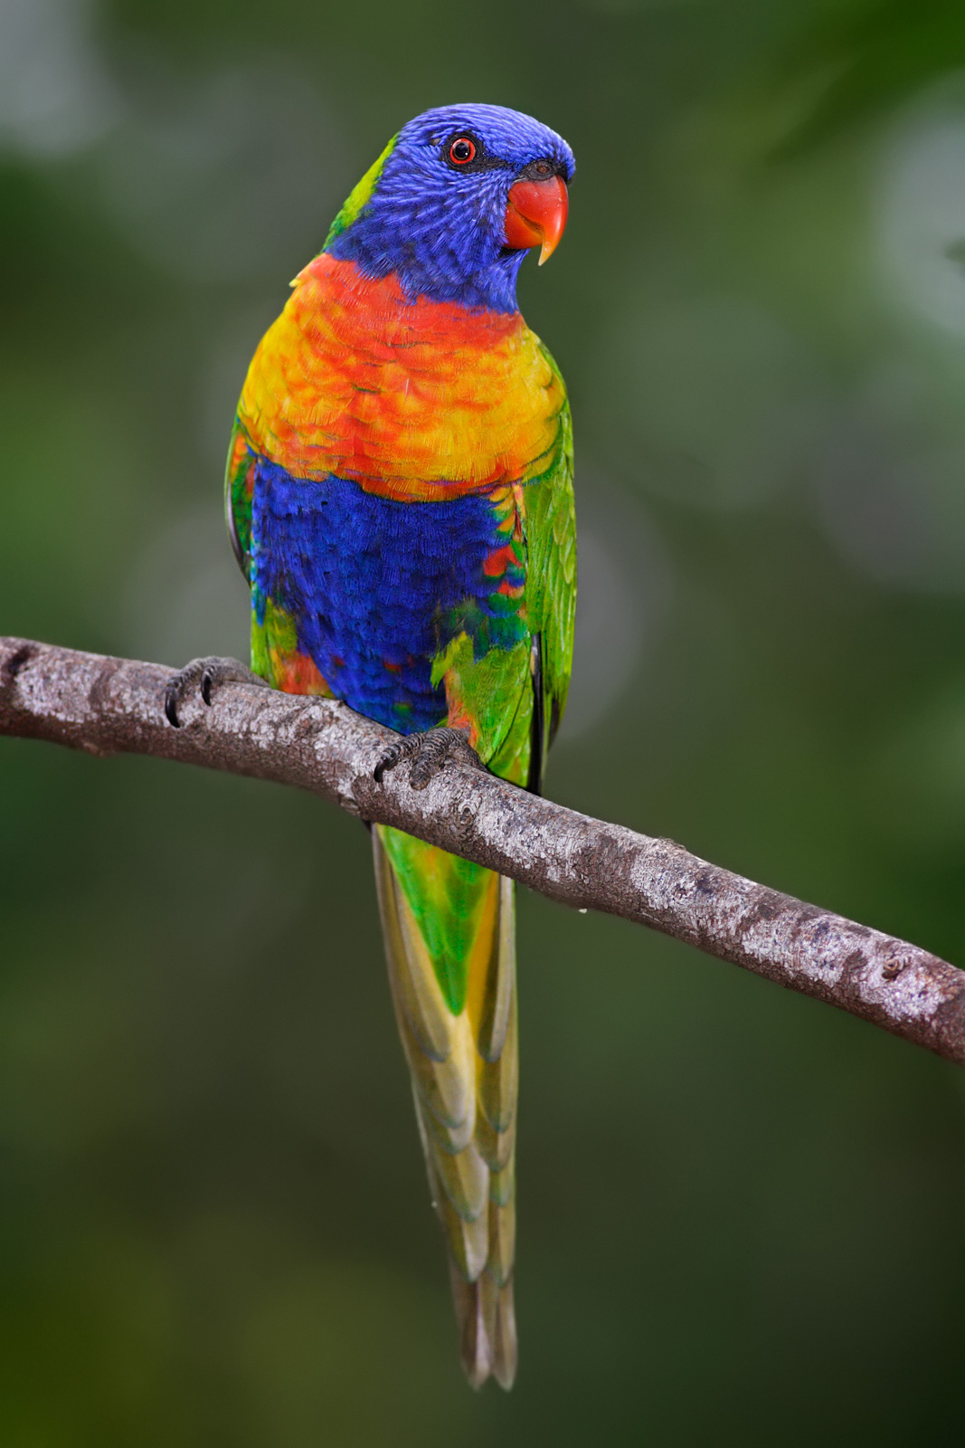
Poetry Task 3: Own Poems
Year 8 English
For this task, you will write three of your own poems using some of the techniques we have studied. They can be about anything you like, with ONE IMPORTANT EXEPTION: they cannot be about other students or teachers at the school!
Your poems must have the following:
- Each poem should have at least 9 lines and at least 4-5 words per line
- At least 2 of the poems should have a rhyme scheme
- At least 1 of the poems should have a meter (rhythm pattern)
- Your poems should all be a different form (can’t do all haikus).
- If you choose a haiku or a limerick, you must write 3 haikus and 2 limericks (to make them up to 9 lines). These will only count as one poem.
- Each poem must use at least FOUR poetic devices or techniques (including figurative language or sound devices – rhyme and rhythm count).
- Annotate your own poems labelling the devices you used.
Due date: Friday 27 May (end of week 4)

Marking Rubric
Criteria | A | B | C | D
Form
- Poems used different forms correctly & followed conventions of form.
- Poems fulfilled criteria of number of lines/words

Techniques
- Used a rhyme or rhythm pattern correctly for 2 poems
- Used at least 4 poetic devices correctly

Annotation
- Identified the devices used

