Cheesecake in a Glass
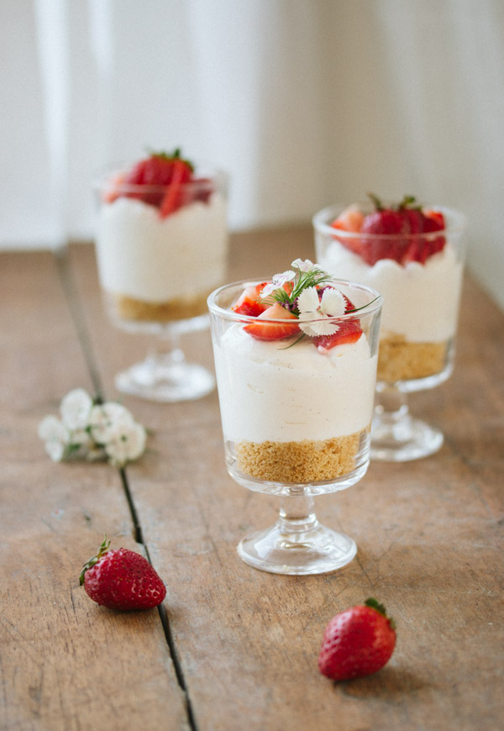
For the Crust:
- 85 g graham cracker/digestive biscuit/vanilla cookie crumbs (pulse in a food processor or blender until finely ground.)
- 2 tablespoons (25g) unsalted butter, melted

For the Cheesecake Filling:
- 225 g cream cheese, at room temperature
- ½ cup caster sugar
- 1 teaspoon vanilla extract
- 1-2 teaspoons lemon zest, optional
- 240ml cream
- 125g strawberries for topping

For the Berry Sauce:
- 2 teaspoons cornflour
- 2 tablespoons sugar
- 1/4 cup water
- 250g frozen berries, thawed

Method:
- Make the crust: In a medium bowl, mix together crumbs and melted butter until combined and crumbs are moistened.
- Divide evenly between individual serving dishes (about 2 tablespoons per serving dish). Press on the mixture with your fingers to form a crust layer.

- Make the filling: In a large bowl, combine cream cheese and sugar, and whisk with an electric mixer well until combined and completely smooth (if grainy, beat with an electric mixer until smooth).
- Add in vanilla and lemon zest. Set aside to let sugar dissolve into the cream cheese.
- Using an electric mixer, whisk heavy cream until soft peaks form. Avoid overbeating.
- Using a spatula, gently fold half of the whipped cream into the cream cheese mixture, then fold in the other half.
- Evenly spoon (or pipe using a piping bag) about ½ cup of filling into each serving dish

- Berry Sauce: In a small saucepan, combine the cornflour, sugar and water.
- Add the raspberries and cook over medium heat.
- Stir constantly until the mixture boils.
- Once boiling, cook and stir for one additional minute.
- Strain the sauce through a fine mesh sieve placed over a bowl to remove seeds.
- Cool to room temperature or chill in refrigerator until ready to serve.

- Plating: Top with fresh fruit or any other topping you like.
- Cover and place in the fridge for at least one hour before serving, or up to 2-3 days

