|  |  |
| --- | --- |
|  | **2020** |
|  | HC Logo (Colour) |

|  |
| --- |
| **Stage 2 - Food and hospitality** |
| Group Activity (20% of total assessment) |

**Group Activity**

**Performance Standards for Stage 2 Food and Hospitality**

|  | **Investigation and Critical Analysis** | **Problem-solving** | **Practical Application** | **Collaboration** | **Evaluation** |
| --- | --- | --- | --- | --- | --- |
| **A** | In-depth investigation and perceptive critical analysis of contemporary trends and/or issues related to food and hospitality.  Perceptive analysis of information for relevance and appropriateness, with appropriate acknowledgment of sources.  Highly effective application of literacy and numeracy skills, including clear and consistent use of appropriate terminology. | Astute identification and discussion of factors involved in problem-solving related to the food and hospitality industry.  Sophisticated and well-informed decision-making about problem-solving and implementation strategies.  Clear and very relevant justification of decisions about problem-solving and implementation strategies. | Ongoing and productive implementation of appropriate techniques, and sophisticated generation and maintenance of quality control in preparing and serving food.  Productive and efficient organisation and management of time and resources.  Logical selection and application of the most appropriate technology to prepare and serve food.  Sustained and thorough application of safe food-handling and management practices. | Initiation of ideas and procedures, display of leadership within the group, and proactive and inclusive response to members of the group.  Proactive and focused involvement in group activities and discussions to support healthy eating practices. | Insightful evaluation of the processes and outcomes of practical and group activities, including their own performance.  Sophisticated appraisal of the impact of technology, and/or sustainable practices or globalisation, on the food and hospitality industry.  Insightful explanation of the connections between research and/or planning, and practical application.  In-depth evaluation of contemporary trends and/or issues related to food and hospitality in a variety of settings. |
| **B** | Detailed investigation and  well-considered critical analysis of contemporary trends and/or issues related to food and hospitality.  Well-considered analysis of information for relevance and appropriateness, with appropriate acknowledgment of sources.  Effective application of literacy and numeracy skills, including mostly clear use of appropriate terminology. | Well-considered identification and discussion of factors involved in problem-solving related to the food and hospitality industry.  Well-informed decision-making about problem-solving and implementation strategies.  Mostly clear and relevant justification of decisions about problem-solving and implementation strategies. | Mostly productive implementation of appropriate techniques, and well-considered generation and maintenance of quality control in preparing and serving food.  Mostly productive organisation and management of time and resources.  Mostly logical selection and application of appropriate technology to prepare and serve food.  Capable application of safe food-handling and management practices. | Initiation of some ideas and procedures, some display of leadership within the group, and thoughtful and active response to members of the group.  Active and thoughtful involvement in group activities and discussions to support healthy eating practices. | Thoughtful evaluation of the processes and outcomes of practical and group activities, including their own performance.  Well-informed appraisal of the impact of technology, and/or sustainable practices or globalisation, on the food and hospitality industry.  Well-considered explanation of the connections between research and/or planning, and practical application.  Well-informed evaluation of contemporary trends and/or issues related to food and hospitality in different settings. |
| **C** | Competent investigation and some considered critical analysis of contemporary trends and/or issues related to food and hospitality.  Considered analysis of information for relevance and appropriateness, with generally appropriate acknowledgment of sources.  Generally effective application of literacy and numeracy skills, including competent use of appropriate terminology. | Considered identification and discussion of some factors involved in problem-solving related to the food and hospitality industry.  Informed decision-making about problem-solving and implementation strategies.  Generally relevant justification of decisions about problem-solving and implementation strategies, with some clarity. | Competent implementation of appropriate techniques, and considered generation and maintenance of quality control in preparing and serving food.  Competent organisation and management of time and resources.  Appropriate selection and application of technology to prepare and serve food.  Competent application of safe food-handling and management practices most of the time. | Some initiative with ideas or procedures, occasional leadership within the group, and generally active response to members of the group.  Active involvement in group activities and discussions to support healthy eating practices. | Considered evaluation of the processes and outcomes of practical and group activities, including their own performance.  Informed appraisal of the impact of technology, and/or sustainable practices or globalisation, on the food and hospitality industry.  Considered explanation of the connections between research and/or planning, and practical application.  Informed evaluation of contemporary trends and/or issues related to food and hospitality in different settings. |
| **D** | Some investigation and basic description of one or more contemporary trends or issues related to food and hospitality.  Some consideration of information for relevance or appropriateness, with some inconsistent acknowledgment of sources.  Inconsistent application of literacy and numeracy skills, with use of some terminology that may be appropriate. | Superficial identification and discussion of some factors involved in solving basic problems related to the food and hospitality industry.  Some basic and inconsistent decision-making about problem-solving and/or implementation strategies.  Some description and partial justification of one or more problem-solving and/or implementation strategies. | Basic implementation of one or more techniques, and some basic consideration of the generation and maintenance of quality control in preparing and serving food.  Inconsistent organisation and management of time and resources.  Identification and some application of technology that may be appropriate to prepare or serve food.  Some endeavour to apply safe food-handling and management practices some of the time. | Some participation within the group, and some response to members of the group. Participation is often passive.  Some basic involvement in group activities or discussions to support healthy eating practices. | Basic consideration of the processes and/or outcomes of practical and group activities, which may include their own performance.  Superficial consideration of the impact of technology, sustainable practices, or globalisation on the food and hospitality industry.  Some basic description of one or more connections between research and/or planning, and practical application.  Superficial reflection on one or more contemporary trends or issues related to food and hospitality, tending towards basic description. |
| **E** | Limited investigation or basic description of one or more contemporary trends or issues related to food and hospitality.  Limited identification or acknowledgment of information that may have some relevance.  Attempted application of literacy and numeracy skills, with attempted use of some basic terminology that may be appropriate. | Identification of one or more factors involved in solving basic problems related to the food and hospitality industry.  Attempted decision-making about a problem-solving or implementation strategy.  Attempted description of one or more problem-solving or implementation strategies. | Attempted development or implementation of a technique, and some awareness of the need for quality control in preparing or serving food.  Limited organisation or management of time and resources.  Limited identification or application of technology that may be appropriate to prepare or serve food.  Emerging awareness of safe food-handling and management practices. | Some attempted participation in one or more aspects of group work, and occasional response to members of the group.  Attempted involvement in one or more group activities or discussions to support healthy eating practices. | Attempted consideration of one or more processes or outcomes of a practical or group activity, which may include their own performance.  Attempted description of an impact of technology, sustainable practices, or globalisation on the food and hospitality industry.  Limited awareness of any connections between research and/or planning, and practical application.  Some recognition of one or more contemporary trends or issues related to food and hospitality. |

**Stage 2 Food and Hospitality Group Decision Making**

**Task:**

The task is to as a group create a gourmet takeaway grazing box, considering generally healthy options. 20 serves will be prepared while maintaining food safety practises, which will be delivered to staff for a takeaway afternoon tea in line with COVID-19 practises. The group collaboratively decided on the menu (Appendix.1).

**Collaboration and Management:**

The dish must offer a range of healthy options therefore advice from the Australian Guide to Healthy Eating must be considered. Fruit and vegetables will be included as a source of vitamins and minerals.[1] All bread components including the bagel buns and crackers will include wholemeal grains as they are high in fibre lowering cholesterol levels,[2] and contain antioxidants to help reduce risk of heart disease.[3] Natural sugars, as opposed to processed sugars, which cause high blood-pressure,[4] will be used in the bliss-balls, bagels and cold-roll dressings to increase health benefits.

The practical will take place over many hours therefore food must be stored correctly. Perishable items such as vegetables must be stored below 4°C to prevent bacteria growing. To maintain hygiene standards, hands will be washed and gloves worn during the practical. Individual components such as the hummus will be packaged individually to maintain freshness. High risk foods such as meat for the bagel will be packaged in vacuumed sealed bags to avoid spoilage and eliminate cross-contamination.

To ensure organisation and efficient time management a weekly plan (Appendix.2) and a plan for the day (Appendix.3) has been created as well as a diagram to ensure consistent plating (Appendix.4). Each group member will be allocated tasks before and during the day (Appendix.5) to ensure efficiency. Food and packaging will be ordered prior to the day to ensure arrival of all components. Gift tags were created to enhance packaging design while also identifying those with dietary requirements. Staff members will be contacted promptly (Appendix.6) to confirm catering numbers and dietary requirements.

Due to COVID-19 dining-in has been restricted so takeaway boxes have become increasingly popular.[5] Therefore, a takeaway box is fitting with contemporary trends. Contrasting flavours, textures and colours are also popular trends which will be displayed through vibrant pink tartlets, yellow hummus, crunchy crackers and a variety of fruits.

**Implementation:**

To ensure a smooth practical the following steps will be implemented:

1. Group discussions to decide the menu and job allocations (Appendix.7).
2. Completion of tasks as outlined in the weekly plan to ensure everything is ready prior to the practical.
3. Practise of all food components to ensure success and appropriate portion sizes allowing for food orders to be completed with correct amounts. This will make sure no food items run out on the day while also prevent potential food waste.
4. Preparation of packaging including assembly of grazing boxes prior.
5. Creation of a menu including a list of ingredients to inform consumers which will be emailed out on the day.
6. Detailed mise en place before commencing practical to double check arrival of all ingredients and ensure all ingredients are on hand.

**Word Count:** 500

**References:**

Better Health Channel. (2020) *Antioxidants*. [online] Available at: <https://www.betterhealth.vic.gov.au/health/healthyliving/antioxidants#:~:text=A%20diet%20high%20in%20antioxidants,be%20studied%20around%20the%20world.> [Accessed 19 October 2020].

Galletly, J., (2020). *Here Are Restaurants That Have Boosted Their Takeaway And Delivery Offerings*. [online] Available at: <https://www.adelaidenow.com.au/delicious-sa/here-are-restaurants-that-have-boosted-their-takeaway-offerings/news-story/1c92546f06166aae9844006cd21b0208> [Accessed 19 October 2020].

Harvard Health Publishing. (2019) *The Sweet Dangers Of Sugar*. [online] Available at: <https://www.health.harvard.edu/heart-health/the-sweet-danger-of-sugar#:~:text=Over%20time%2C%20this%20can%20lead,pathological%20pathways%20to%20heart%20disease.> [Accessed 19 October 2020].

NHS. (2018) *Why 5 A Day?* [online] Available at: <https://www.nhs.uk/live-well/eat-well/why-5-a-day/#:~:text=Fruit%20and%20vegetables%20are%20a,your%20risk%20of%20bowel%20cancer.> [Accessed 19 October 2020].

Mayo Clinic. (2020). *Dietary Fiber: Essential For A Healthy Diet*. [online] Available at: <https://www.mayoclinic.org/healthy-lifestyle/nutrition-and-healthy-eating/in-depth/fiber/art-20043983> [Accessed 19 October 2020].

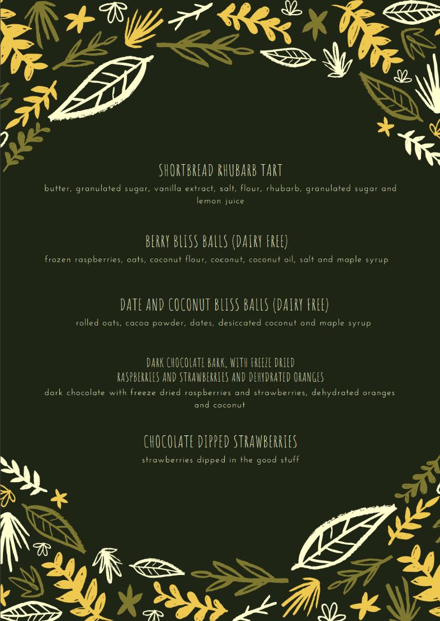**Appendix 1.**

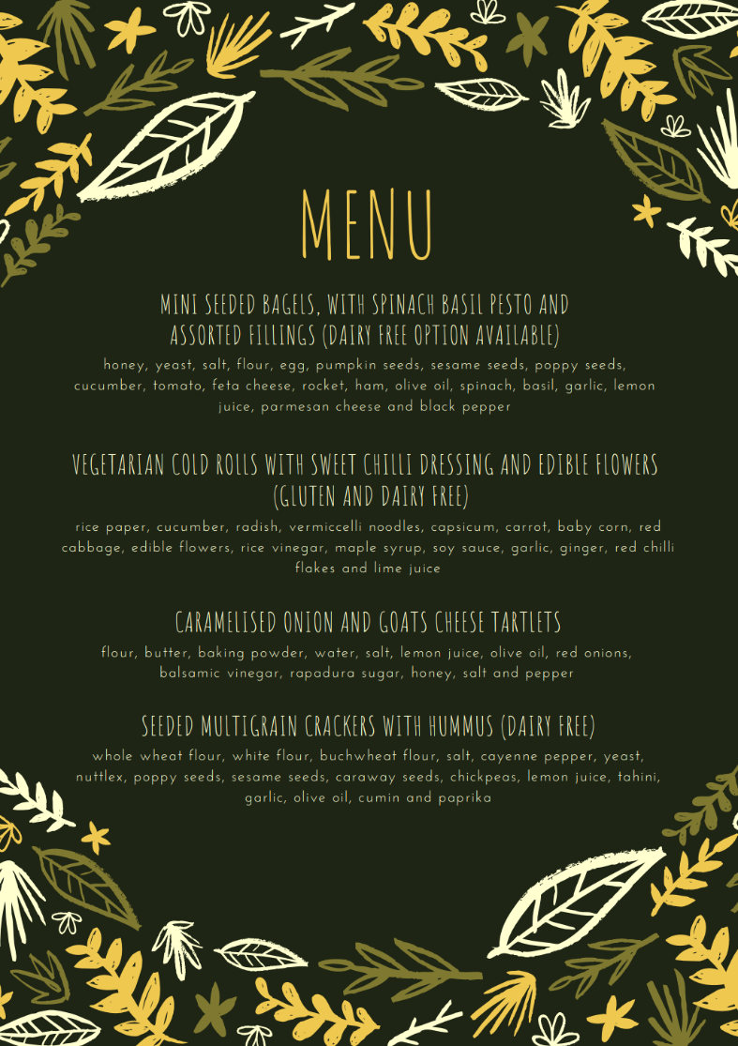

**Appendix 2.**

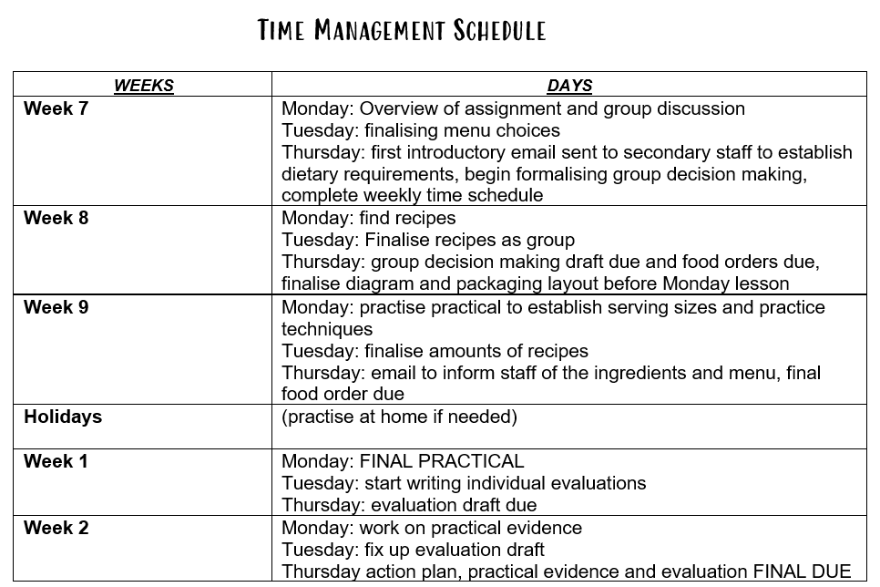

**Appendix 3.**

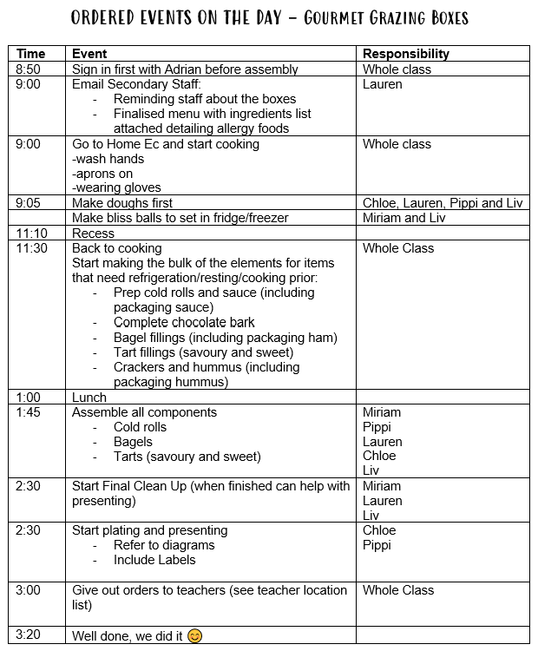

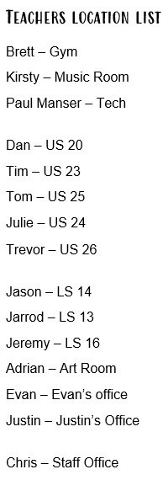

**Appendix 4.**

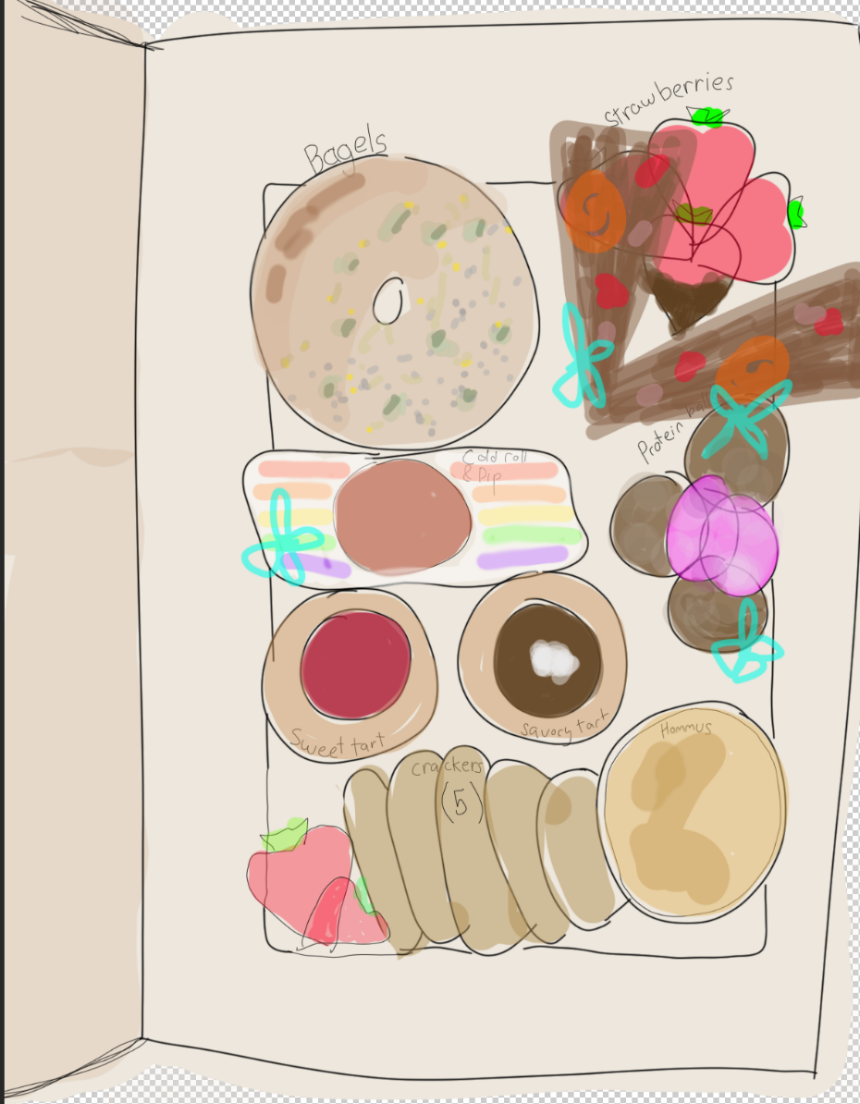

**Appendix 5.**

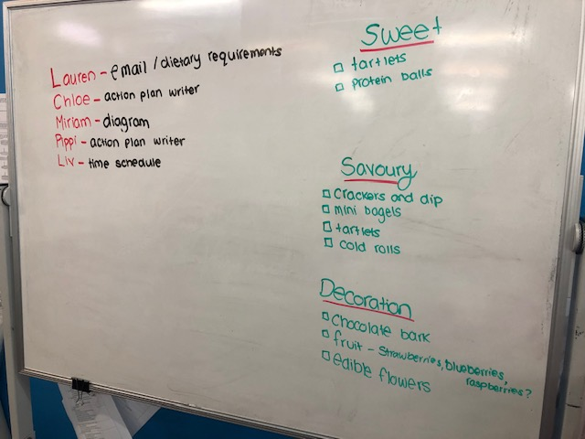

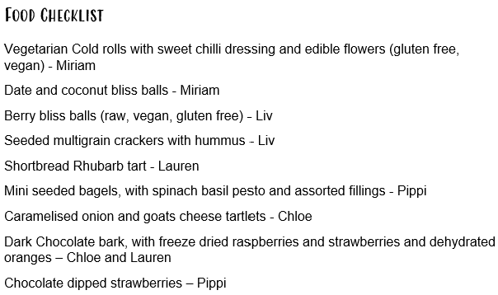

**Appendix.6.**

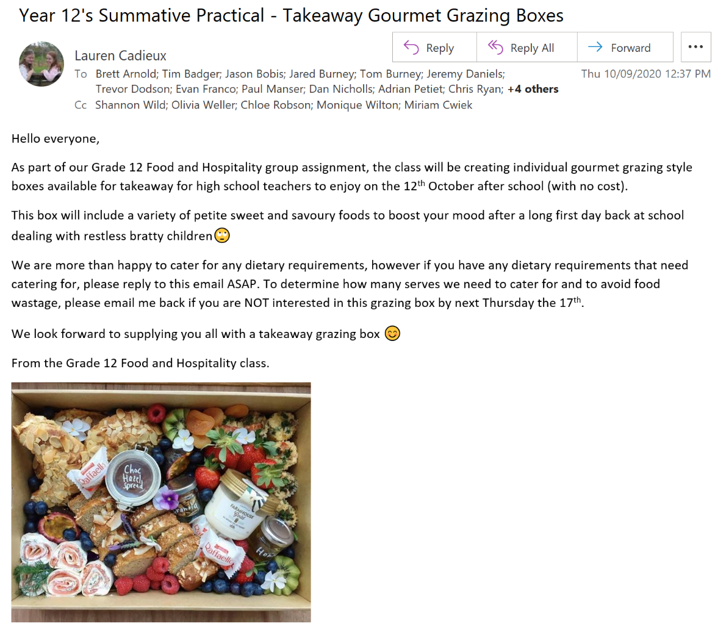

**Appendix 7.**

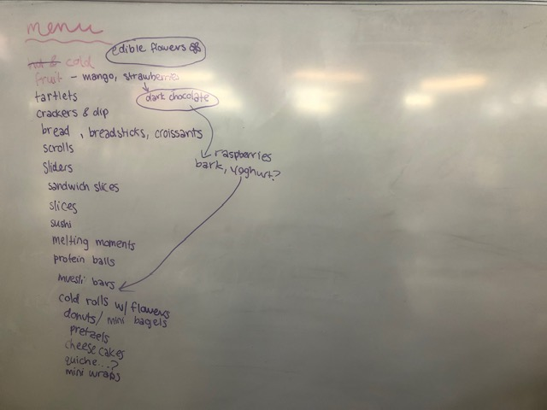

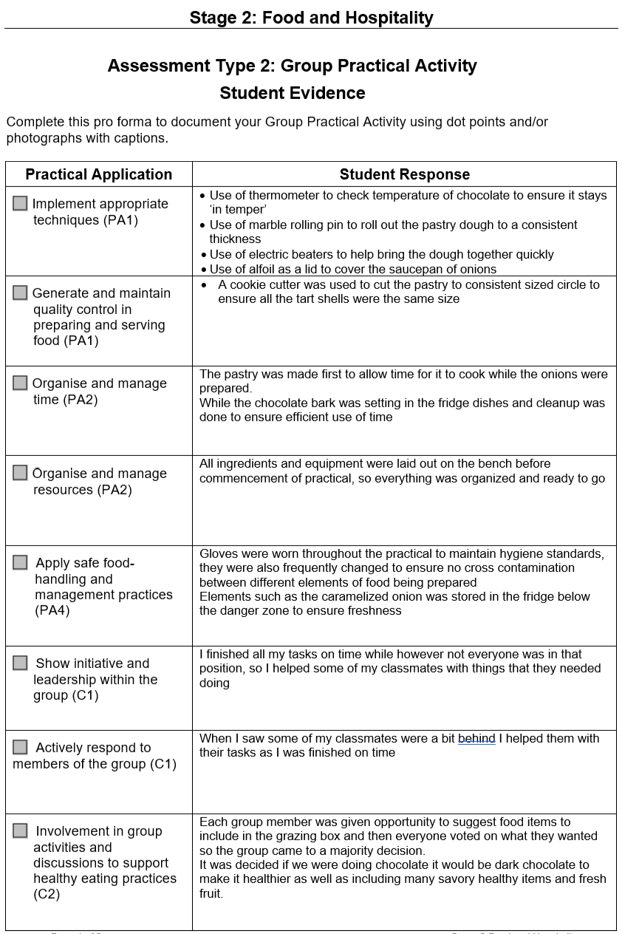

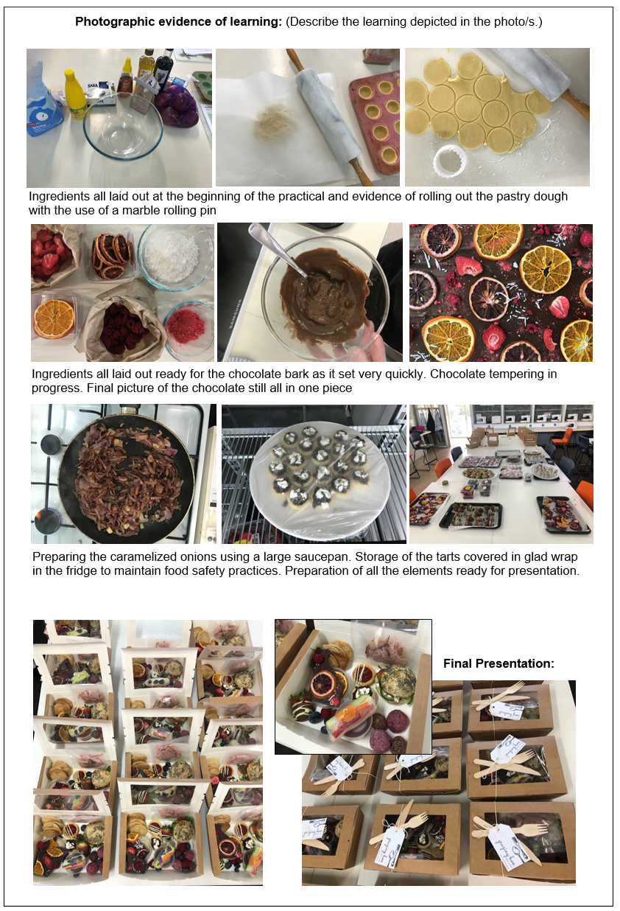

**Food and Hospitality Evaluation – Grazing Style Takeaway Boxes**

The task was to create a gourmet grazing box as a group, including predominantly healthy food options. 16 serves had to be prepared and delivered to staff, while maintaining food hygiene standards.

Prior to the day, a time plan and job allocations were organised, helping the event run smoothly. However, some people were quicker at tasks than anticipated, therefore communication across group members was beneficial to help those running behind schedule prepare all elements on time. Towards the end of the day the group split into plating and presenting while the others cleaned up remaining dishes. This allowed everything to be ready simultaneously for end of day delivery. While individually delivering each box was time-consuming, it was necessary to meet COVID-19 requirements.

Presentation was planned prior to balance shapes and sizes such as the larger bagels and hummus with smaller items like protein balls. A diagram of the presentation was then constructed which was used on the day to ensure efficient and consistent plating. Berries were distributed throughout the grazing box to add colour and items such as the chocolate bark made a trending statement piece.

Tasked with making caramelised-onion tarts I used a marble rolling pin to roll the pastry. This proved beneficial as it made it significantly quicker to roll the pastry to the desired thinness and helped achieve a consistent thickness to ensure the tart shells were all the same size. The recipe required the caramelised onions to be covered while cooking on the stove however the large saucepan used didn’t have a lid. Alfoil was used as a replacement allowing the onions to be cooked on a low heat so they didn’t burn or stick to the pan while also ensuring quick and even caramelisation.

I was also involved in producing gourmet chocolate bark. The chocolate was tempered with the assistance of a microwave and thermometer to ensure the temperature didn’t exceed 35°C. This process gave the chocolate a nice shine and snap, allowing it to be broken into appropriately sized pieces. Tempering the chocolate meant it set quickly at room temperature, so toppings were all prepared before tempering to ensure they were ready to be placed on the chocolate as soon as it was spread out.

Throughout the practical, all members wore gloves to maintain food hygiene standards. All foods once prepared were stored in the fridge below danger zones (4°C) in adherence to Australian Food Safety Standards. The meat in the bagels was the only high-risk food and was therefore packaged separately in a vacuum-sealed bag to avoid contamination with other foods in the grazing box and was stored under until needed for delivery. Including only one high-risk food meant all other foods could be presented together creating a desirable arrangement.

To improve customer experience, it may have been beneficial to separate sweet and savoury elements in the dish. This would allow consumers to know what flavours they were expecting from the food and allow them to eat the savoury before sweet if desired.

**Word Count:** 500

**Stage 2 F&H Observation Checklist – Group Activity**

|  |
| --- |
| PA 1 – Implementation of techniques and quality control |
| Appropriate techniques followed and understood A B C D E  Consistent portion control applied and maintained A B C D E |
| PA 2 – Organisation and management of time and resources |
| Food order completed accurately and on time A B C D E  Recipe meets the needs of the practical A B C D E  Mise en place – resources organised A B C D E  Food prepared in time available A B C D E  All equipment left clean and returned to its appropriate place of storage A B C D E |
| PA 4 – Safe food handling and management practices |
| Follows and maintains safe food handling practices A B C D E |
| C 1 – Response to other group members, and sharing in decision-making. |
| Responds constructively to other group members A B C D E  Proactive throughout, and demonstrates leadership A B C D E |
| C 2 – Involvement in group activities and discussions to support healthy eating practices. |
| Consideration and implementation generally healthy options A B C D E |
| Comments:   * Applied appropriate techniques throughout, specifically through her tempering of the chocolate bark to ensure shine and a snap. * Demonstrated a high level of organisation through her food preparation throughout and organisation in preparing food labels prior. * Demonstrated safe food handling practices throughout * Showed initiative throughout helping others throughout the practical and through her input in group discussions. |
| Overall Grade A B C D E |

1. NHS. (2018) *Why 5 A Day?* [online] Available at: <https://www.nhs.uk/live-well/eat-well/why-5-a-day/#:~:text=Fruit%20and%20vegetables%20are%20a,your%20risk%20of%20bowel%20cancer.> [Accessed 19 October 2020].
2. Mayo Clinic. (2020). *Dietary Fiber: Essential For A Healthy Diet*. [online] Available at: <https://www.mayoclinic.org/healthy-lifestyle/nutrition-and-healthy-eating/in-depth/fiber/art-20043983> [Accessed 19 October 2020].
3. Better Health Channel. (2020) *Antioxidants*. [online] Available at: <https://www.betterhealth.vic.gov.au/health/healthyliving/antioxidants#:~:text=A%20diet%20high%20in%20antioxidants,be%20studied%20around%20the%20world.> [Accessed 19 October 2020].
4. Harvard Health Publishing. (2019) *The Sweet Dangers Of Sugar*. [online] Available at: <https://www.health.harvard.edu/heart-health/the-sweet-danger-of-sugar#:~:text=Over%20time%2C%20this%20can% 20lead,pathological%20pathways%20to%20heart%20disease.> [Accessed 19 October 2020].
5. Galletly, J., (2020). *Here Are Restaurants That Have Boosted Their Takeaway And Delivery Offerings*. [online] Available at: <https://www.adelaidenow.com.au/delicious-sa/here-are-restaurants-that-have-boosted-their-takeaway-offerings/news-story/1c92546f06166aae9844006cd21b0208> [Accessed 19 October 2020].