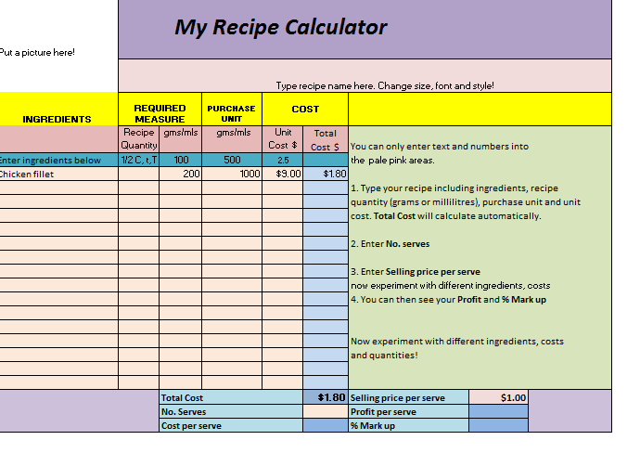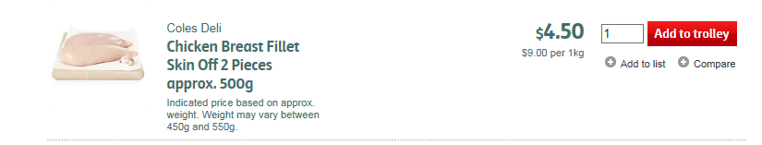

Purchase unit is 1kg or 1000g, as the recipe calculator needs you to use grams or millilitres.

Cost/unit, which in this case is $9.00

The actual amount you need in grams or millilitres

Actual cost of the chicken you need.