What is OnGuard….and how do I use it?
Instructions
OnGuard is online safety training to which is used in conjunction with in-class training to help maintain a safe learning environment.

1. Go to the following link: https://onguardv3.com.au/
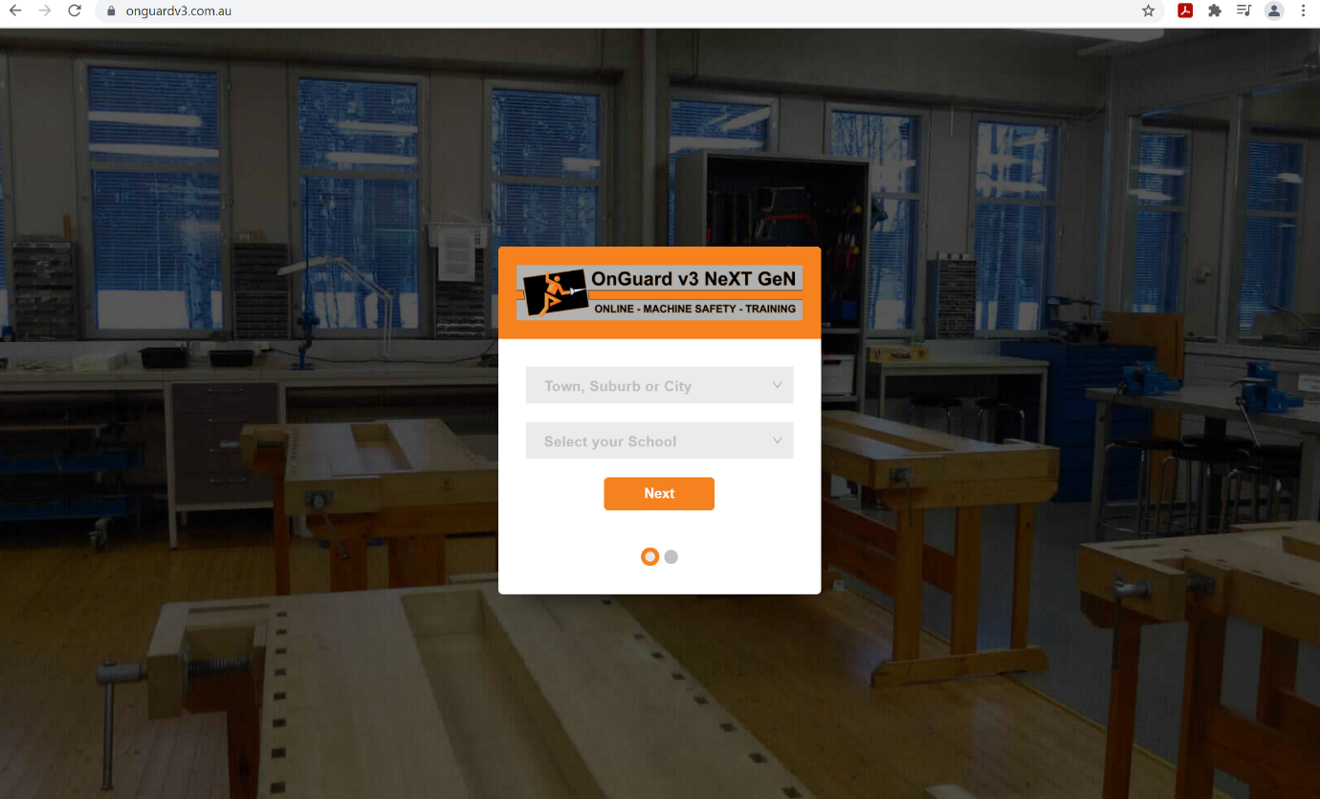

2. Select ‘Oakden’ for the suburb; and ‘Heritage College – Oakden’ for the school.
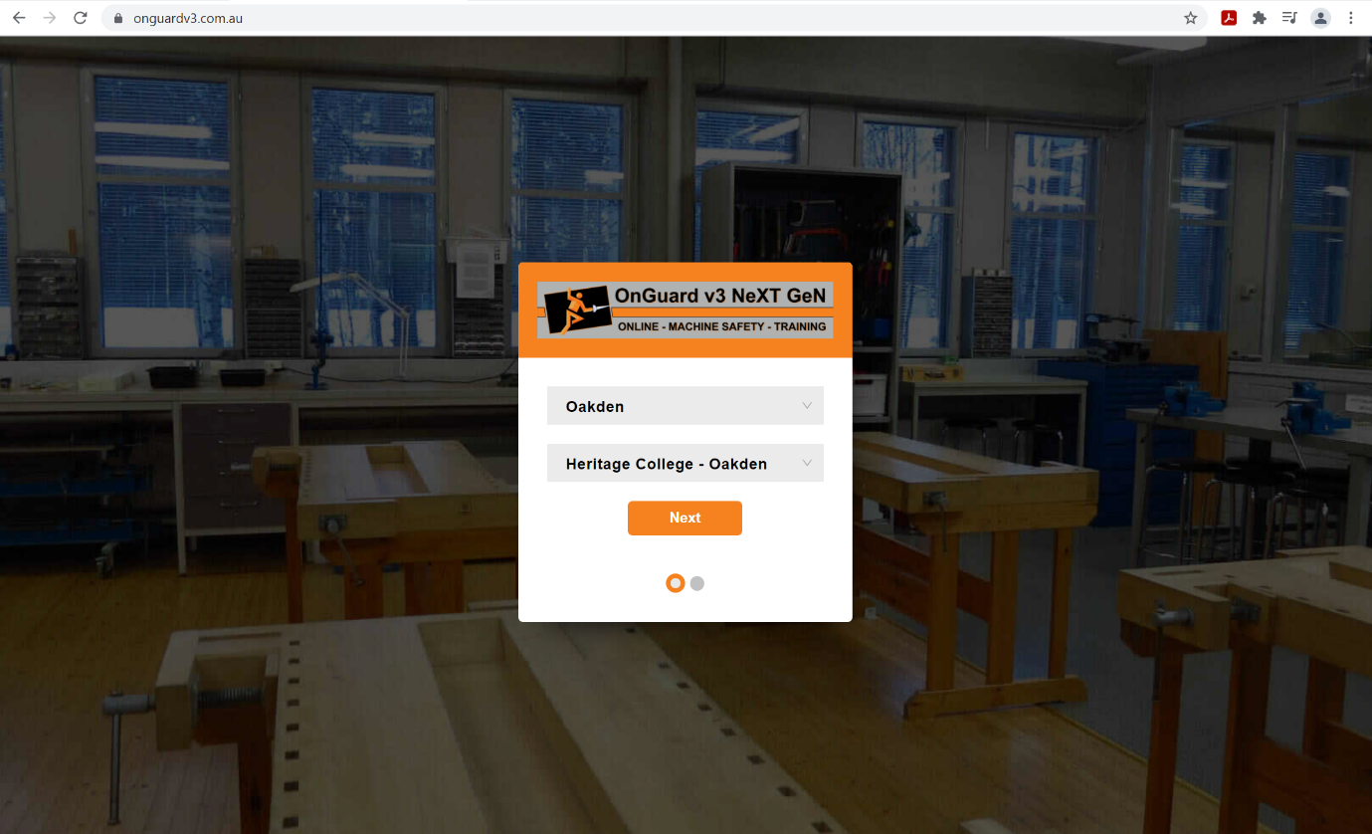

3. Then enter your username and password, your username and password should be the following:
Username = Your lastname followed by the first letter of your first name ie John Smith is smithj
(all lowercase)
Password = You should already have a password which you used in Tech or Science, if you can’t remember send me and email and I will reset it for you. All reset passwords become: onguard
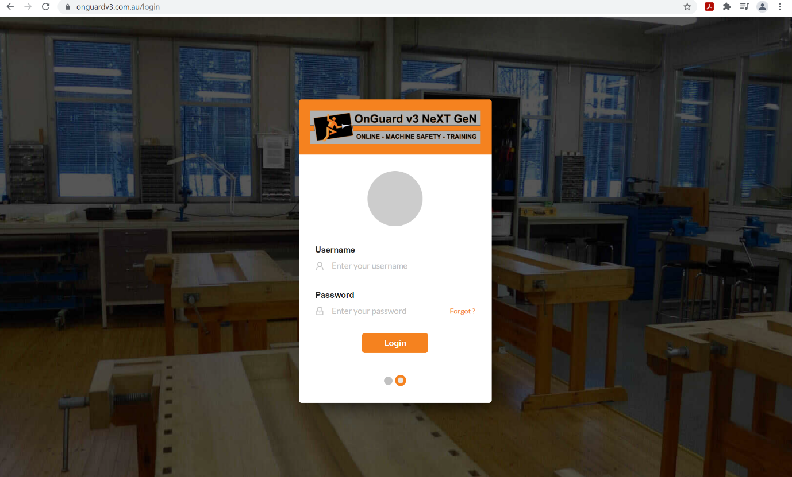

4. Once you are logged in click the ‘My Courses’ button.
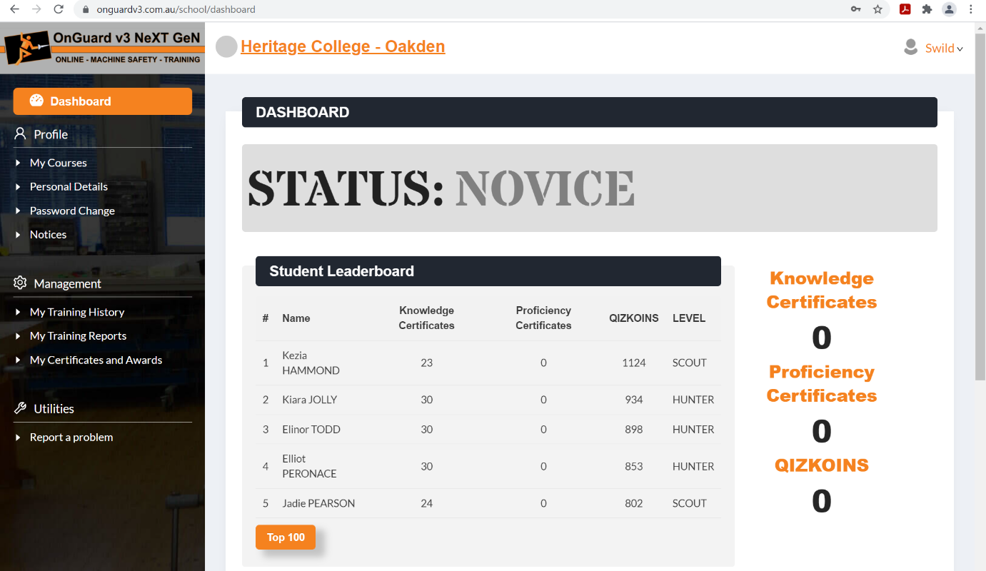

5. Then click on the ‘Year 7 Textiles Technology 2’ button.
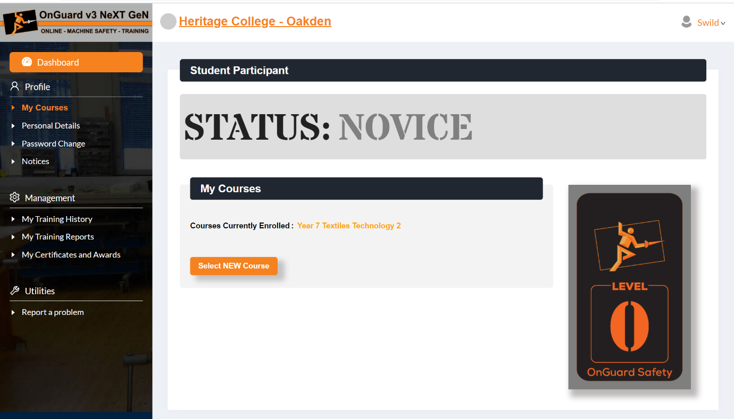

6. Choose one of the following course to complete, it’s best to start with ‘Textiles Technology Safety’
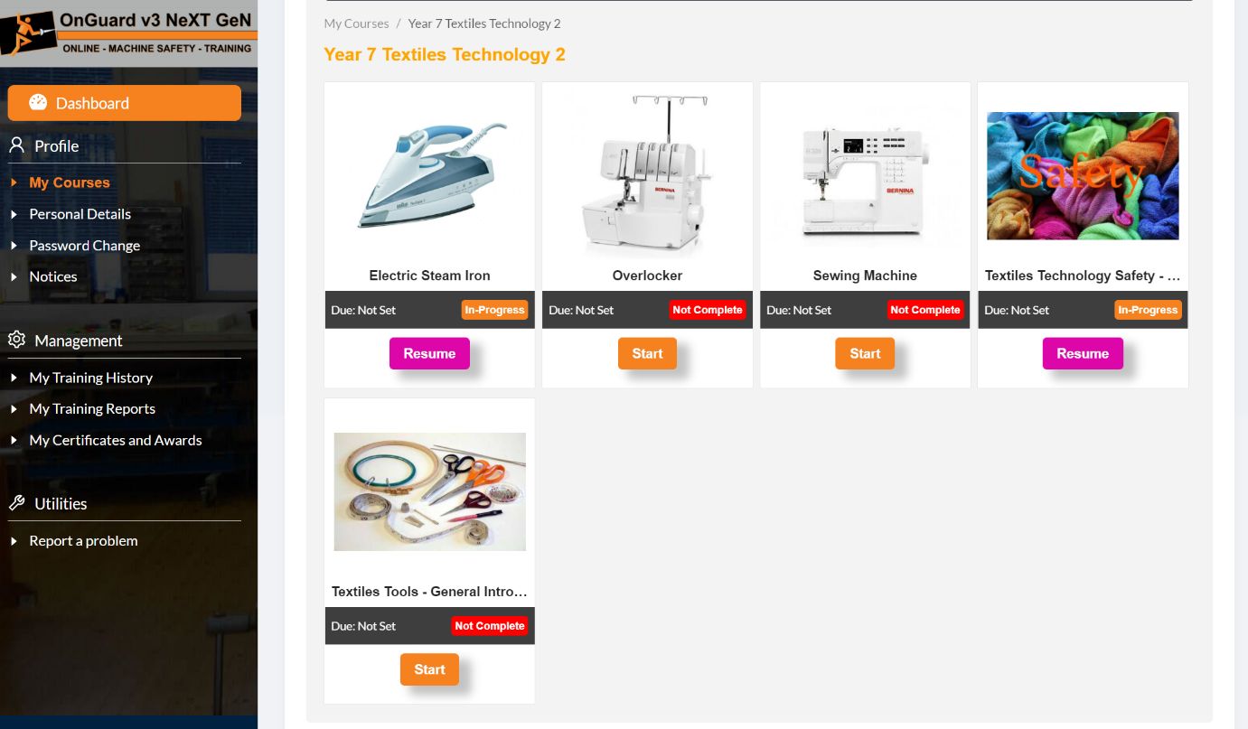

7. Read the information then answer the question on the right hand side and click next.
If you run out of time and want to continue later, click the finish later button and it will save what you have done and you will be able to go back to it later
NOTE: You are only allowed to get 2 questions wrong throughout.
