Chicken Pie makes 4
Ingredients
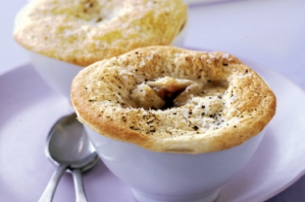
Mustard sauce
10g butter
10g plain flour
75ml milk
1tsp Dijon mustard
pinch of salt and nutmeg
Chicken filling
200g chicken breast
¼ leek, diced
¼ cup corn
50g pumpkin, cubed
50g broccoli, cut into small pieces
¼ zucchini, diced
30g bacon, diced
2 sheet of puff pastry
4 x 10-12cm foils pie trays
Method
Preheat oven to 200°C
Chicken Filling
- In a frying pan over a medium heat fry chicken, bacon and leek until the chicken is cooked.
- Add the vegetables and cook for another 2 minutes.
- Set aside to cool while you make the cheese sauce.
Mustard Sauce
- Melt the butter in a medium saucepan.
- Add the flour and cook for 1 minute.
- Turn of the heat and slowly add the milk a little bit at a time until all the milk is added.
- Heat until the sauce thickens.
- Add the Dijon mustard and stir until combined.
To make
- Mix the mustard sauce with the chicken filling mixture.
- Cut pastry circles to fit dishes and press in each tray carefully.
- Divide the filling mixture between the pie trays and add the pastry lid, pressing down the edges with a fork, this is so the pastry lid stays on when it is cooked.
- Bake in the oven for 20-25 minutes or until golden brown.

