Balsamic Berry Bruschetta
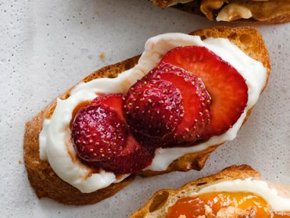
Ingredients
4 slices ciabatta
Butter, for spreading
2tsp caster sugar
1 cup strawberries or mixed berries, sliced
2Tblsp caster sugar
1Tblsp balsamic vinegar
¼ cup mascarpone
2Tblsp icing sugar
⅛ tsp vanilla essence

Method
- Preheat oven to 200°C.
- In a small bowl gently combine the strawberries, caster sugar and balsamic vinegar, and set aside for 30 minutes.
- In another small bowl mix well the mascarpone, icing sugar and vanilla, cover and place in the fridge until ready to use.
- Spread 1 side of the ciabatta with butter and sprinkle each piece with ½ teaspoon of sugar

- Cook in oven for 5 - 7 minutes or until golden. Remove from oven and transfer to a serving platter.
- Spread each slice of the ciabatta with the mascarpone mixture
- Divide the strawberry mixture between the 4 slices of ciabatta.
- Serve immediately.

