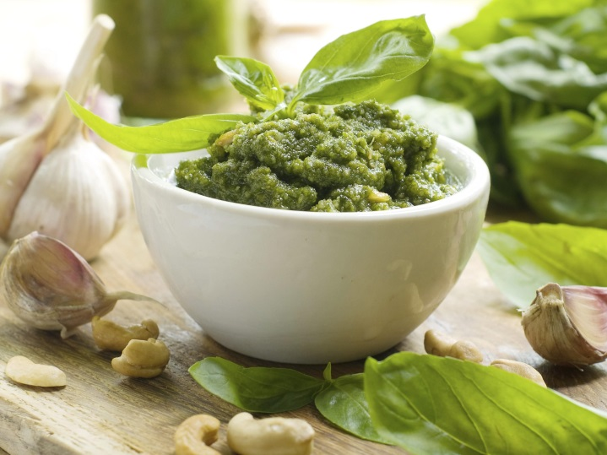
Pesto
Makes 3/4 cup

Ingredients
2 cups firmly packed fresh basil leaves
2 large garlic cloves, peeled
60mls (¼ cup) extra virgin olive oil
30g (⅓ cup) grated parmesan
2 tsp lime juice

Method
Place basil leaves, garlic, olive oil, parmesan and lime juice into the bowl of a food processor and process until finely chopped.
Store in an airtight container in the refrigerator until required.

