Pesto, semi-dried tomato & bocconcini bruschetta
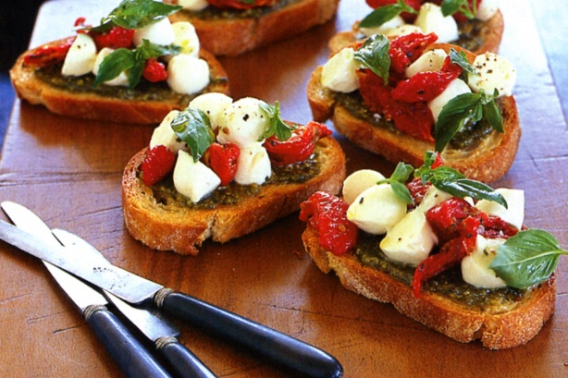
Ingredients
20ml olive oil
1 small garlic clove, crushed
4 slices ciabatta
1Tblsp basil pesto
25g semi-dried tomatoes, drained on paper towel
50g cherry bocconcini, drained, halved
Small fresh basil leaves, to serve
Sea salt flakes & freshly ground black pepper

Method
- Preheat oven to 200°C.
- Combine the oil and the garlic in a bowl.
- Brush both sides of ciabatta with the garlic oil and place on a baking tray.
- Cook in oven for 5 minutes or until golden. Remove from oven and transfer to a serving platter.
- In a small bowl gently combine the pesto, semi-dried tomato and bocconcini.
- Divide the topping mix between the 4 slices of ciabatta.
- Sprinkle with basil leaves and season with salt and pepper.
- Serve immediately.

