Muesli Cookies makes approx. 30
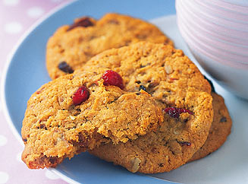
Ingredients
1 ½ cups toasted muesli
1 cup plain flour
1 cup desiccated coconut
½ cup dried cranberries
¼ cup firmly packed brown sugar
1 ½ teaspoons ground ginger
125g butter, chopped
¼ cup golden syrup
4 Tablespoons water
1 teaspoon bicarbonate of soda

Method
- Preheat oven to 160°C.
- Line 2 baking trays with baking paper.
- Combine the muesli, flour, coconut, dried cranberries, brown sugar and ginger in a large bowl.
- In a medium microwave safe bowl heat the butter, golden syrup and water until the butter is melted, and combines well with the golden syrup and water, approx. 2 minutes on medium.
- Remove from heat and add the bicarbonate of soda and stir until just combined, it will go very frothy. Add to muesli mixture and stir well.
- Use your hands to roll 1 Tblsp of mixture into balls and place on prepared trays, allowing room for spreading. Use your fingers to flatten to 1cm thick.
- Bake for 12-15 minutes or until golden brown and crisp.
- Remove from oven and set aside for 5 minutes before transferring to a wire rack to cool completely.

