Toasted Muesli makes approx. 1 ½ cups
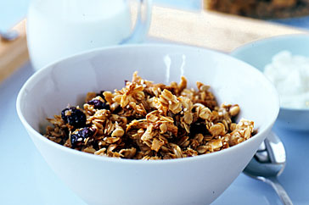
Ingredients
1 Tblsp honey
1 Tblsp brown sugar
1 Tblsp olive oil

1 cup rolled oats
2 Tblsp bran flakes
2 Tblsp shredded coconut
1 Tblsp sesame seeds
1 Tblsp sunflower seeds
1 Tblsp chopped pecan nuts
2 Tblsp dried apple or apricots, roughly chopped
2 Tblsp dried cranberries

Method
- Preheat oven to 150⁰C.
- Line an oven tray with baking paper.
- Combine honey, brown sugar and olive oil in a small microwave safe bowl and heat for 30 seconds or until the sugar is dissolved.
- Mix together the remaining ingredients in a large bowl
- Pour the warm honey mixture over the dry ingredients and mix well to combine.
- Spread mixture evenly over your lined baking tray.
- Bake for 15 minutes, or until golden and toasted.
- Set aside to cool completely (muesli will form crisp cluster on cooling).
- When cool break into clumps and store in an airtight container.

