Cinnamon Scrolls
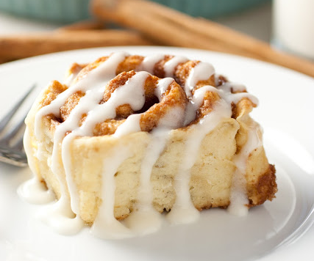
Ingredients
Dough
2½ cups plain flour
2 Tblsp caster sugar
1½ tsp baking powder
½ tsp bicarbonate of soda
½ tsp salt
65g butter, melted
1¼ cups buttermilk
Filling
¾ cup brown sugar
4 Tblsp caster sugar
2½ tsp cinnamon
⅛ tsp nutmeg
⅛ tsp salt
45g butter, melted
Vanilla glaze
1 cup icing sugar
2 tablespoons milk
1/4 teaspoon vanilla extract

In a small bowl, combine the sugar, milk and vanilla and stir until smooth.

Method
Preheat the oven to 180°C.
Filling: In a small bowl mix together the brown sugar, caster sugar, cinnamon, nutmeg and salt. Add the melted butter and mix together.
Dough: In a large bowl mix together the flour, caster sugar, baking powder, bicarbonate of soda and salt.
Mix the buttermilk with 65g of melted butter, and add to the flour mixture and mix until combined and the mixture is soft and sticky.
Sprinkle the bench with some flour and pat the dough out with your hands until it measures a 20cm x 30cm rectangle. Spread the dough evenly with sugar and butter mixture.
Starting on the long side, roll the dough into a log shape. Cut into 8 equal slices.
Arrange the slices onto a lined baking tray and bake for 20-25 minutes.
When cooled slightly, drizzle with vanilla glaze.

