Tomato Chutney
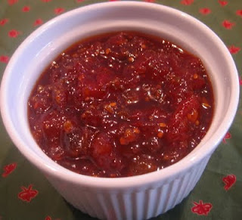
Ingredients
¼ large onion,
finely chopped
1 tsp minced garlic
¼ cup sugar
1 tsp curry powder
⅛ tsp chilli powder
1 Tblsp sultanas
½ tsp salt
300g tinned diced tomatoes
60ml apple cider vinegar
1 grind of pepper

Method
- Place all of the ingredients into a large saucepan and cook over a medium heat, stirring until the mixture boils.
- Reduce the heat to low and simmer for 15-20 minutes or until the mixture has thickened.
- Spoon mixture into a clean dry jar and let cool.
- Once cool top with a lid and label.

